1. **Hong Kong relaxes Covid rules for tour groups**

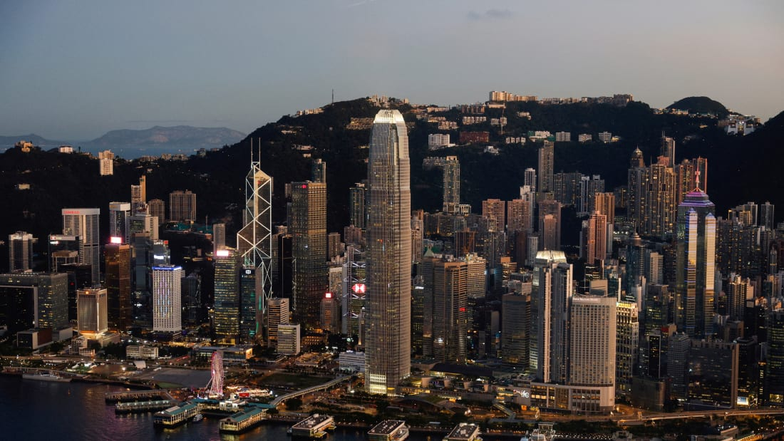

Hong Kong's government said on November 7 it was relaxing COVID-19 restrictions on inbound tour groups including allowing them to enter theme parks and museums after arriving in the financial hub.

Hong Kong has relaxed many of its stringent coronavirus policies in recent months, including hotel quarantine for international arrivals as of Sept. 26.

International arrivals are still, however, subject to multiple coronavirus tests and barred from entering bars, restaurants and venues like sports clubs for the first three days.

The government said specific arrangements for visiting tourists would be launched this month, without specifying a start date.

Related content [Hong Kong is opening up to tourism -- but is it too late?](https://edition.cnn.com/travel/article/hong-kong-tourism-recovery-intl-hnk/index.html)

"The relevant arrangements can support the gradual resumption of the inbound travel market in an orderly manner and provide more favorable business environment for the travel trade," the government said.

The announcement came after Hong Kong last week hosted a high-profile financial summit for which more than 200 financial executives who flew into the former British colony were exempted from Hong Kong's rules for international arrivals.

Many local residents have pointed to inconsistencies in government policy and said authorities should remove the restrictions for everyone equally.

Hong Kong's economy has been battered by the coronavirus restrictions which have lasted for nearly three years with many small and medium-sized businesses closing down.

# Inside the Barossa Valley's newly-renovated luxury lodge, The Louise

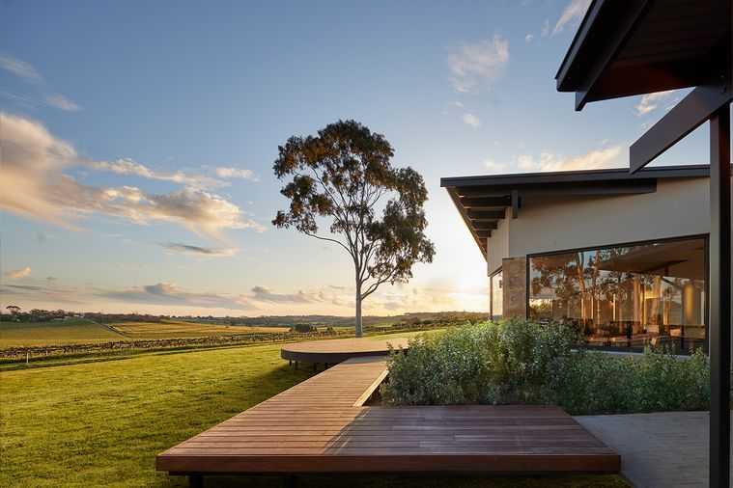

[](https://www.delicious.com.au/people-events/people/krysia-bonkowski/v519mvo6)

##### [BY KRYSIA BONKOWSKI](https://www.delicious.com.au/people-events/people/krysia-bonkowski/v519mvo6)

##### [EDITOR](https://www.delicious.com.au/people-events/people/krysia-bonkowski/v519mvo6)

##### NOV 04, 2022

**After a multi-million dollar renovation, this iconic Barossa spot serves up a lesson in understated luxury.**

[The Louise](https://thelouise.com.au/) has set the standard for five-star accommodation in the [Barossa Valley](https://www.delicious.com.au/travel/australia/article/depth-guide-barossa-valley/u2kuh27y) ever since hoteliers Jim and Helen Carreker took over the low-rise lodge in the western reaches of the legendary wine region. Now in the hands of [Baillie Lodges](https://baillielodges.com.au/) and fresh from a $3 million renovation, the South Australian retreat has entered a new era with a transformed main building and new-look suites.

## ****Pitch-perfect first notes****

From the road, The Louise cuts a low profile in its agricultural setting. A lavender-lined grapevine arbour guides new arrivals towards the reception, where bags are whisked away and guests seated in the lobby to enjoy a welcome cocktail and snack prepared with local produce, dabbing away any vestiges of the trip with a towelette scented by The Louise’s signature fragrance of peppermint, lemon myrtle, and musky ambrette. The main lodge has a languid new look based on designs by Max Pritchard, the SA architect behind Kangaroo Island’s much-mourned Southern Ocean Lodge, with bespoke works by local artists Renee de Saxe and Emma Hack (the latter known best for her bodypainting in Gotye’s hit music video ‘[Somebody that I used to know](https://www.youtube.com/watch?v=8UVNT4wvIGY)’). After refreshments, it’s time to settle into your suite, also spritzed with the signature scent in anticipation of your arrival.

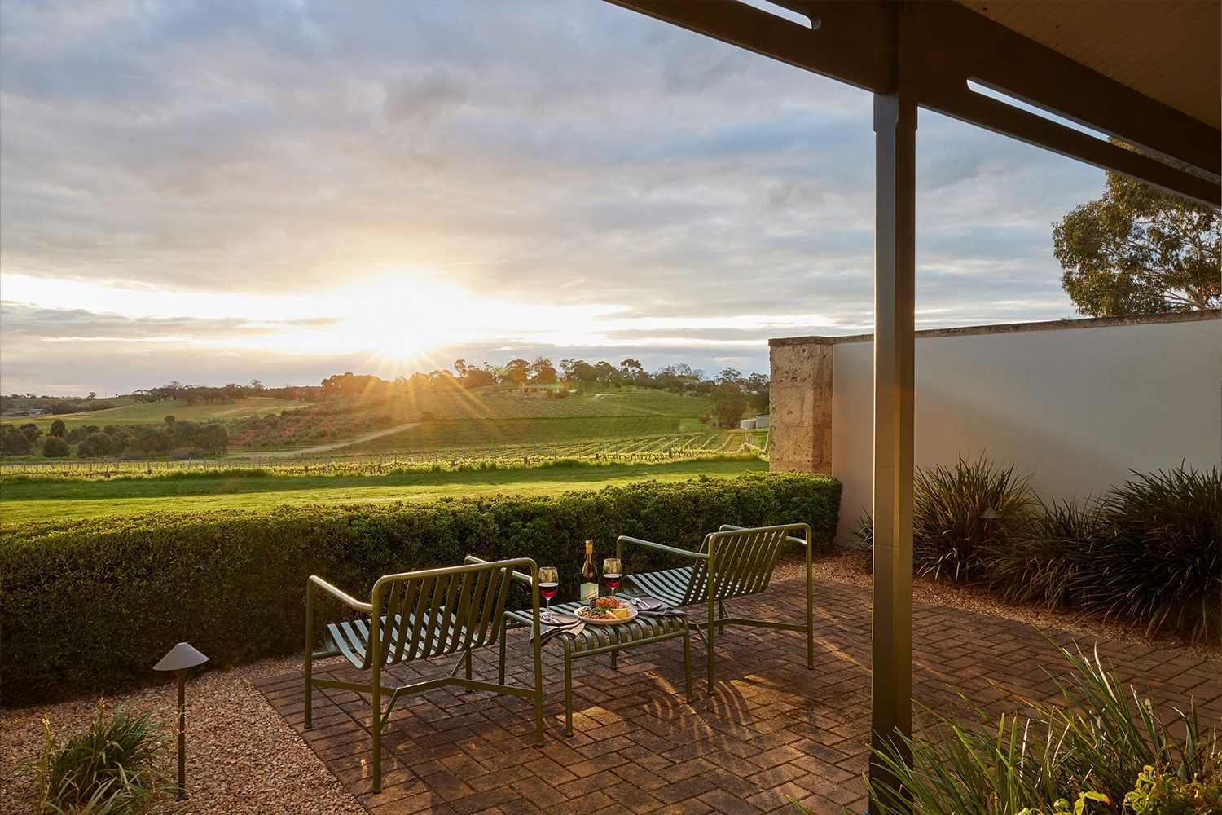

## ****Suite life****

All 15 of The Louise’s suites are angled to offer views of the Barossan patchwork of vines, fields and gently undulating hills. The Restore series by local artist Janelle Amos picks up rich greens in the soft furnishings of the 10 Stonewall Suites, as well as glimpses of the farmland visible through every window. En suite bathrooms offer bathtubs (with nooks for tealights) and both an indoor and open-air shower.

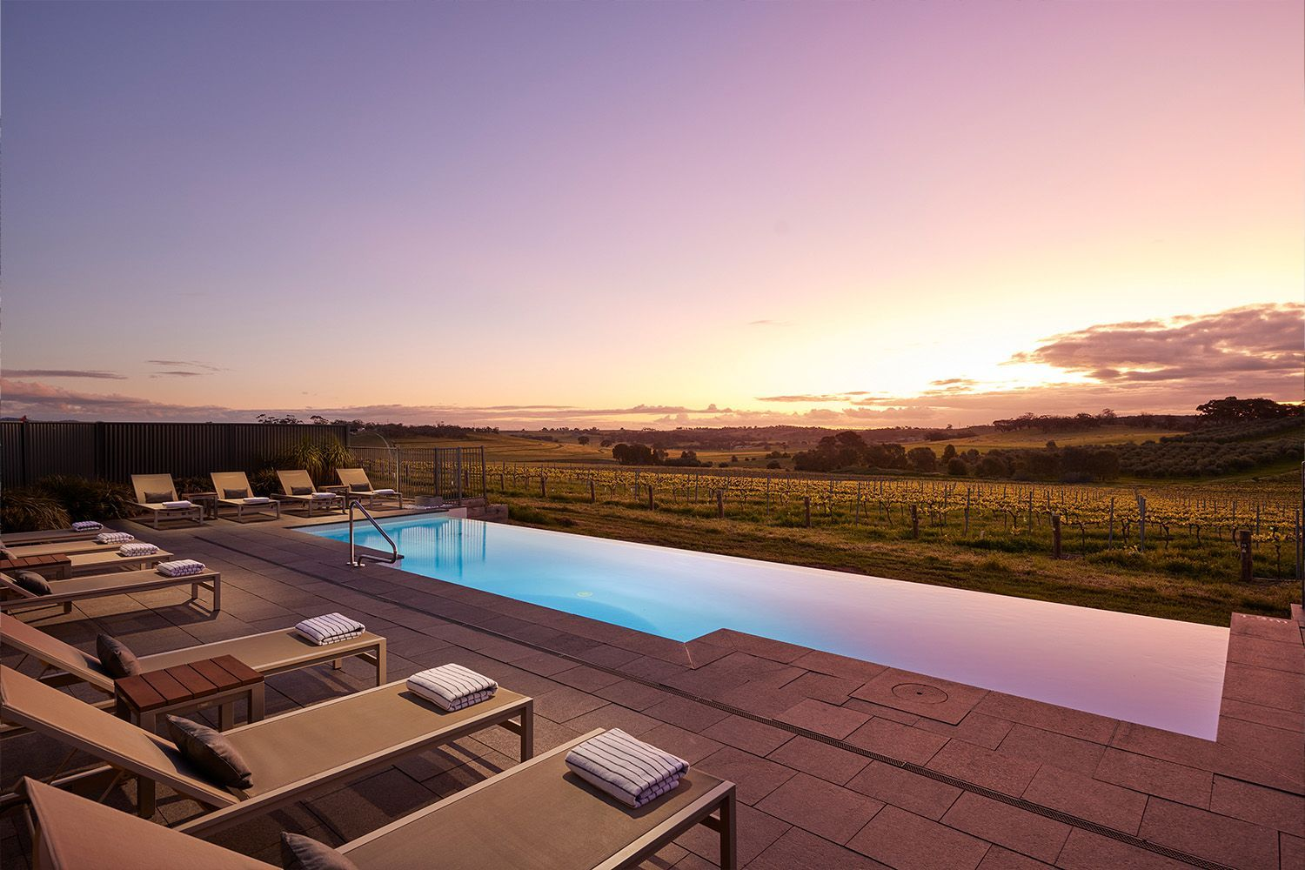

On cold winter days the in-house gas fire beckons; while the private terraces connected to each suite through French doors make the perfect nook on sunny afternoons. In those scorching South Australian summers, however, the infinity [pool](https://www.delicious.com.au/travel/australia/gallery/australias-50-best-natural-pools-summer/7izhg58g) overlooking the vines is still the place to be. A discreet turn-down service includes a just-boiled kettle and sleep tea waiting in your suite post-dinner, curtains drawn and pillows plumped, with a candle burning on the hearth and music playing softly over the speakers.

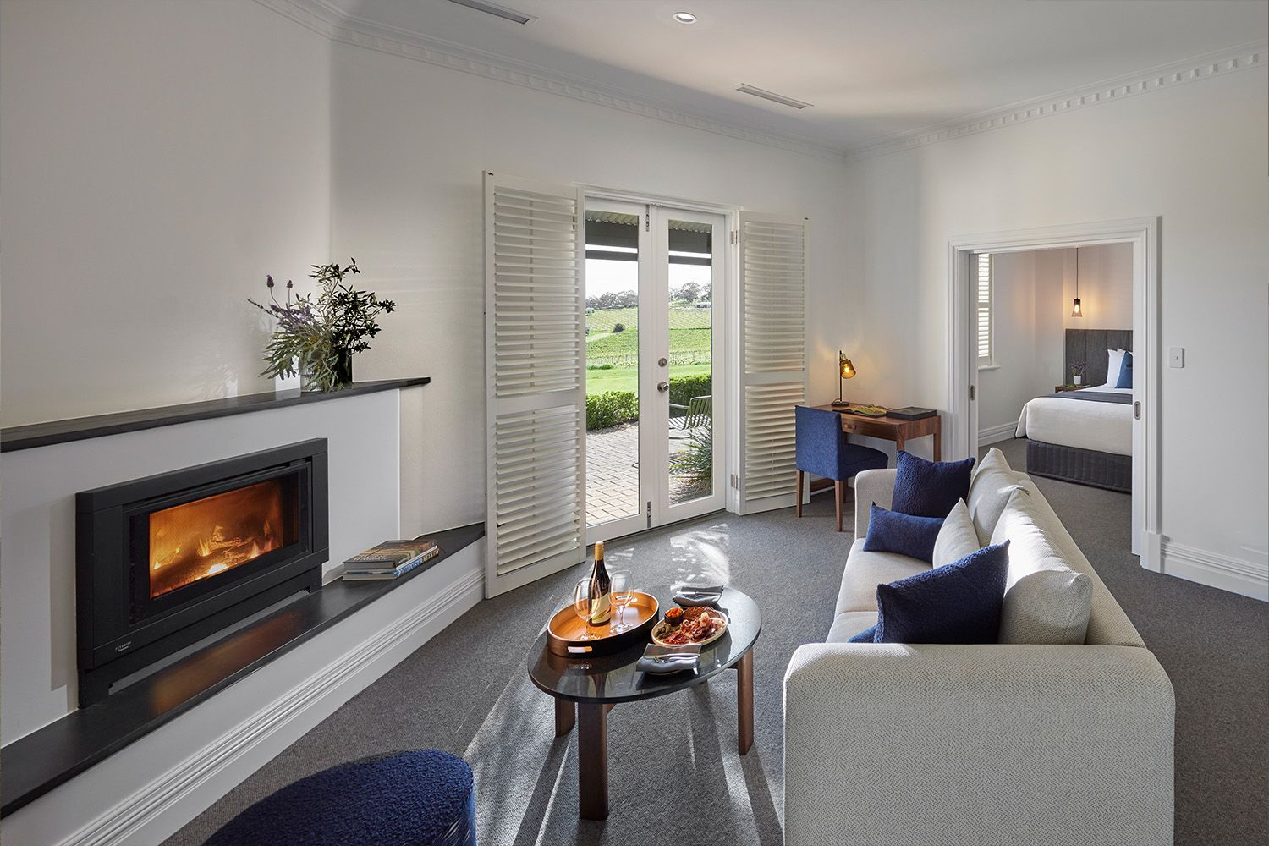

***Related story:***[***5 Adelaide wineries you need to visit***](https://www.delicious.com.au/travel/australia/gallery/top-5-adelaide-vineyards-to-visit-this-autumn/4ubtbnx0)

## ****Vine and dine****

The Louise is invariably mentioned in the same breath as Appellation, its acclaimed in-house restaurant. With the renovation, the lobby has been opened up to flow naturally into this well-lit space, angled to catch both the sun sinking over the vines during the evening’s set tasting menu (included in the room rate for guests) and sunrise during the included guest a la carte breakfast. Just off the main restaurant, the soon-to-be-revealed Contour will offer casual dining for locals and visitors, overlooking a terrace and sunken firepit. But for in-house guests, the defining dining experience remains Appellation.

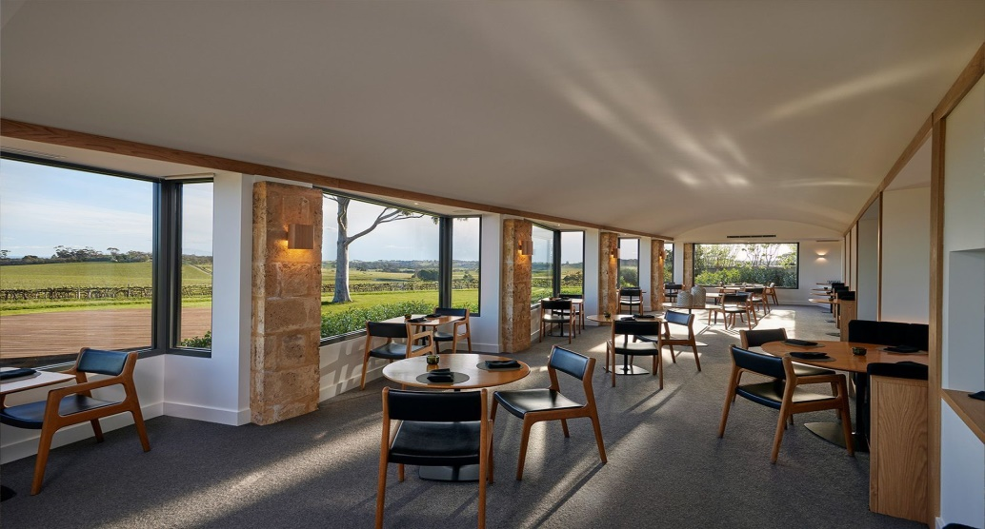

Stepping into the shoes of executive chef is Baillie Lodges alum Asher Blackford, who brought his interpretation of place on the plate most recently to Clayoquot Wilderness Lodge on Vancouver Island, and previously to the Southern Ocean Lodge. What unfolds over the course of a nightly five-course menu – opt for matched wines to benefit from the in-house expertise – is a tribute to the farmers and producers of the[Barossa](https://www.delicious.com.au/travel/australia/gallery/seppeltsfield-winery-barossa-valley-offers-birth-year-wine-tasting/zkmsx8w1), in turns playful and sophisticated. Such is the team’s attention to detail, Blackford often caters his menu to suit the independent dining experiences guests may have been booked into that day.

## ****The not-so-mini bar****

If you visited the Barossa and didn’t imbibe in fine wine, did you even go? [Wine](https://www.delicious.com.au/travel/australia/gallery/best-wineries-western-australia/ri7sfdiw) flows through the veins of The Louise, sitting as it does surrounded by iconic vineyards. The renovation has taken the lodge’s respected wine collection out of the cellar and turned it into an immersive feature. The American oak curved “wine lantern” sits between the lobby and restaurant, a curated selection of 800 bottles of the Barossa’s best (and notable imports) open to guests and diners to peruse. Guests who stay three or more nights are given a $100 credit towards any selections. For an intimate nightcap, a bottle can be whisked into a speakeasy-inspired space hidden behind concealed doors off the lobby.

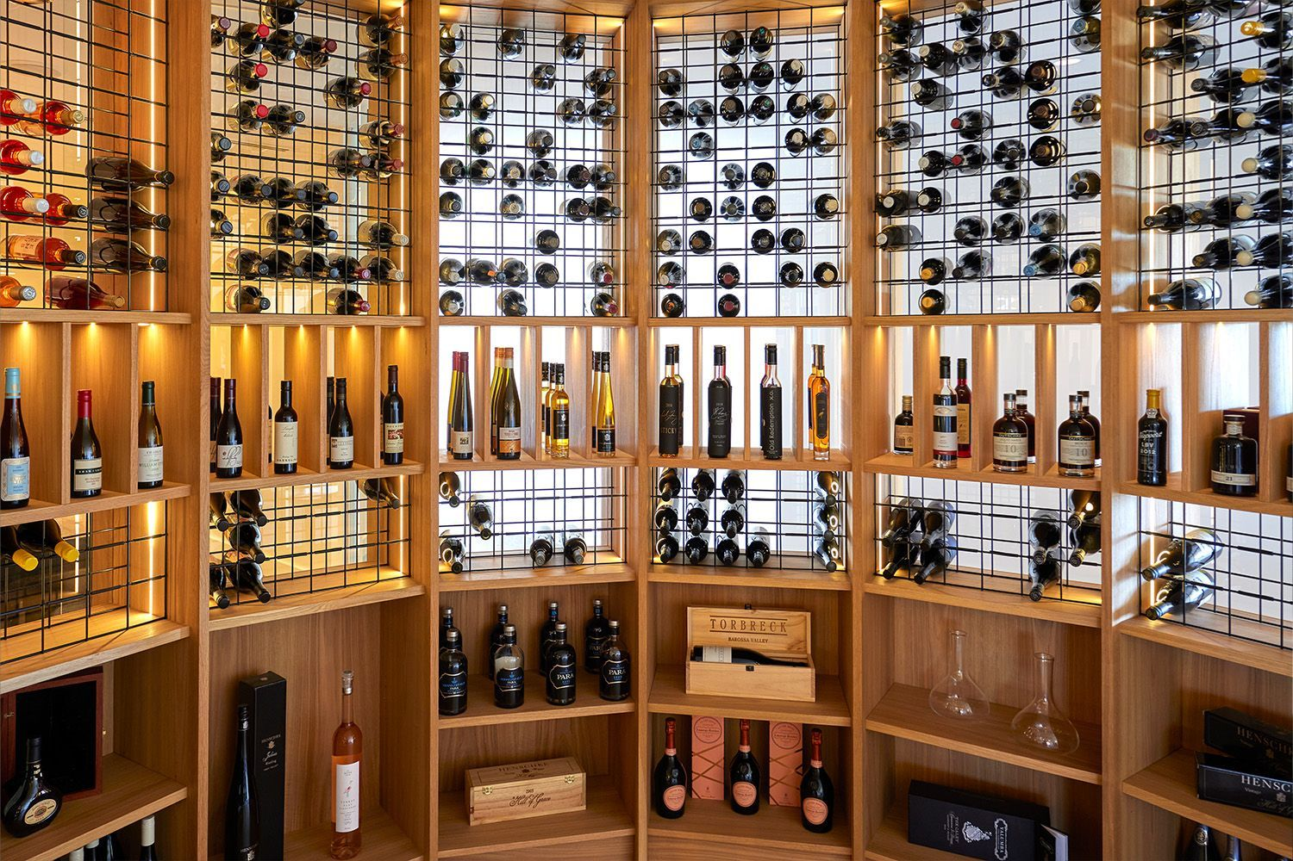

## ****Good neighbours****

In the spirit of the Barossa, the concierge team at The Louise is always on hand to offer a local recommendation, arrange a private experience or help secure a booking – whether that’s to visit neighbour Hentley Farm for a long lunch prepared by chef-to-watch Clare Falzon; or to meet musician-turned-restaurateur/winemaker Grant Dickson at locavore Angaston restaurant and micro cellar door Otherness.

The highlight of the activities on offer is found directly across Seppeltsfield Road at [Tscharke Wines](https://tscharke.au/), where an exclusive experience is available only to top-tier customers of the winery – and guests of The Louise. At this pioneering biodynamic vineyard patrolled by a troupe of peacocks (yes, really), Damien Tscharke is offering one of the Valley’s most exciting wine tastings. To say more is to reveal too much, just ask The Louise when you visit.

# Bali travellers warned of stricter airport measures due to foot-and-mouth disease



Ubud, Bali, Indonesia

##### [BY DELICIOUS. TEAM](https://www.delicious.com.au/people-events/people/delicious-team/jm9n0yzl)

##### [DELICIOUS. TEAM](https://www.delicious.com.au/people-events/people/delicious-team/jm9n0yzl)

##### JUL 15, 2022

**A North Queensland senator has warned that if Aussies don’t take foot-and-mouth disease seriously, they will see the cost of everyday items skyrocket. Words by Madeleine Achenza.**

Australian travellers returning from [Bali](https://www.delicious.com.au/travel/international/gallery/best-new-hotels-bars-beach-clubs-bali/ypgxiw7o) could face tough restrictions as fears grow over the foot-and-mouth outbreak.

North Queensland senator Susan McDonald is calling for tighter border restrictions similar to those employed during the Covid pandemic, including quarantine procedures for returning passengers, to stop the spread of the disease in its tracks.

The highly contagious disease is spreading rapidly through Indonesia and fears are escalating for the safety of livestock.



***Related story:***[***What to do if your flight is cancelled, according to an airline worker***](https://www.delicious.com.au/travel/travel-news/article/if-flight-cancelled-according-airline-worker/ksvu26it)

“We cannot overstate the impact of foot and mouth disease if it got into this country,” Ms McDonald told Sunrise on Thursday.

“It‘s a cruel disease.”

The senator warned that Australian farmers will have to destroy healthy animals inside of a quarantine zone.

“Consumers would pay more for red meat, milk, pork,” she said.

“Whatever price we pay now will look cheap in the years and months ahead.”

She said a week of quarantine for returned travellers should be considered.

If an outbreak occurred in Australia, it would be likely necessitate mass slaughter of animals and could cost as much as $80 billion nationwide in a single year.

The LNP senator explained that unintentionally bringing the disease back into the country is a risk for anyone who has walked through Bali’s streets.

“They might think about “I haven‘t been on a farm,” but what we’re saying is in Bali you have contact with animals and people who work with animals,” Ms McDonald said.

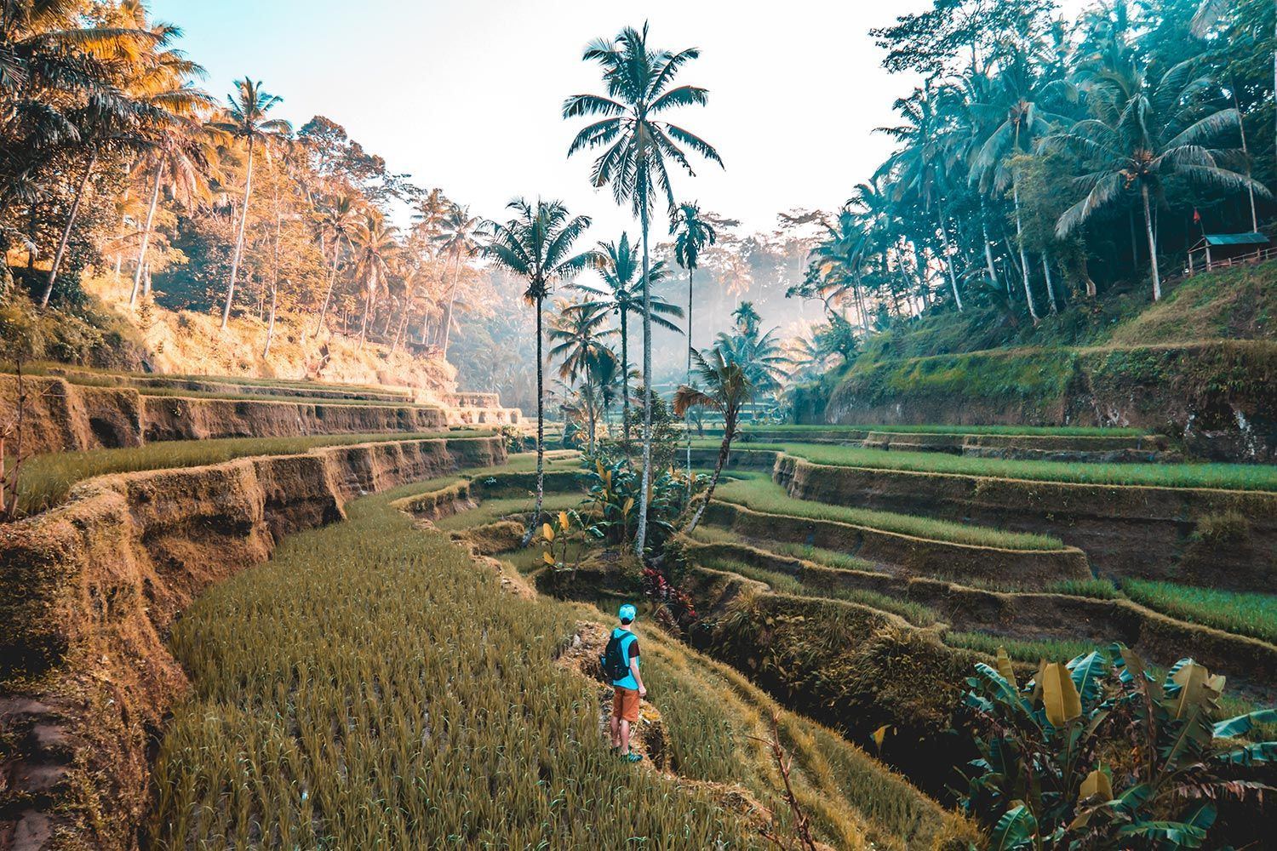

***Related story:***[***This easy passport mistake could see you banned from your flight***](https://www.delicious.com.au/travel/travel-news/article/why-damaged-passport-could-see-you-banned-flight/4pagl3jw)

“There is dung you can walk through, drag your suitcase through”

“The impact of getting this wrong is catastrophic, it is biblical proportions the impact it would have on Australian farmers, Australian animals and Australian consumers.”

NSW Deputy Premier Paul Toole said on Wednesday that the disease was “right now on our doorstep”.

Mr Toole [urged travellers to be safe](https://www.nsw.gov.au/media-releases/holidaying-bali-play-your-part-protecting-our-livestock-industry) rather than sorry and to make sure they don’t bring contaminated soil into Australia.

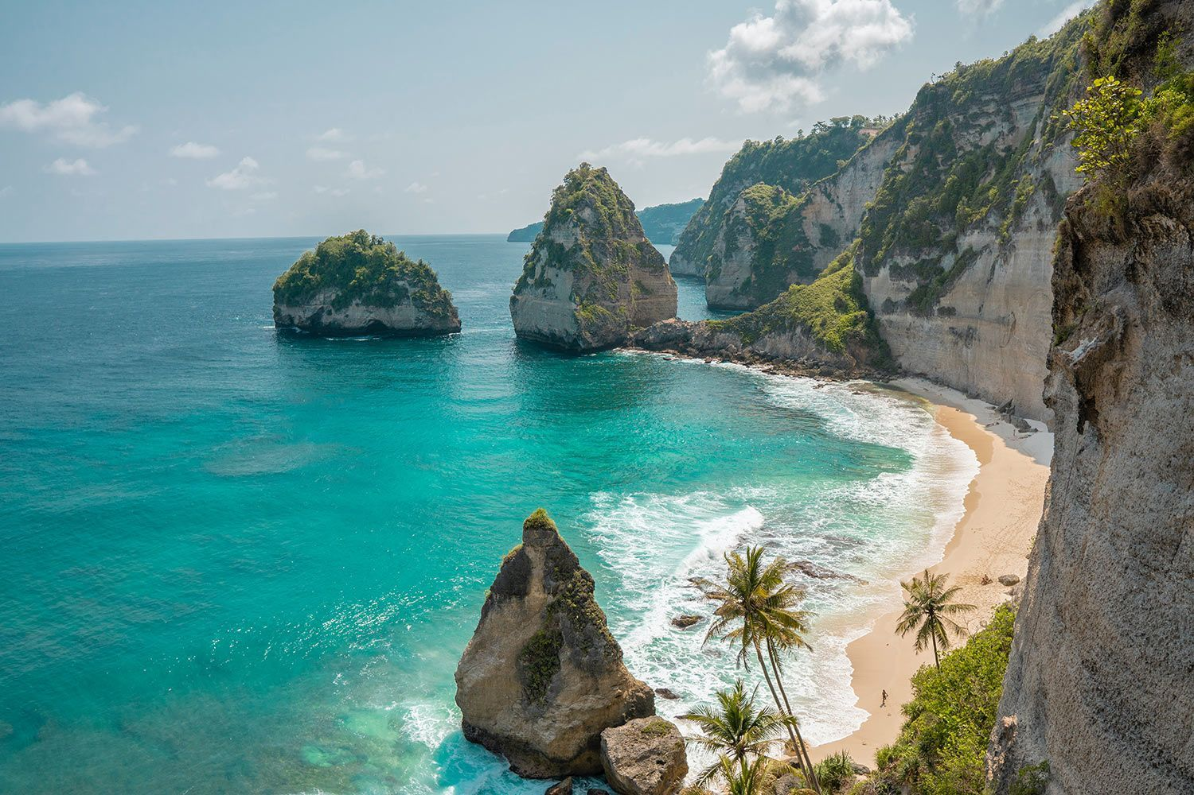

He even pleaded with [Bali tourists](https://www.delicious.com.au/travel/travel-news/article/bali-offer-new-5-year-digital-nomad-visa-remote-workers/rrgs4vju) to leave their shoes behind before returning home.

Foot and mouth disease is one of the most serious livestock diseases in the world and affects cloven-hoofed animals like cattle, sheep, and pigs.

An outbreak of foot-and-mouth disease has not occurred in Australia in 130 years.

Stay up to date on the current Bali travel restrictions and travel warnings at [*Smart Traveller*](https://www.smartraveller.gov.au/destinations/asia/indonesia).

This article originally appeared on [*news.com.au*](https://www.news.com.au/travel/travel-advice/flights/call-to-quarantine-travellers-from-bali-to-stop-biblical-spread-of-footandmouth/news-story/9401a5a0d874b0a2fd28570daa06ea45). It has been reproduced here with permission.

1. **Newark airport authorities remove snake from a plane**

Gregory Wallace, CNN • Published 19th October 2022

FacebookTwitterEmail

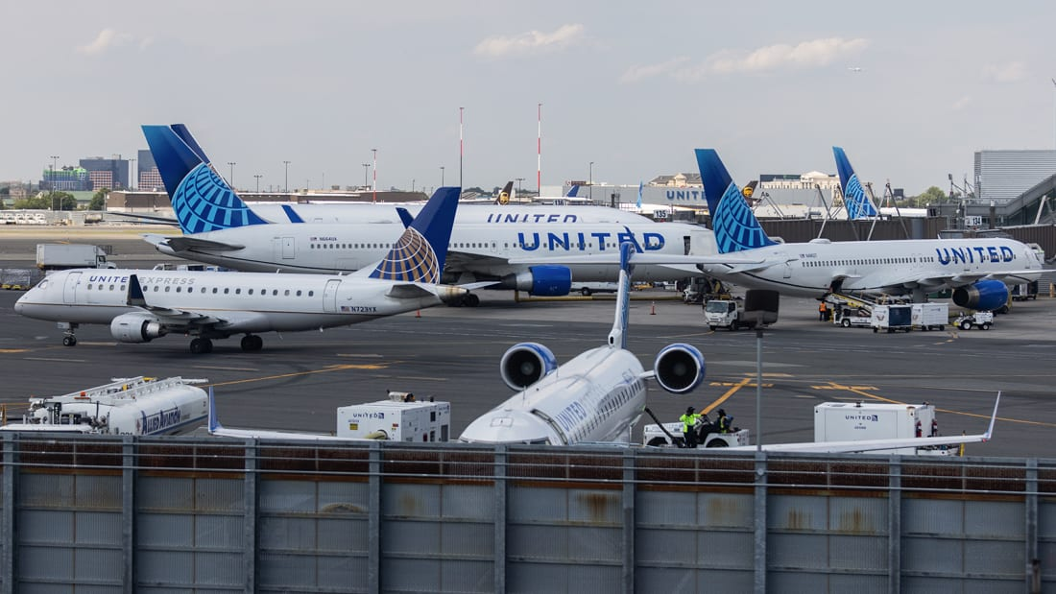

**(CNN) —**Although it sounds like a Hollywood plot, authorities didn't need help from "Snakes on a Plane" actor Samuel L. Jackson when an airline passenger found a snake underfoot after arriving at Newark Liberty International Airport.

Police and operations employees met the plane at its gate early Monday afternoon "and removed the garden snake," the Port Authority of New York and New Jersey told CNN. It said nobody was injured.

A passenger onboard told News 12 The Bronx, a CNN affiliate, that "passengers in business class started shrieking and pulling their feet up" while the flight was taxiing.

Related content [How to survive a rattlesnake bite](https://edition.cnn.com/travel/article/how-to-survive-rattlesnake-bite/index.html)

United Airlines tells CNN that crew members requested help from airport officials "after being alerted by passengers" to the snake.

The flight was United 2038 from Tampa, according to the Port Authority. Unlike the infamous 2006 film "Snakes on a Plane," the incident did not impact operations at the airport.

According the [North Carolina Wildlife Resources Commission](https://www.ncwildlife.org/Learning/Species/reptiles/eastern-garter-snake), various types of garter snakes are often colloquially called "garden" snakes. The snakes are nonvenomous, and they are indeed [often found in gardens](https://www.growingwithnature.org/garter-snakes/), where they help keep control of pests.

# Is Oxford House going to be the hotel of the summer? We think so

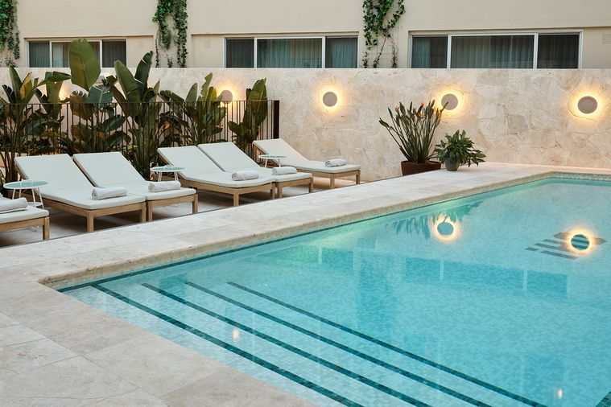

##### [BY CONSTANTINA DEMOS](https://www.delicious.com.au/people-events/people/constantina-demos/ymnhynwz)

##### [DELICIOUS. TRAVEL EDITOR](https://www.delicious.com.au/people-events/people/constantina-demos/ymnhynwz)

##### NOV 14, 2022

**BRB, checking in stat.**

Step off Oxford Street, one of Sydney’s liveliest streets, and into [Paddington](https://www.delicious.com.au/eat-out/latest-news/article/el-primo-sanchez-paddington-new-mexican-bar-maybe-sammy-team/v8phpd44)’s newest accommodation offering, [Oxford House](https://www.oxfordhouse.com.au/) (OH!), to be transported to a Palm Springs-inspired urban sanctuary.

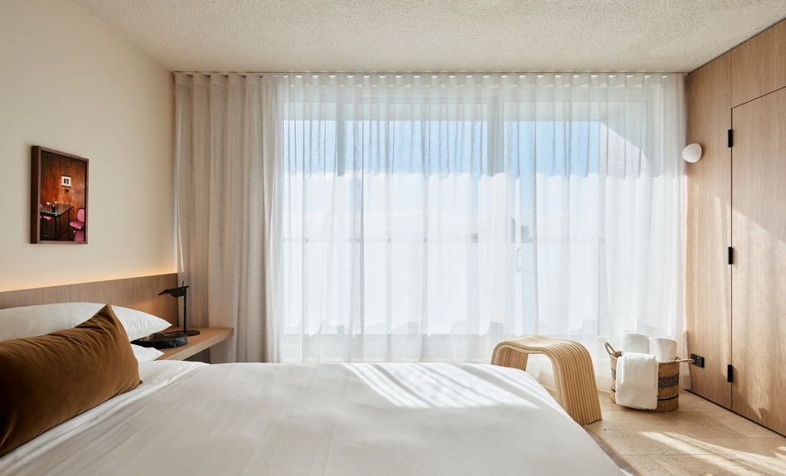The newest venture from the Public Hospitality group – see our first look at its predecessor The Strand Hotel [here](https://www.delicious.com.au/travel/travel-news/article/first-look-inside-strand-hotel-darlinghurst/tp9pw72q) – is a welcome addition to Sydney’s buzzy fashion and art hub, which the hotel’s aesthetic draws upon.

Neutral-coloured rooms are decked out with furniture in muted tones (we’ll state the obvious, it’s giving [The Calile](https://www.delicious.com.au/travel/australia/gallery/james-st-boutique-hotel-the-calile-opens-in-brisbane/sbfhtjs5)) and finished with pops of colour thanks to stylish artworks by Lena Gustafson, Adam Turnbull and Niah McLeod, just to name a few. There are 56 rooms in total, including four spacious suites.

In each room you’ll find lush amenities like [Grown Alchemist](https://grownalchemist.com/au) hair care, Marc Newson crockery, retro Marshall speakers and guest robes that are the antithesis of the customary white fluffy hotel robe. Aussie resort wear label [Double Rainbouu](https://doublerainbouu.com/) has lent its creative hand to custom design monogrammed OH! robes that come in two colours: olive green and salmon pink.

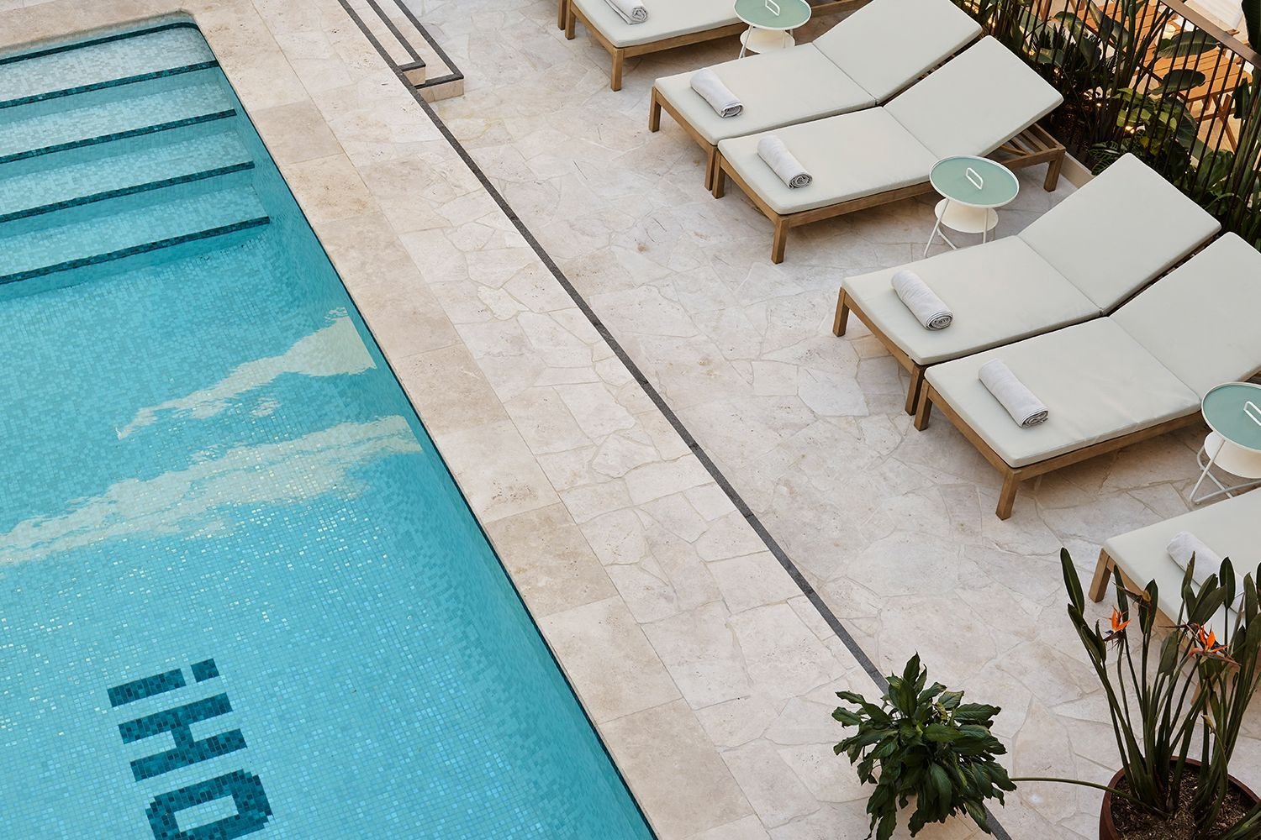

***Related story:***[***First look inside new Kangaroo Island Luxury Eco Pods***](https://www.delicious.com.au/travel/australia/article/first-look-inside-new-kangaroo-island-luxury-eco-pods/eu0503i8)

And what is a hotel of the summer without an irresistibly Instagrammable pool?

After a refreshing dip (and some sneaky Insta pics) head to the light-drenched courtyard where the Oxford House Pool Bar pours its signature OH! Margarita, a mix of Habanero infused tequila, mezcal, lime, passionfruit, completed with a volcano salt rim.

The bar also serves light dishes like Hiramasa Kingfish sashimi seasoned with nam jim ,Thai basil, kaffir lime and coconut. While the pool is exclusive to guests, the pool bar is open to the public. As is the street level restaurant where heartier dishes are plated up.

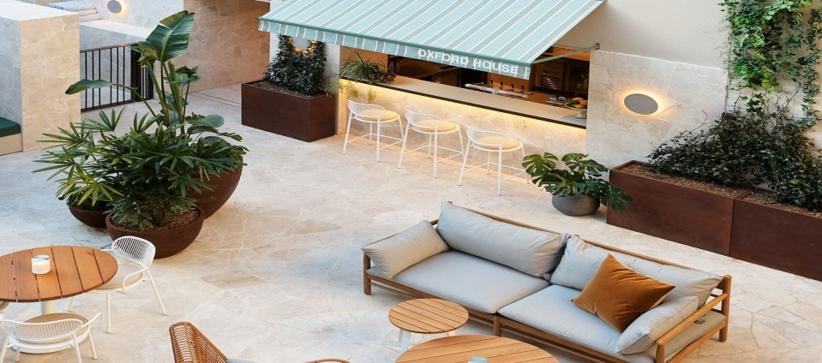

At the Oxford House Restaurant the menu evolves to suit the time of day. “The concept for the menu was dictated by the space. It has that diner feel, but is more upmarket than your all-day American diner,” says up and comer executive chef, Tyler Preston.

“We needed to have snacks and small dishes to encourage the casual vibe throughout the day, but also the more substantial stuff for when people come in with their partners or friends and have a bistro-style meal.”

For breakfast, try the signature OH-melette with woodside goats curd, chives, seasonal herbs salad and sourdough. If you’ve got an appetite you can’t go past the Lobster roll in toasted milk bun served with potato crisps or the tonkatsu chicken schnitzel with BBQ sauce, dressed cabbage and herb salad, both of which are available from 12pm onwards.

# Planning a trip to Japan? This travel expert answers all of your questions



##### [BY DELICIOUS. TEAM](https://www.delicious.com.au/people-events/people/delicious-team/jm9n0yzl)

##### [DELICIOUS. TEAM](https://www.delicious.com.au/people-events/people/delicious-team/jm9n0yzl)

##### OCT 26, 2022

**From affordable flights to proper etiquette, here's everything you need to know.**

For a spell there you couldn’t visit Japan unless you were part of an authorised tour group. But on October 11 restrictions eased, so now Aussies can return to one of their favourite destinations… unsupervised.

We wanted a little expert advice on how best to navigate a Japan holiday in the coming months, so we had a quick chat with Nathan Varney, a Flight Centre Travel Consultant from Brisbane. Here’s what he had to say.

## ****Why are flights to Japan so expensive right now?****

Because Japan only fully opened to tourists recently, there are far less seats flying to Japan than before Covid, with many Asian carriers (mostly Chinese) still not flying between Japan and Australia.

## ****Do you predict prices will come down when more flights are added?****

Once more airlines and low-cost carriers fire up their Japan routes, we’ll see fares start to drop. But without a crystal ball or psychic powers we can’t guarantee it of course.

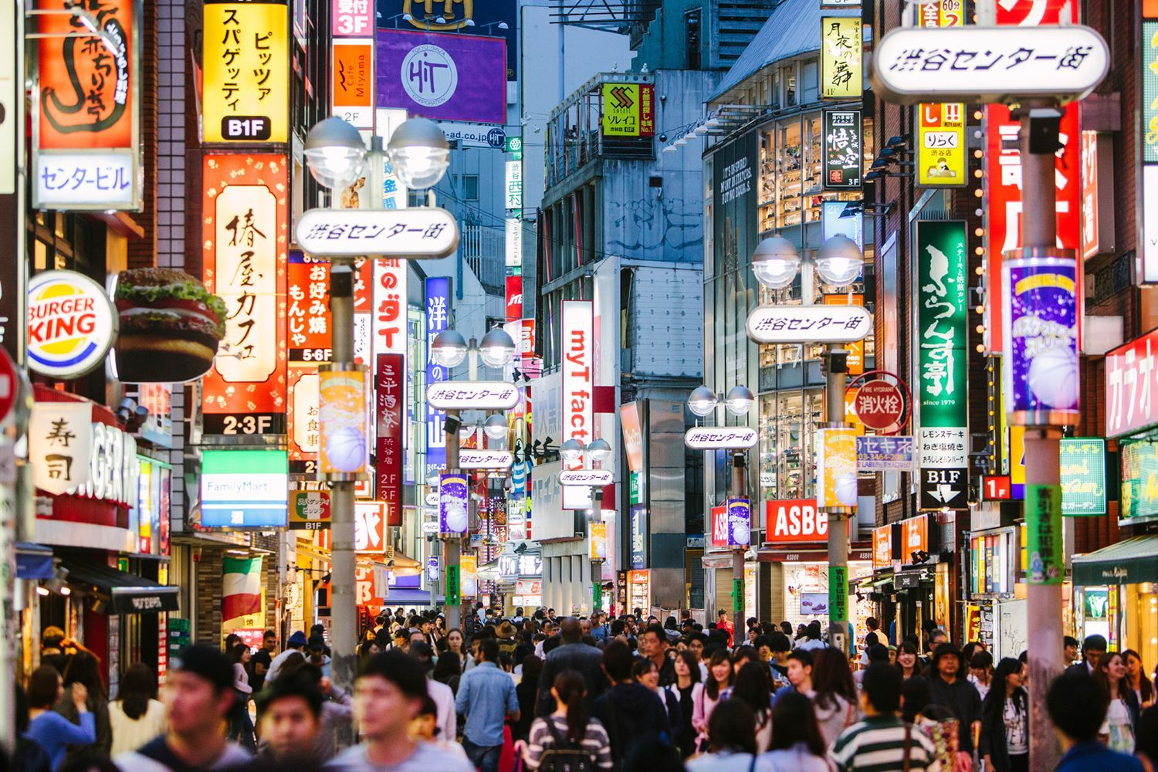

## ****Any tips for finding the best airfare?****

Book as far in advance as you can, get email alerts or VIP sales alerts from Flight Centre. Japan is a very popular destination for families, so if you are a couple or solo traveller book outside school holidays. Likewise, if you are a family, try and book outside school holidays if you can.

## ****Which hotel are you most excited about in Tokyo?****

The Tokyo EDITION, Toranomon opened during Covid and has been revitalised this year. It’s only minutes from [Tokyo](https://www.delicious.com.au/travel/international/article/tokyo-food-lovers-guide-best-places-stay-eat-drink/s19kiypl) Tower and Tokyo’s renowned art scene, cultural landmarks, nightlife and restaurants. It’s ultra-modern luxe with amazing views of Tokyo Tower and the city’s skyline.

## ****What’s the No.1 thing Aussies want to do in Japan?****

Aussies mainly want to ride the bullet train, see the cherry blossoms and ski.

***Related story:***[***13 best things to do in Japan now that borders are opening***](https://www.delicious.com.au/travel/international/article/best-things-japan/zv7np2oq)

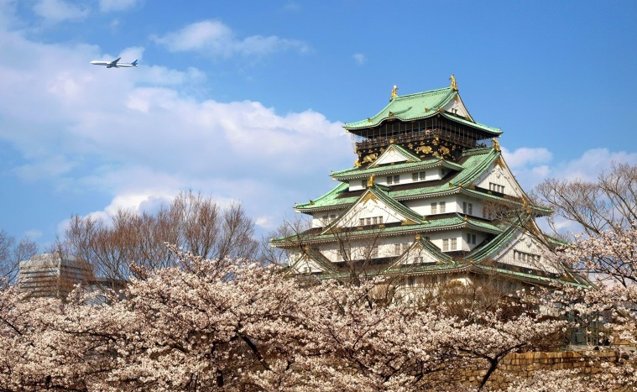

## ****Is there one thing you tell every Aussie to do in Japan?****

Riding the real-life Mario go-kart through the streets of Tokyo is wild – my number one Japan must-do! I also recommend visiting the deer temple at Nara Park, and Tokyo’s massive [Pokemon](https://www.delicious.com.au/travel/travel-news/article/scoot-launches-new-routes-additional-pikachu-jet-flights/tn5x4udu) Centre. And be sure to check out their crazy vending machines!

## ****What’s the No.1 mistake most Aussies make in Japan?****

Too often, Aussies make the mistake of not taking out [insurance](https://www.delicious.com.au/travel/travel-news/article/avoid-australias-most-common-travel-insurance-mistake/5g9p7254) when visiting Japan. Even though health care costs there aren’t massive like in the US, hospitals or clinics in Japan will ask you for a valid policy with cover for health costs if you’re in need of care.

## ****What’s your best piece of advice for Aussies in Japan?****

Learn some words to help you get around because the language is very different to English. Download [Google Translate](https://www.delicious.com.au/travel/travel-news/article/genius-google-translate-travel-hack-goes-viral-tiktok/hxmsn6cu) too, the app helps you decipher what most signs mean – just snap a photo and it instantly translates for you.

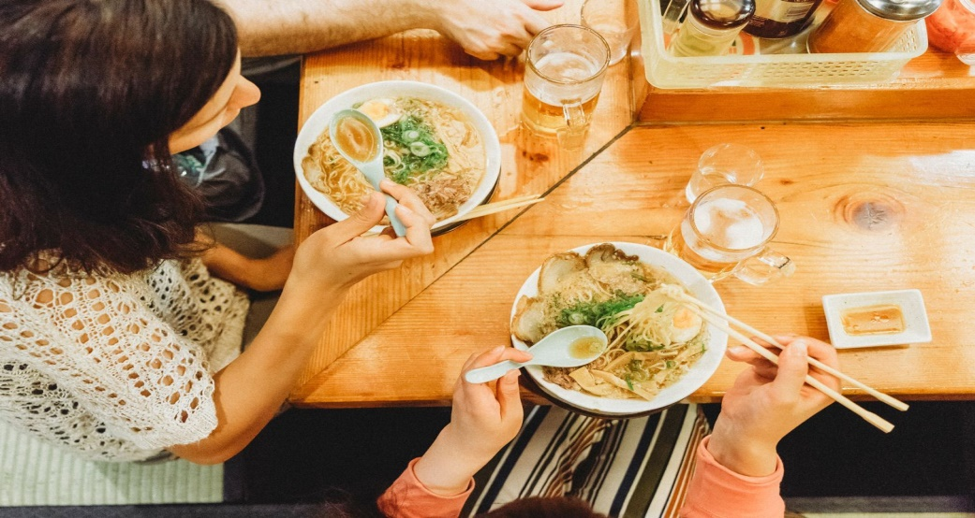

## ****What’s the best value month to travel to Japan?****

If you want quiet, go mid-year outside school holidays for lower pricing. If you want good value for a higher spend, go in early March for some snow and cherry blossoms.

## ****We hear Japan cruises have risen in popularity. What are some of the most popular itineraries?****

Princess Cruise Line does Japan really well, so does Celebrity Cruises. The best thing about a Japan cruise is that it’s an ideal way to see the whole country and get an idea of the diversity of its cultures and landscapes. From rugged [Hokkaido](https://www.delicious.com.au/travel/international/article/best-restaurants-bars-hokkaido-japan/99ux1xtg) in the north to subtropical Kyushu in the south, there’s so much more to this dazzling country than Tokyo and Kyoto.

This article originally appeared on [*escape.com.au*](https://www.escape.com.au/destinations/asia/japan/now-that-japan-is-open-how-do-we-get-cheap-airfares/news-story/7a149ecbc53a69fa2128d3a9fc544ead). It has been reproduced here with permission.

# How to find the most affordable flight for Christmas and beyond



##### [BY DELICIOUS. TEAM](https://www.delicious.com.au/people-events/people/delicious-team/jm9n0yzl)

##### [DELICIOUS. TEAM](https://www.delicious.com.au/people-events/people/delicious-team/jm9n0yzl)

##### OCT 21, 2022

**Tips and tricks to booking the cheapest flight. Words by Sabine Leroy.**

Between pent up travel demand and ramifications of the war in Ukraine, airfare prices are still skyrocketing. This is especially true for those looking to take a trip over [Christmas](https://www.delicious.com.au/recipes/christmas-pudding-recipe/o5xjuq4w).

“The cost increases reflect everything from higher fuel costs, higher maintenance costs and higher staff costs with rising wages and the need to fix the problems evident upon reopening – like baggage handling and general operation that were causing flight cancellations,” observes Shane Oliver, Chief Economist at AMP.

“Demand has also been very strong as people want to catch up for holidays and travel forgone over 2020 and 2021. This has enabled airlines to put through the price rises.”

Despite sky-high airfares, 60% of Australians are planning a getaway in the next 12 months, according to Finder’s Consumer Sentiment Tracker – up from 49% in December.



While some might be happy to cough up the extra cash, many of us aren’t ready to let the silly season wipe out our savings.

“If you’re looking forward to a summer holiday in [Europe](https://www.delicious.com.au/travel/international/article/inside-champagnes-luxury-barge-coquelicot-belmond-boat/oapxp51r) next year, the good news is that the data shows recovery and flight capacity is steady and consistent across many parts of the world. [North America](https://www.delicious.com.au/travel/international/article/best-bagels-new-york-city/c97whhja) is now operating at just about pre-pandemic levels, with Europe also tracking well,” says [Expedia](https://www.expedia.com.au/) Senior Director, Daniel Finch.

But Angus Kidman, travel expert at[Finder](https://www.finder.com.au/travel), warns that flights back from [Europe](https://www.delicious.com.au/travel/international/article/spain-making-commuter-train-travel-free-until-end-2022/ulizzwec) are generally pricier than into Europe, with mixing and matching airlines likely to score you a better deal.

“For the European summer, there are still cheaper options if you’re willing to spend hours hanging around in an airport in [Asia](https://www.delicious.com.au/travel/international/gallery/take-a-trip-around-the-world-at-asias-best-restaurants/4xp188aq) or the [Middle East](https://www.delicious.com.au/travel/article/floating-hotels-launch-qatar/37r9dc86). The planned coronation for King Charles in May has added to early season demand.”

***Related story:***[***Why is my flight delayed? 4 reasons for cancellations, queues and delays***](https://www.delicious.com.au/travel/travel-news/article/why-my-flight-delayed-4-reasons-why-cancellations-happen/sva7j3g2)

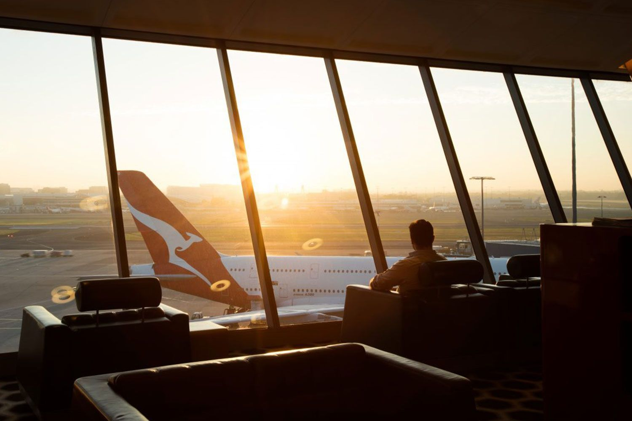

## ****TIPS TO SAVE ON AIRFARES****

### Book your flights on a Sunday

After analysing thousands of flight bookings, Expedia’s 2023 Air Travel Hacks Report reveals that booking flights on a Sunday can save you up to 20% on average – both for domestic and international flights. Friday is the worst day to book.

### Don’t stick to one airline

For destinations like Europe, it’s worth comparing the price of two one way tickets with completely different rather than a return fare, as Kidman has discovered.

“Thinking laterally can also score you big savings without forcing you onto low-cost carriers. I’ve scored a business class return trip to Europe for $6,000 with creative routing, which is under half what Qantas will charge on that route. The secret? Fly via Asia using Malaysian and Finnair instead.”

### Make use of price alerts

Set up a price alert with booking sites such as [Skyscanner](https://www.skyscanner.com.au/) and [KAYAK](https://www.kayak.com.au/). They’ll automatically notify you when a fare reaches the price you’re prepared to pay.

### Avoid the school holidays (if you can)

“It’s a good way to keep costs down as these are peak seasons that come with peak prices. November and February are two of the cheaper months to travel that still have great weather in most parts of Australia,” says Kidman.

### Book domestic flights 3 months ahead

According to Expedia, the sweet spot for snagging the best price on domestic flights falls between 70 – 100 days – or three months ahead of your travel dates. Travellers who booked during that period saved 30% on average compared to those who waited until the last minute.

### For Europe and international flights, book at least 6 months in advance

The key to booking international airfares is to book as far in advance as possible. Expedia research reveals holidaymakers who booked around six months in advance saved on average 25% compared to those who waited until three months out or less to book.

# There's a goop cruise setting sail in September and we're completely on board

# Celebrity Cruises launches 'goop at sea' with Gwyneth Paltrow

*Celebrity Beyond*

##### [BY ROSEMARY SLADE](https://www.delicious.com.au/people-events/people/rosemary-slade/c8lky6yh)

##### [TRAVEL AND NEWS EDITOR](https://www.delicious.com.au/people-events/people/rosemary-slade/c8lky6yh)

##### JUL 14, 2022

**‘goop at Sea’ will feature exclusive wellness experiences and an appearance by founder and CEO, Gwyneth Paltrow.**

Celebrity Cruises and lifestyle brand goop are making waves with an exclusive [wellness retreat](https://www.delicious.com.au/travel/international/gallery/the-worlds-most-luxurious-health-retreats/ywbcbkps) on-board the brand’s newest luxury ship, [Celebrity Beyond.](https://www.delicious.com.au/travel/international/article/covid-rules-safety-ships-new-era-luxury-cruising/eh792vl9)

Dubbed goop at Sea, the experience will take place on a 9-night Italian Riviera & France sailing departing from [Barcelona](https://www.delicious.com.au/travel/international/gallery/the-best-things-to-do-in-barcelona/6j74uea9) on September 24.

It will feature transformative experiences and ‘mind, body, soul’ sessions led by goop wellness practitioners, along with an appearance by founder and CEO, [Gwyneth Paltrow.](https://www.delicious.com.au/recipes/gwyneth-paltrows-seared-scallops-watercress-asparagus/df9a663e-6927-47ec-8778-b5243f411246)

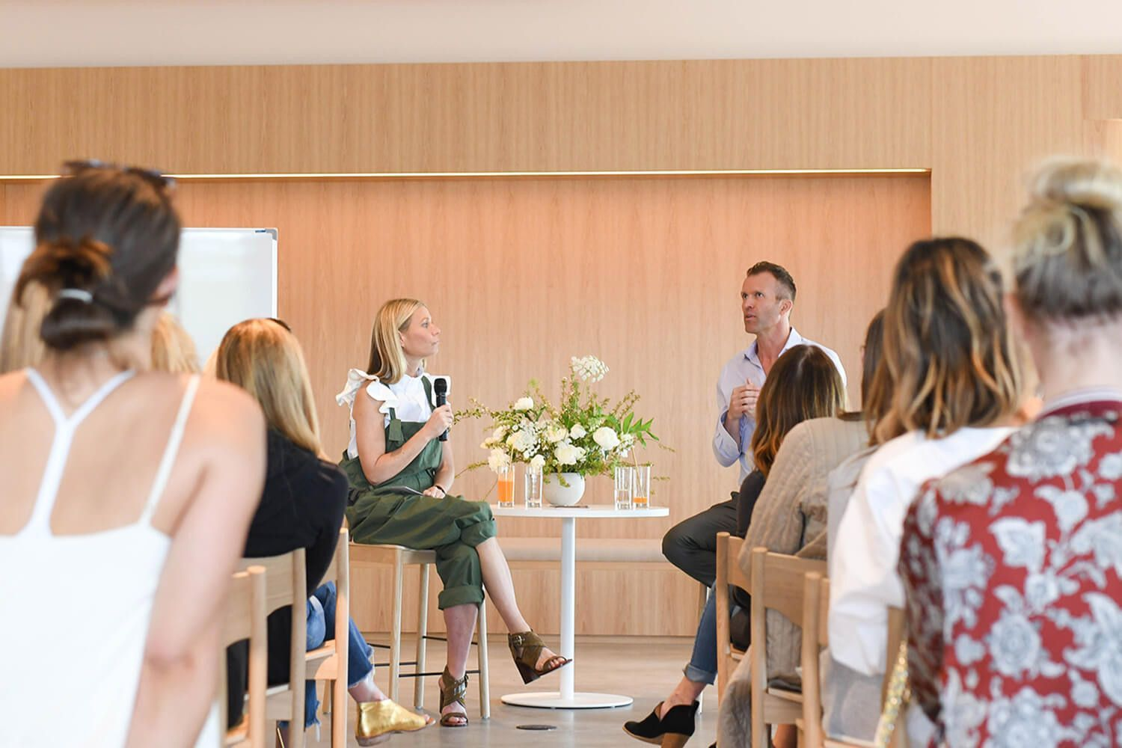

***Related story:***[***These are the most complained about tourist attractions in the world***](https://www.delicious.com.au/travel/travel-news/article/most-complained-tourist-attractions-world/8vs5ykqh)

The wellness experience is an extension of Celebrity Cruises partnership with the lifestyle brand, which began in early 2020.

[Paltrow](https://www.delicious.com.au/entertaining/style-trends/gallery/inside-gwyneth-paltrows-nyc-kitchen/edm2r736) serves as Celebrity’s wellbeing advisor, curating exclusive holistic wellness programming and products, like on-demand wellness classes, fitness tools for guests and a custom detox smoothie.

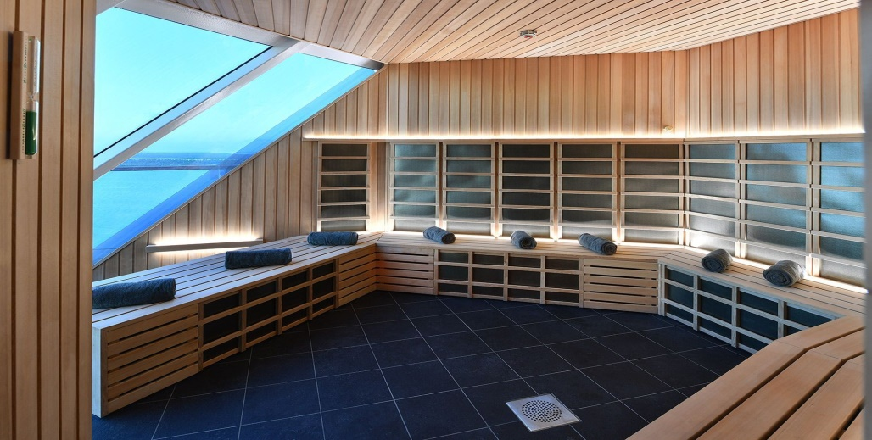

***Related story:***[***What to do if your flight is cancelled, according to an airline worker***](https://www.delicious.com.au/travel/travel-news/article/if-flight-cancelled-according-airline-worker/ksvu26it)

A selection of goop‘s signature products, including the GOOPGLOW and GOOPGENES collections, are also available on-board [Celebrity Beyond.](https://www.delicious.com.au/travel/travel-news/gallery/why-we-desperately-want-to-stow-away-on-these-luxe-ships/r2dkxz8t)

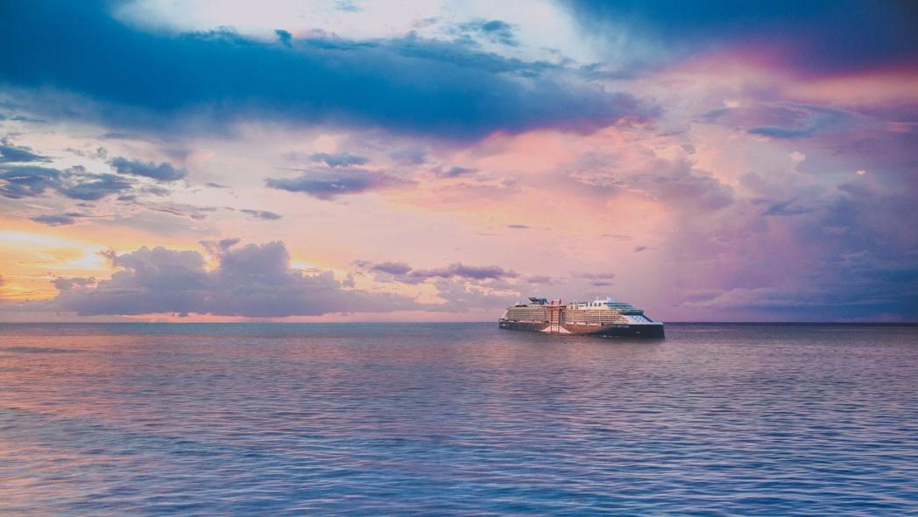goop at Sea is priced from $750 per guest, with limited availability.

To secure a spot, book your vacation on Celebrity Beyond via [*celebritycruises.com/au*](http://www.celebritycruises.com/au/specialty-cruises/goop) then add the goop at Sea experience in your planner.

# There's more to Birmingham than the Commonwealth Games

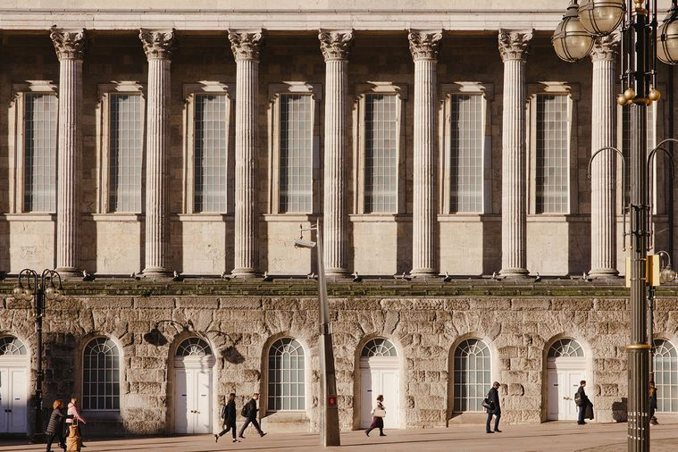

*Birmingham Town Hall. Photography: Claire Menary*

##### [BY DELICIOUS. TEAM](https://www.delicious.com.au/people-events/people/delicious-team/jm9n0yzl)

##### [DELICIOUS. TEAM](https://www.delicious.com.au/people-events/people/delicious-team/jm9n0yzl)

##### JUL 28, 2022

**There's never been a better time to discover the rough-hewn charms and booming culinary scene of England’s ‘Second City’. These are the best places to eat, drink and stay in B'ham. Words by Kerry Parnell. Photography by Claire Menary.**

“They don’t know what they’re on about – you’re bloody gorgeous,” the glamorous young woman bellows at her friend in a broad Brummie accent, as they clatter up the stairs ahead of me in a busy bar-bistro in Birmingham. And to be honest, there’s no better way of describing the city in the heart of [England](https://www.delicious.com.au/travel/international/gallery/why-instagrammers-are-heading-to-whitstable-uk/iik7v2um). It has long hidden its charms, but Birmingham is an absolute revelation.

Buzzing with life, its city centre thrumming with locals enjoying the bars, restaurants, cafes and thriving arts scene, [Birmingham](https://www.delicious.com.au/travel/international/gallery/the-best-day-trips-from-london-england/0c7q0pav) is enjoying a gourmet groove and it’s a case of wham, B’ham, thank you from this ma’am.

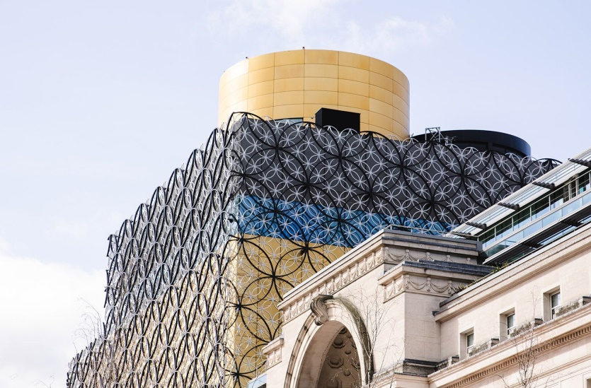

Britain’s ‘second city’ is about to take top position when it hosts the Commonwealth Games in July and August. As well as the Games – the first sustainable games – visitors will have plenty to entertain them, including wandering around the city and along its famous canals, and enjoying the arts scene, from the Birmingham Royal Ballet to rock concerts. And that’s before they get to the vast array of eateries.

***Related story:***[***Thinking about heading to London in the next year? You need to read this***](https://www.delicious.com.au/travel/international/article/london-heathrow-airport-caps-could-continue-until-mid-2023/0sq6lijw)

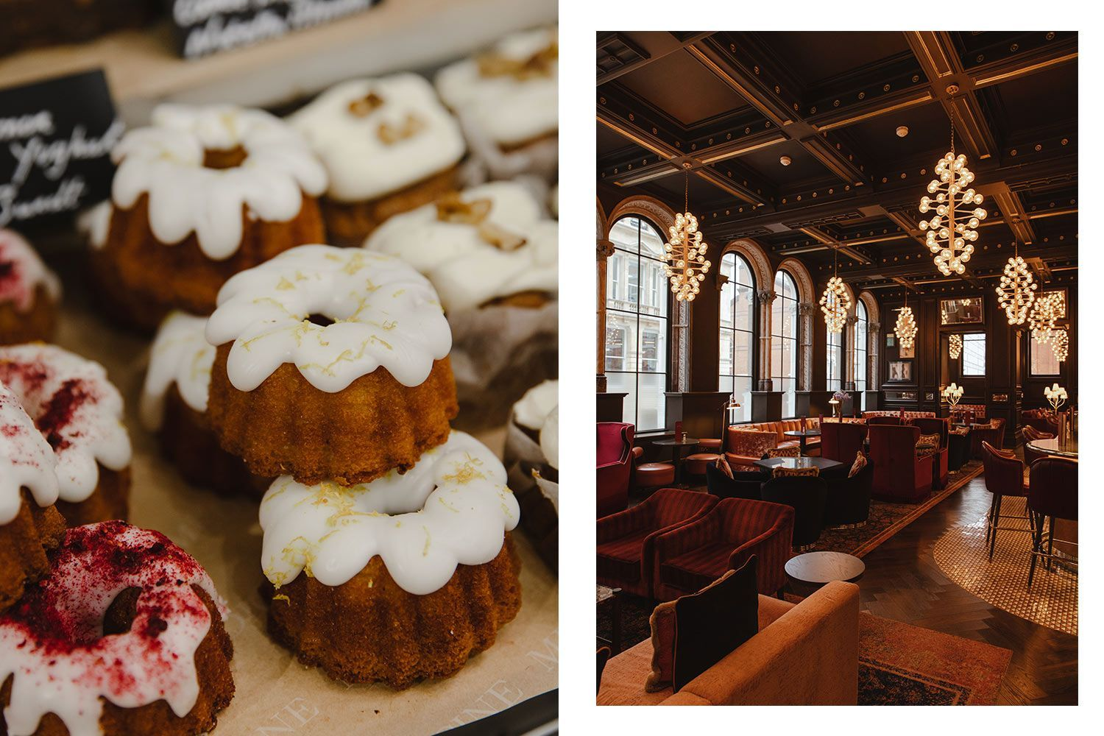

Everywhere I go, locals spontaneously tell me how proud they are of their city. At the [Birmingham Brewery Company](https://birminghambrewingcompany.co.uk/), a sustainable brewery which makes craft Brummie beer from its base in Stirchley, one punter almost weeps as he earnestly tells me, “For the first time in my life, I’m proud to be from Birmingham.” Admittedly, he had polished off several pale ales, but he should be proud – not least for the city’s food and drink scene.

“BRITAIN’S ‘SECOND CITY’ IS ABOUT TO TAKE TOP POSITION WHEN IT HOSTS THE COMMONWEALTH GAMES IN JULY.”

Birmingham is full of independent eateries. You can eat food from all over the world for every budget, from the city’s famous balti curries and street food at the hip [Hockley Social Club](http://hockleysocialclub.com/), right up to fine dining. Birmingham is home to five Michelin-starred restaurants: Purnell’s, Carters of Moseley, Adam’s, Simpsons Restaurant and Opheem.

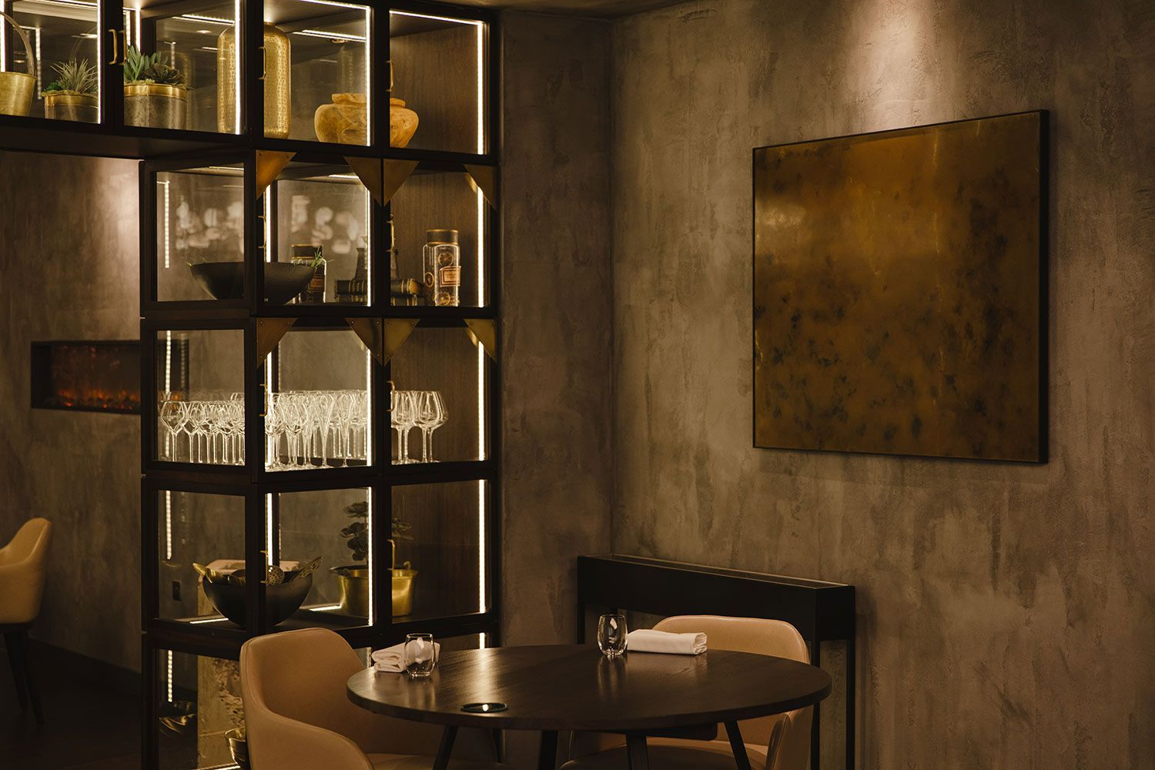

I begin my gastronomic tour in [Purnell’s,](https://purnellsrestaurant.com/) which has been a Birmingham institution for 15 years. The masterful modern-British menu serves up dishes such as haddock foam with roasted cornflakes and a spin on 1970s cheese and pineapple with dehydrated frozen pineapple and silver leaf. But the stand-outs are its famous desserts, including chef Glynn Purnell’s signature dish, burnt English egg custard surprise – a form of crème brulee with which he won the Great British Menu TV show and probably wishes he could stop making but will never be able to, because it’s truly magnificent. Served in eggshells, it comes with a pink lady apple and miso caramel, pine nut crumble on my visit.

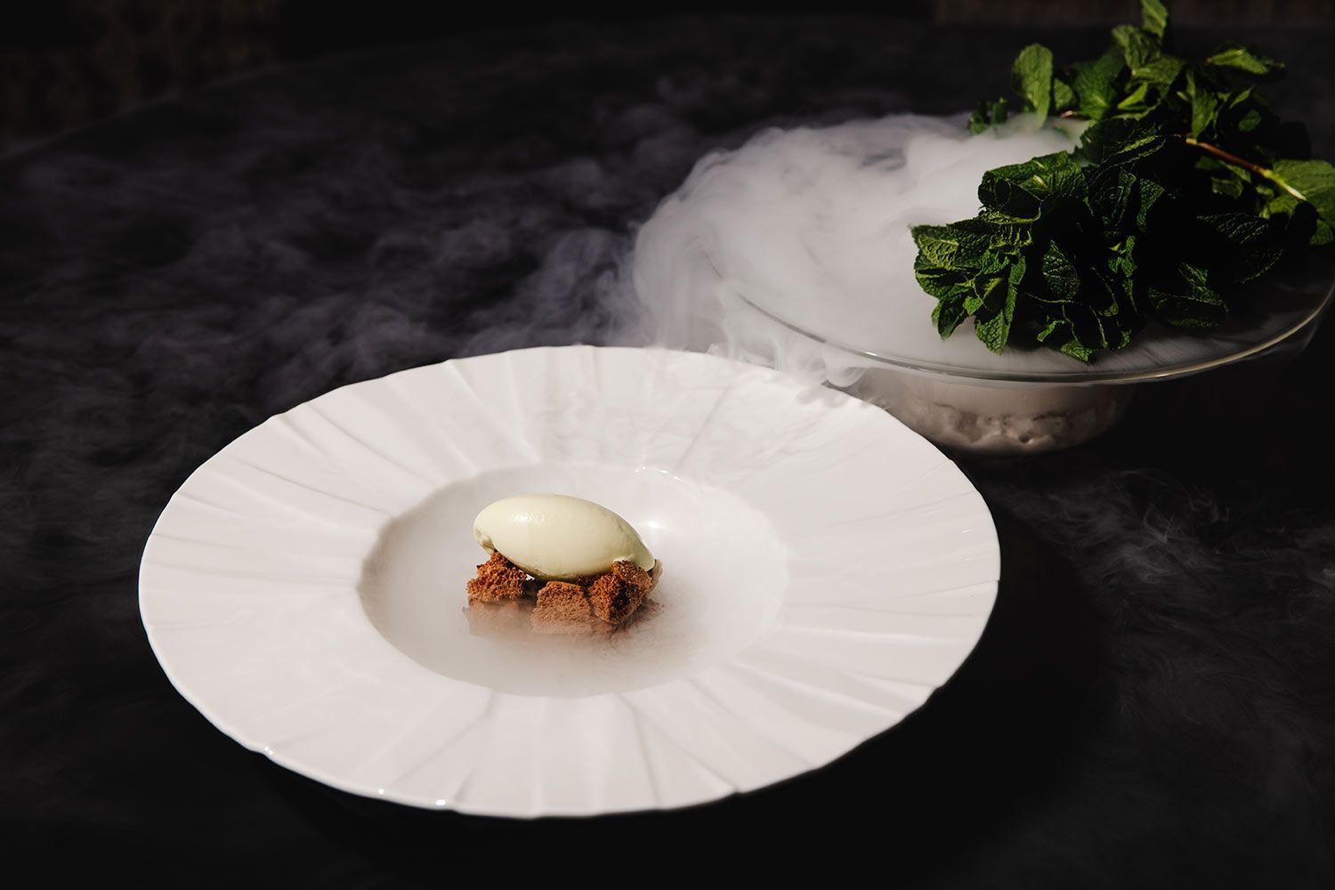

While Purnell’s is classic, [Carters of Moseley](https://cartersofmoseley.co.uk/) is creative; this unassuming, dark little restaurant in the cool suburb of Moseley is like a metaphor for the city – you have to know it’s there, but when you find it, you’ll be astounded.

Chef Brad Carter is one of those inspiring people so passionate about their craft that they stop at nothing to challenge themselves. His menu is British – so British, in fact, that barring a few exceptional items, he won’t use anything, right down to lemons or black pepper, that isn’t grown in the UK. Instead, he creatively seasons his food with indigenous ingredients, many grown on his own allotment.

***Related story:***[***Inside the epic new first class suites for Qantas’s non-stop London flights***](https://www.delicious.com.au/travel/travel-news/gallery/inside-qantass-new-first-class-suites-non-stop-london-flight/aqv2mi0q)

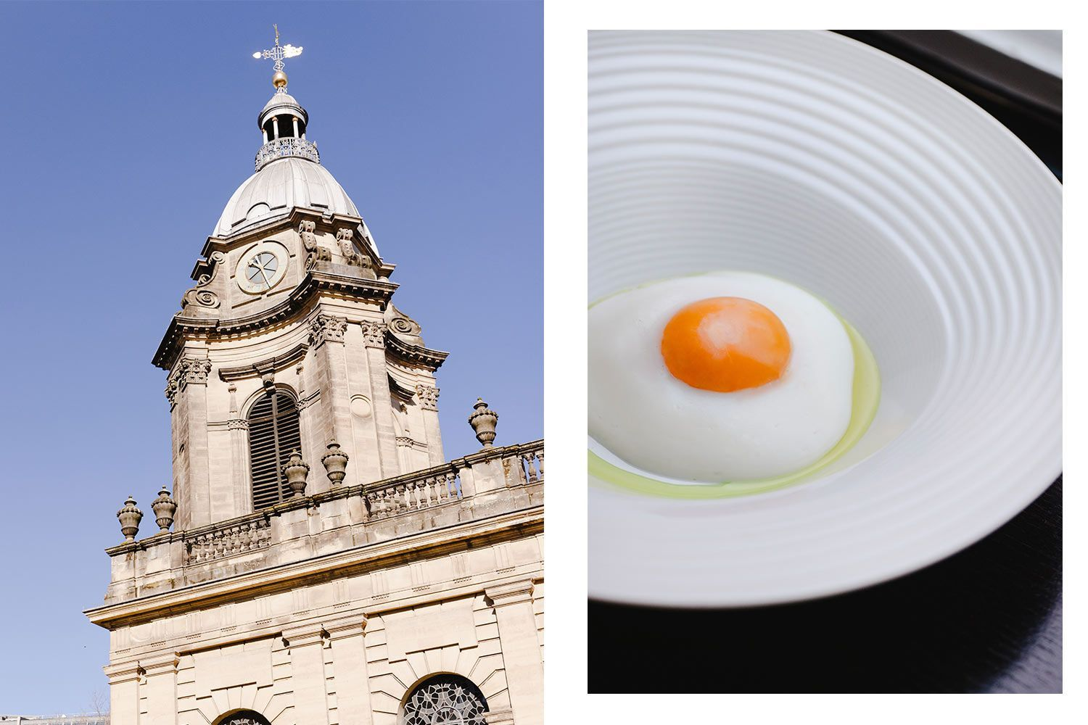

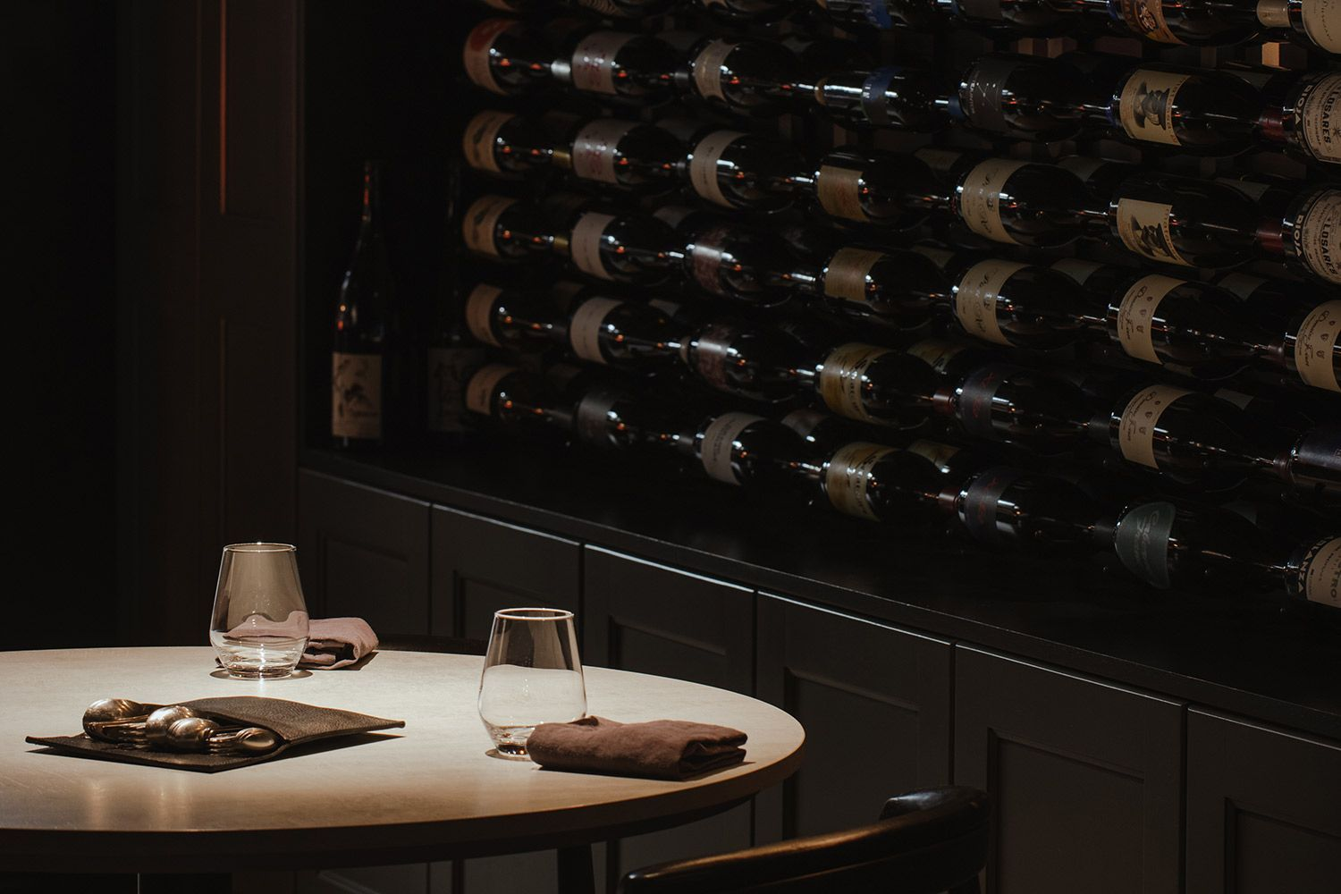Every course of the tasting menu is a flavour explosion, from the monkfish liver and Exmoor caviar amuse-bouche, to his superb Birmingham Soup, a beef consommé with tartare of ox heart, seasonal veg and a lattice tuile mimicking the design of the [Library of Birmingham.](https://www.birmingham.gov.uk/libraries)

Everything is thought out and nothing is wasted in this sustainable restaurant, even the tableware is made by a local potter using ashes from the kitchen’s barbecue and, until it was damaged in a flood, the flour came from nearby Sarehole Mill, a watermill which inspired local author J.R.R. Tolkien’s Middle Earth.

It’s not all fine dining, Birmingham is also famous for a completely different cuisine: the curry. And true to style, even that has been turned into an art form. [The Balti Triangle](https://visitbirmingham.com/inspire-me/areas/balti-triangle) is home to the city’s favourite dish – the balti. Invented in the late 1970s by local curry houses, the dish is cooked and served in a special balti bowl, a kind of mini wok.

***Related story:***[***What to do if your flight is cancelled, according to an airline worker***](https://www.delicious.com.au/travel/travel-news/article/if-flight-cancelled-according-airline-worker/ksvu26it)

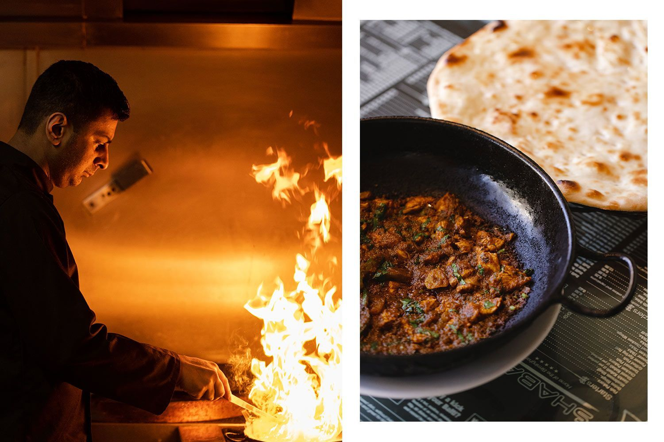

At [Shababs](https://www.shababs.co.uk/), one of the remaining few Balti houses, owner Zafar Hussain gives me a quick – and I mean quick – cooking demonstration of the perfect balti, which is cooked at extremely high temperature and eaten from the same bowl. It’s basically a stir-fry, with spices including paprika, cumin and turmeric. His version is surprisingly light, which he credits to using vegetable oil over ghee. “It’s going to clog your arteries, otherwise” he says.

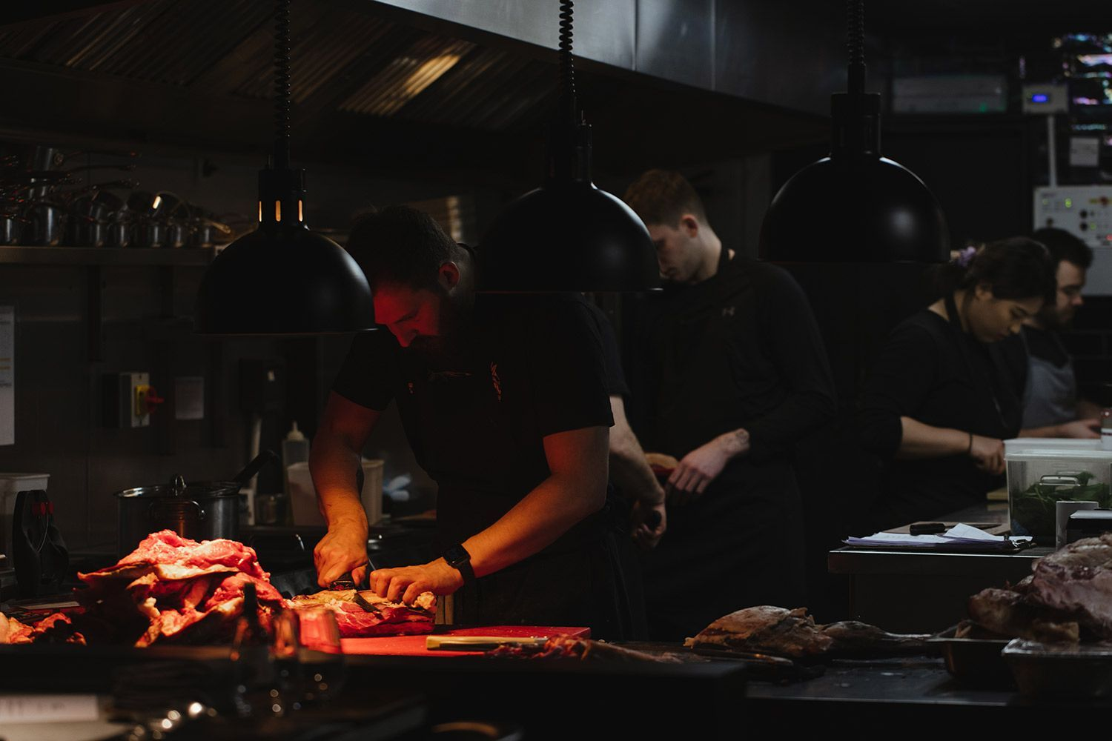

While the [Balti Triangle](https://visitbirmingham.com/inspire-me/areas/balti-triangle) once catered to post-pub diners, times are changing along with consumers’ tastes – and so I head back to the city for a completely different Indian food experience. [Mowgli Street Food](https://www.mowglistreetfood.com/) in Grand Central shopping centre is part of a burgeoning chain by innovative entrepreneur Nisha Katona of tiffin-style fast-food restaurants which use super-fresh ingredients, much of them vegetarian and vegan. The Mowgli Paneer, with its velvety cheese and soft spices, is delicious, as is house ‘showstopper’ the Bunny Chow, a tangy chicken and potato curry served on a bread loaf.

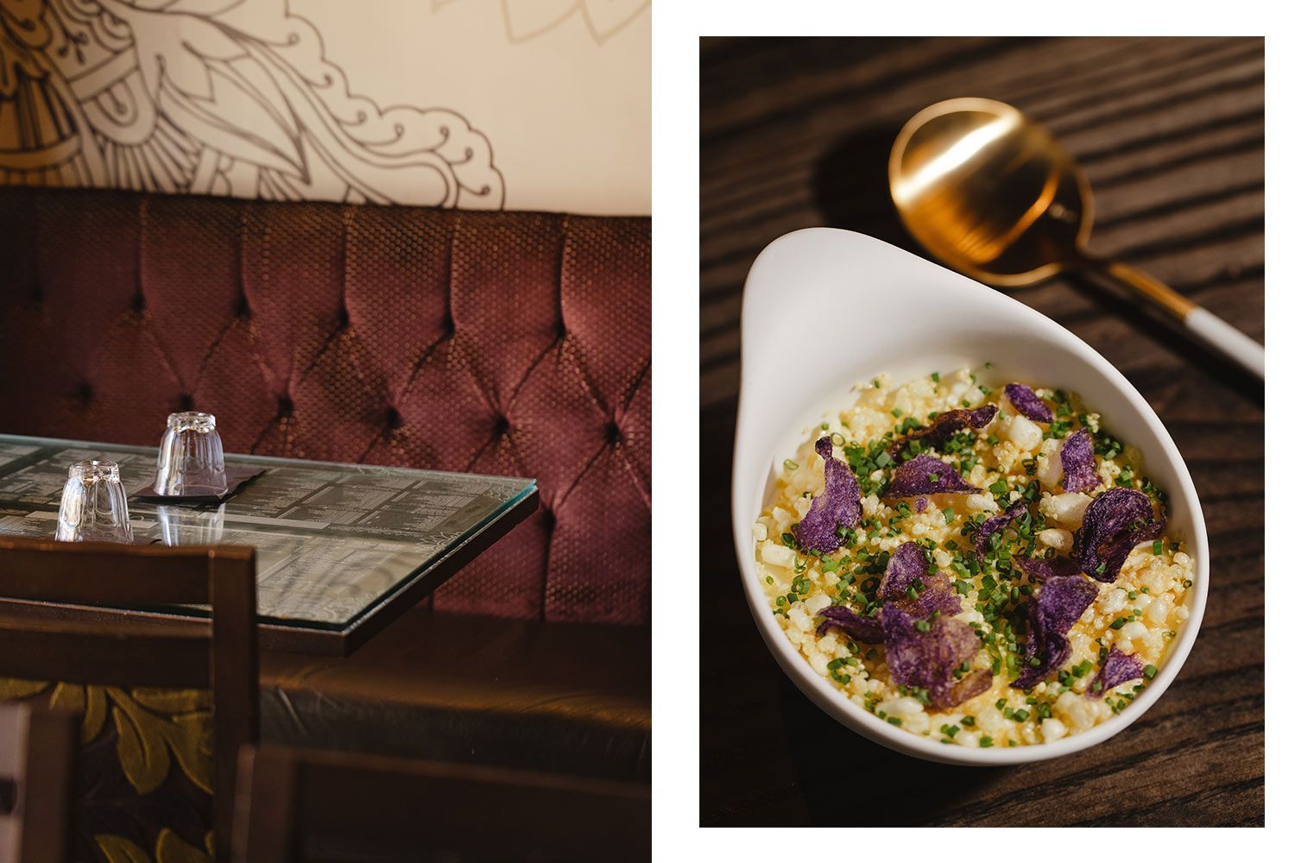

At the other end of the scale, in its own sphere, is Michelin-starred [Opheem](https://opheem.com/) by another passionate Brummie, chef Aktar Islam.

“Having the choice of living anywhere in the world, I choose to live here, I love Birmingham,” he says.

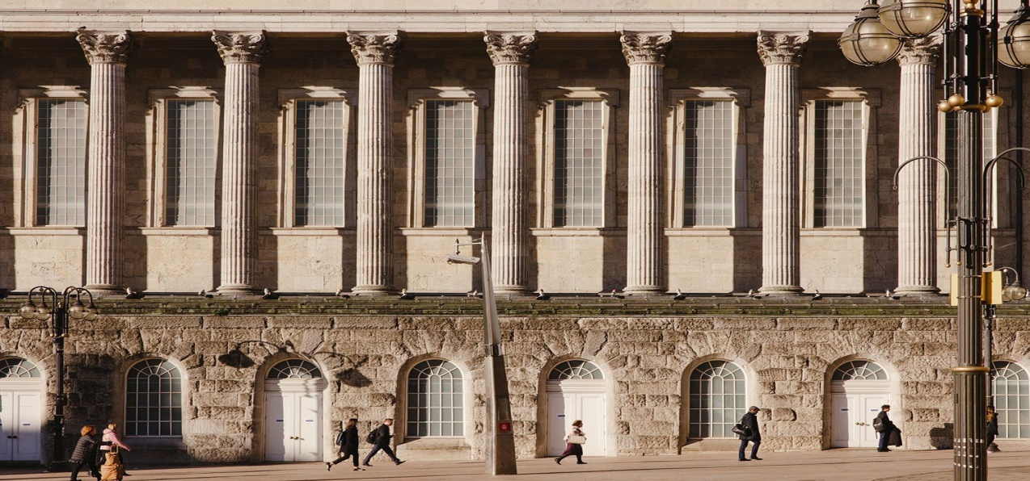

But what he loves even more is the challenge of creating progressive Indian cuisine, on a par with perhaps only two other restaurants in the world: Masque in Mumbai and Haoma in [Bangkok](https://www.delicious.com.au/travel/international/article/24-hours-bangkok/cb743950-9dff-4562-8ca3-7c08a1f8025f). “We are all about taking the aura of a dish and instilling a spirit into it,” he says, maintaining he doesn’t make food to look good, only taste good. But that’s being modest, because dishes such as his Aloo Tuk manage to do both. The humble achaari pink fir potato is manipulated five ways to produce a dish I’d be happy to eat on its own for the rest of my life.

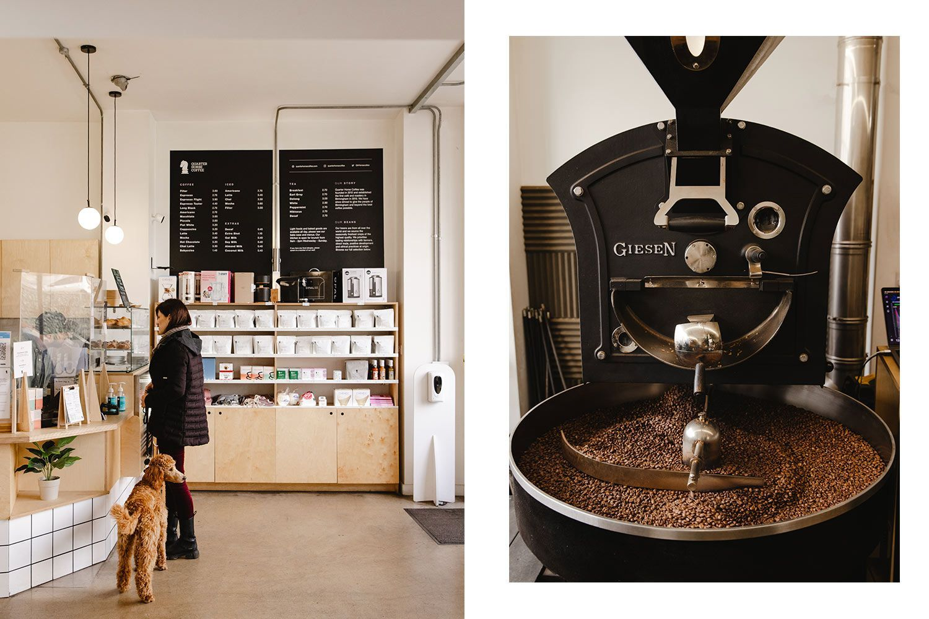Thankfully, after all this curry, I discover another benefit of Birmingham is its walkability. The city centre is easy to stroll around from my base in the heritage [The Grand Hotel,](https://www.google.com/aclk?sa=l&ai=DChcSEwjYpOS5ypr5AhWYk2YCHT02DgAYABABGgJzbQ&ae=2&sig=AOD64_2Gpl0iXAFmZ0bcKO0ALULDfCRs9A&q&adurl&ved=2ahUKEwjK2t25ypr5AhV7RWwGHT0HBmQQ0Qx6BAgFEAE) a former Grand Dame of the city overlooking Cathedral Square, which hosted everyone from Charlie Chaplin to Winston Churchill and Malcolm X and has now been lovingly brought back to life.

With knowledgeable local tour guide Mary Moore, I wander everywhere, from the iconic Library of Birmingham, the cultural hub of the city with its delightful secret garden, along the canal to Brindley Place, a pretty waterside area of eateries that comes alive at night, and around the historic Jewellery Quarter.

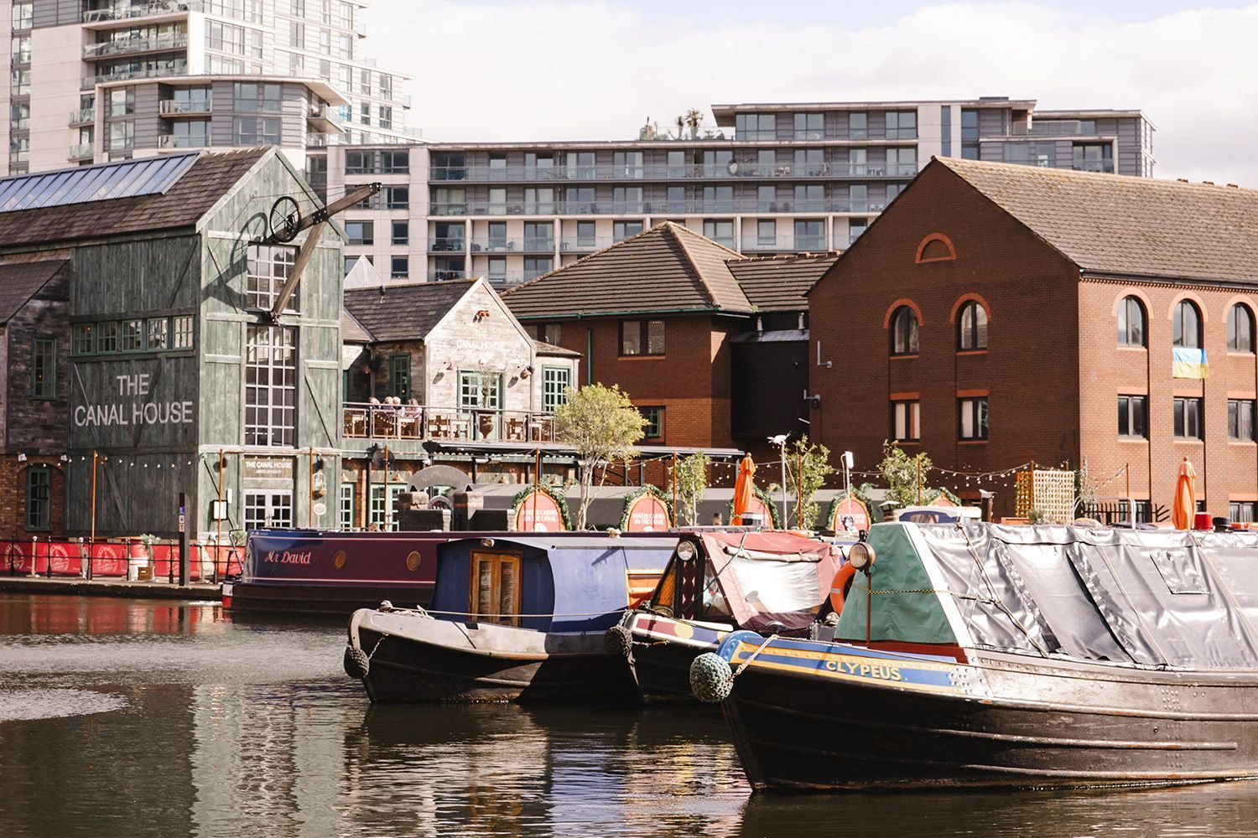

All this activity is punctuated with pit-stops at some of the city’s excellent independent coffee shops, including industrial cafe and roastery [Quarter Horse Coffee](https://quarterhorsecoffee.com/) on Bristol St and local favourite F[aculty Coffee](https://www.facultycoffee.com/) in pretty Piccadilly Arcade, which rotates its beans every two weeks. Then there’s [Medicine Bakery](https://www.medicinebakery.co.uk/), with its Instagrammable cronuts. This artisan, ethical bakery mixes food with art in beautiful and surprising industrial spaces.

Which pretty much sums up Birmingham, really

# Get free entry to all US National Park sites on Friday

Forrest Brown, CNN • Published 11th November 2022

FacebookTwitterEmail

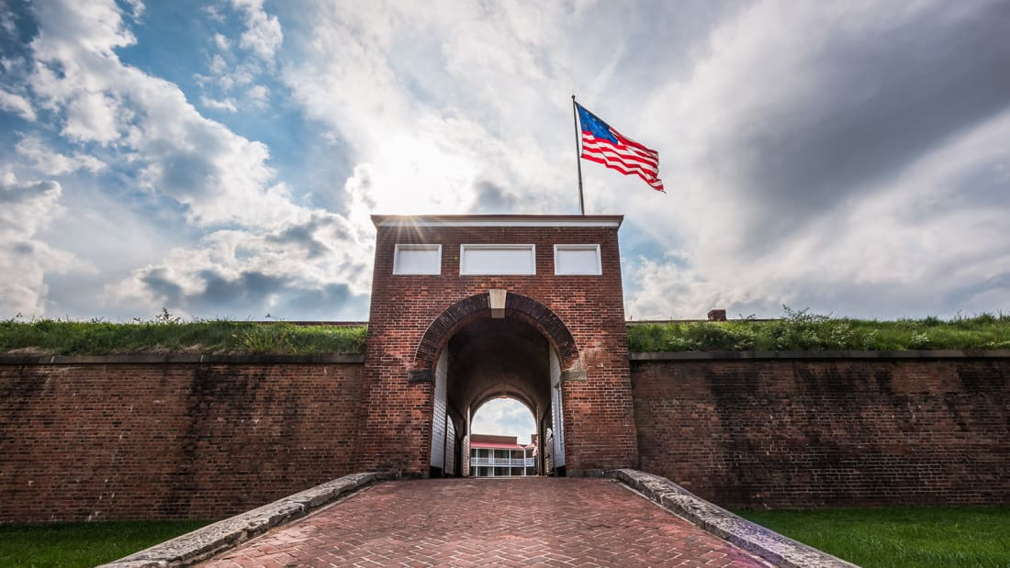

**(CNN) —**The US National Park Service offers free entry a handful of times each year to all of its more than 400 sites. We're at the last one for 2022.

No fees will be charged to enter any site -- including the marquee names -- on Friday, November 11.

The NPS chose [Veterans Day](https://www.nps.gov/subjects/npscelebrates/veterans-day.htm) for the last free-entry day to honor the people who have served in the military.

If you wish to commemorate veterans or learn more about US history in general while saving some money, you have have plenty of sites from which to choose, including:

• [Antietam National Battlefield](https://www.nps.gov/anti/index.htm) in Maryland  
•[Chickamauga & Chattanooga National Military Park](https://www.nps.gov/chch/index.htm) in Georgia and Tennessee  
• [Fort Davis National Historic Site](https://www.nps.gov/foda/index.htm) in Texas  
• [Fort McHenry National Monument and Historic Shrine](https://www.nps.gov/fomc/index.htm) in Maryland  
• [Fort Vancouver National Historic Site](https://www.nps.gov/fova/index.htm) in Oregon and Washington  
• [Golden Spike National Historic Park](https://www.nps.gov/gosp/index.htm) in Utah  
• [Perry's Victory and International Peace Memorial](https://www.nps.gov/pevi/index.htm) in Ohio  
• [Vicksburg National Military Park](https://www.nps.gov/vick/index.htm) in Mississippi

[Click here](https://www.nps.gov/aboutus/national-park-system.htm) for a full listing of every NPS site, which it calls "units."

Most NPS sites are free all year anyway. Only [108 charge a fee](https://www.nps.gov/aboutus/entrance-fee-prices.htm). And as you'd suspect, it's mostly the big names that ask you to pay to enter: Places such as [Arches](https://www.nps.gov/arch/index.htm) in Utah, [Rocky Mountain](https://www.nps.gov/romo/index.htm) in Colorado and [Shenandoah](https://www.nps.gov/shen/index.htm) in Virginia.

But they're [all free this Friday](https://www.nps.gov/orgs/1207/fee-free-days-2022.htm).

One catch: "The entrance fee waiver for fee-free days does not cover amenity or user fees for activities such as camping, boat launches, transportation or special tours," the NPS says.

### Planning pays off

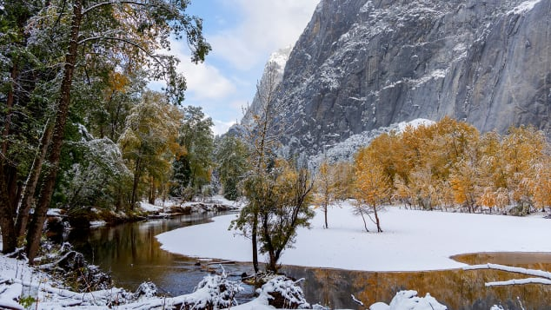

A light autumn snow comes to Yosemite National Park in California. Things can get much deeper there.

DanitaDelimont.com/Adobe Stock

If you're not much of a planner, it might be a good idea to develop the habit -- particularly if you want to see a popular NPS site on a free day.

Of those 420+ sites in the National Park System, the top 25 got [more than half of the system's total number of visits](http://www.cnn.com/travel/article/most-visited-us-national-park-sites-2021/index.html) last year. Some parks set all-time records for visitors in 2021.

# This Christmas-themed hotel room is bringing a taste of the North Pole to Melbourne

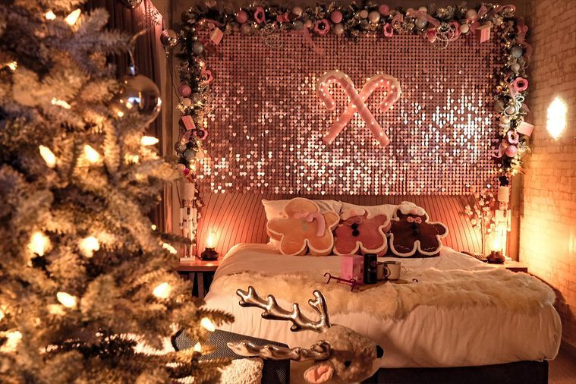

*Ugg Express DoubleTree by Hilton Christmas Room. Source: supplied*

##### [BY CONSTANTINA DEMOS](https://www.delicious.com.au/people-events/people/constantina-demos/ymnhynwz)

##### [DELICIOUS. TRAVEL EDITOR](https://www.delicious.com.au/people-events/people/constantina-demos/ymnhynwz)

##### NOV 08, 2022

**Deck the halls with sheepskin slippers and rugs.**

Always dreamt of a white [Christmas](https://www.delicious.com.au/recipes/group/gallery/14-christmas-puddings-you-still-have-time-to-make/3ubdiybr?r=zone/christmas&z=Christmas)? Now you can get a taste of what a Northern Hemisphere Chrissy could be like thanks to [UGG Express](https://uggexpress.com.au/) and [DoubleTree by Hilton Melbourne](https://www.hilton.com/en/hotels/melfsdi-doubletree-melbourne-flinders-street/).

From November 1 to January 10, a collaboration between the brands will see two of the hotel’s Flinders St. Station View Rooms transformed into winter wonderlands for guests. The festive-themed rooms will be decked out with a host of holiday decorations including a Christmas tree, light-up wreath, child-sized nutcracker and more.

UGG Express have also guaranteed the visit will be a comfortable one, providing reindeer slippers, sheepskin rugs and UGG boots for guests to enjoy during their stay. Complimentary [marshmallows](https://www.delicious.com.au/recipes/collections/gallery/best-marshmallow-smores-recipes/0dsnkbpu) and hot chocolate will also be on offer to keep those cosy vibes going.

Here’s a hot tip: set the air conditioner to low to ensure you can enjoy all the warming treats without overheating during Melbourne’s summer. Seasons Greetings!

# 5 things every traveller should know before catching a bullet train in Japan

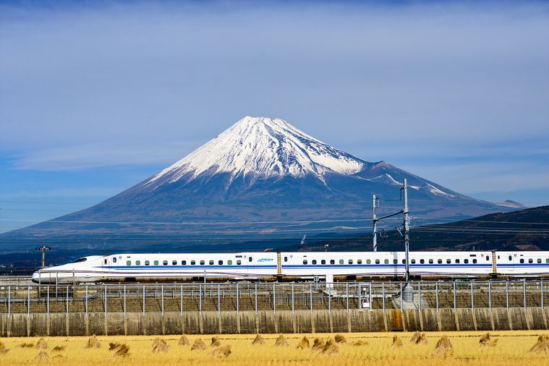

*Japan Bullet Train. Source: iStock*

**Tips and tricks for catching a bullet train like a local.**

A trip on a high-speed Shinkansen train is, for many people, one of the must-do experiences in Japan. Here is our beginners’ guide to doing it right:

## Booking your ticket

Different shinkansen are operated by different local rail companies. Depending on which region you are travelling through you can buy your tickets on the website of [JR East](https://www.jreast.co.jp/multi/en/index.html), [JR Central](https://global.jr-central.co.jp/en/), [JR West](https://www.westjr.co.jp/global/en/) or [JR Kyushu](https://www.jrkyushu.co.jp/english/). Most [shinkansen](https://www.delicious.com.au/eat-out/restaurants/article/chocolate-buddha-melbourne-japanese-eatery-reopens-shinkansen-inspired-sushi-train/4bqygca9) have both reserved and unreserved seating but as trains can sell out, particularly at peak time, booking a reserved seat in advance is recommended.

You can also buy tickets at the railway station, either from a machine or at the counter. Your ticket will be divided into three components: the base fare, the Shinkansen supplement (called the limited express fee) and your seat reservation fee.

If you have a [Japan Rail Pass](https://www.japanrailpass.com.au/?gclid=CjwKCAjw79iaBhAJEiwAPYwoCGYk1P2ZAK32aMekDk4kCf8Yjw7SsY5ZhUvV6TW9FlHPRE26a2USwxoC2vwQAvD_BwE), travel is free on almost all shinkansen trains. (The most important exception is the express Nozomi service between [Tokyo](https://www.delicious.com.au/travel/international/article/japan-travel-tips-order-bowl-ramen-tokyo/4r7aomqw) and [Osaka](https://www.delicious.com.au/travel/international/gallery/osaka-the-new-tokyo-for-foodies/h8ooyqgj), and between Osaka and Fukuoka/Hakata.) Get a free seat reservation at a ticket machine or ticket office.

## Selecting a seat

You can book a seat either in standard class or in the Green Car, the Shinkansen’s version of business class. The carriages are similar, although green cars have larger seats with more leg room. Some shinkansen also offer a premium option called Gran Class, where attendants will bring you little luxuries such as blankets, slippers and warm towels. No matter which class you are travelling, most shinkansen have wi-fi and USB charge points.

## A word about luggage

You will rarely see Japanese travellers clutching anything larger than a carry-on bag, and storage space on board the Shinkansen is tailored accordingly. If you do have a larger suitcase (160cm or above), you will need to buy an oversized luggage ticket, which comes with extra storage space.

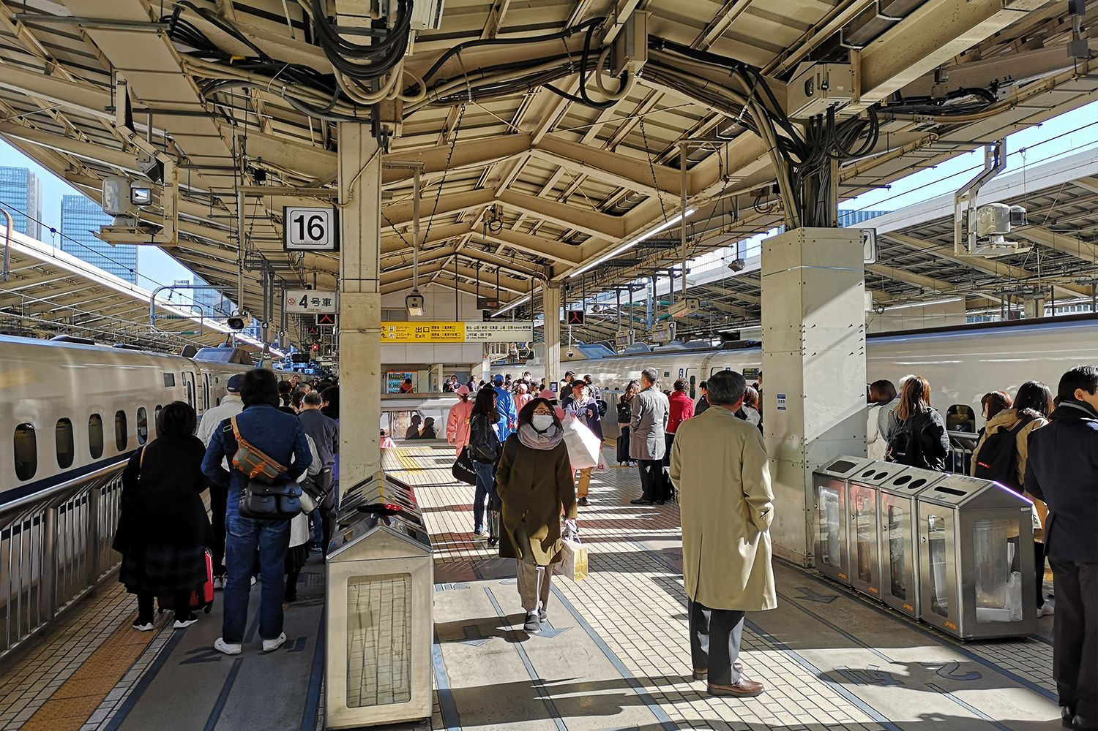

***Related story:***[***Melissa Leong’s Tokyo guide: 5 best food experiences to try***](https://www.delicious.com.au/travel/international/gallery/melissa-leong-tokyo-guide/vwt4c7tq)

## Eating onboard

If you are used to long-distance travel in western Europe, you may be surprised to learn that most shinkansen do not have a dining car. Do as the Japanese do and pick up a bento box at the station to enjoy while you are on the train. There are always plenty to choose from, including ones featuring local specialties.

The exception is if you are travelling in Gran Class where in some cases – not all – your ticket includes complimentary snacks, drinks and bento boxes. And in case you are wondering, there are no rules against drinking alcohol on trains – in fact, you will see plenty of salarymen cracking open a beer as soon as they sit down.

## Consider the alternatives

If you need to get somewhere in a hurry, the shinkansen is always your best choice. If you have more time up your sleeve, however, you might want to consider taking the scenic route. Japan has some magnificent sightseeing trains designed to showcase the best of the country’s landscapes. On Kyushu, for instance, the [Yufuin No Mori](https://www.jrkyushu.co.jp/english/train/yufuin_no_mori.html) takes you from Hakata station in the hub of Fukuoka to the lovely hot springs town of Yufuin, travelling through forested valleys and mountains along the way.

There are also themed train trips such as the [Koshino Shu*Kura](https://www.jreast.co.jp/e/joyful/shukura.html) in Niigata Prefecture, an area famous for its sake. The interiors of the Koshino Shu*Kura are designed to resemble a sake brewery, complete with casks, and guests can enjoy free sake tastings as well as jazz performances.

# Is this year's Tourism Australia campaign ad their best one yet?



##### [BY CONSTANTINA DEMOS](https://www.delicious.com.au/people-events/people/constantina-demos/ymnhynwz)

##### [DELICIOUS. TRAVEL EDITOR](https://www.delicious.com.au/people-events/people/constantina-demos/ymnhynwz)

##### OCT 21, 2022

**It definitely has ‘Where the bloody hell are you?’ beat.**

[Tourism Australia](https://www.tourism.australia.com/) campaigns are always a topic of hot debate among Aussies. Upon the release of a new [campaign](https://www.delicious.com.au/travel/article/watch-tourism-australias-new-ad-featuring-kylie-minogue/v19ovtoq) people firmly plant their feet in either the ‘love it’ or ‘hate it’ camp. This year, you’ll find us in the ‘love it’ camp.

As international travellers return to our shores after two years of restrictions, ‘Come and Say G’Day’ is a warm welcome back to those we haven’t seen in a while. The $125 million short film introduces the world to the adorably cute Ruby, a CGI-animated, toy souvenir kangaroo who is voiced by Australian actor, Rose Byrne.

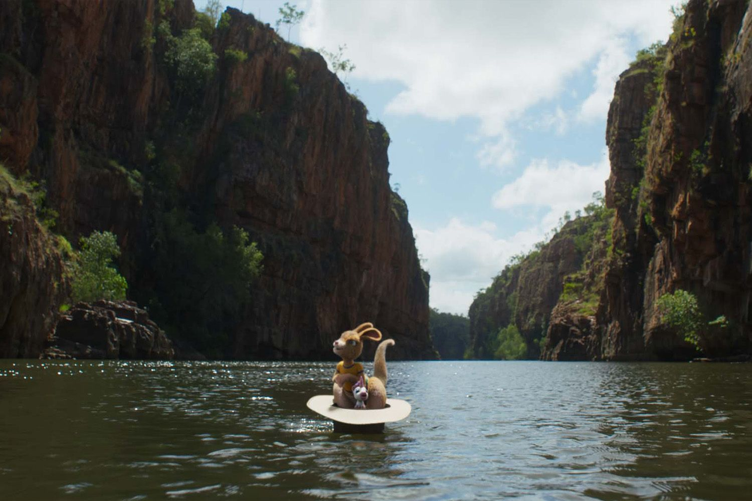

With the help of Louie, an American toy unicorn voiced by Will Arnett, Ruby breaks out of a gift shop at the Great Barrier Reef and sets off on a country-wide adventure to get to Uluru. Along the way the duo visit iconic sites like [Melbourne’s](https://www.delicious.com.au/drinks/bars-pubs/gallery/best-laneway-bars-melbourne/igbwk80o) laneways, [Sydney Harbour](https://www.delicious.com.au/travel/australia/article/inside-pullman-quay-grand-sydney-harbours-updated-hotel-suites/wjqq42sv) and [Nitmiluk Gorge](https://www.delicious.com.au/travel/delicious-deals/article/ghan-luxury-expedition-travel-deal-2022/nr78r4uq), just to name a few.

While these types of campaigns aren’t aimed at locals, we like to see (and judge) how our country and its people are being presented to the world. Packed with witty puns, good-natured fun and beautiful shots of our varying landscapes, this campaign doesn’t take itself too seriously (just like us Aussies). And we’re here for it. Let us know what you think in the below poll.

# Melbourne’s best hidden bars of 2022

delicious rates Melbourne’s best speakeasy-style bars, from hidden gems to basement dive bars and rooftop watering holes. From subterranean speakeasies to concealed courtyards, attic hideouts and rooftop watering holes behind locked doors, here are Melbourne’s best secret bars – and how to find them.  This guide has been brought to you in partnership with American Express and the Shop Small campaign. To learn about American Express and the Shop Small campaign, visit [here](https://www.americanexpress.com/au/shop-small/).

##### [BY MARIAM DIGGES](https://www.delicious.com.au/people-events/people/mariam-digges/301pnvvl)

##### [WRITER](https://www.delicious.com.au/people-events/people/mariam-digges/301pnvvl)

##### OCT 17, 2022

[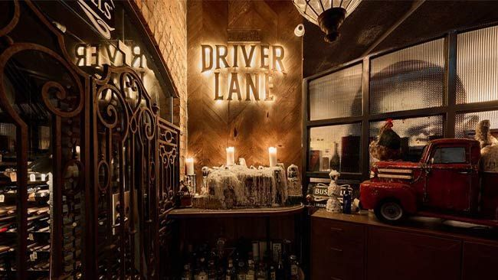](https://www.driverlanebar.com/)

## [Beneath Driver Lane](https://www.driverlanebar.com/)

You could be in a basement in New York, Chicago or New Orleans at this jazz-heavy subterranean bar. The service, whisky collection and blues tunes are strong, with a build-your-own martini offering and the option to order Reuben sandwiches until 2am. Shop/3 Driver Lane, Melbourne

[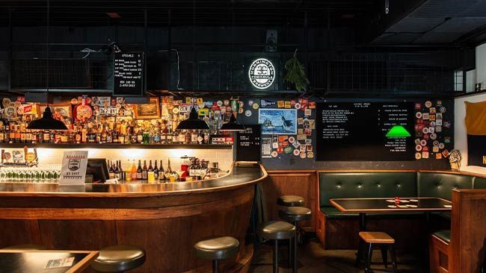](https://www.savinggracebar.com.au/)

## [Saving Grace](https://www.savinggracebar.com.au/)

Under an unassuming office block off Little Collins Street, you’ll find this laidback dive bar where crowds roll in for a worldly selection of whiskies, gins and craft beers served in industrial-chic surrounds. If you haven’t already, order the namesake cocktail – a palate-priming sour featuring Ardberg, Amaretto, maraschino, bitters and vanilla. 32 Church Lane, Melbourne

[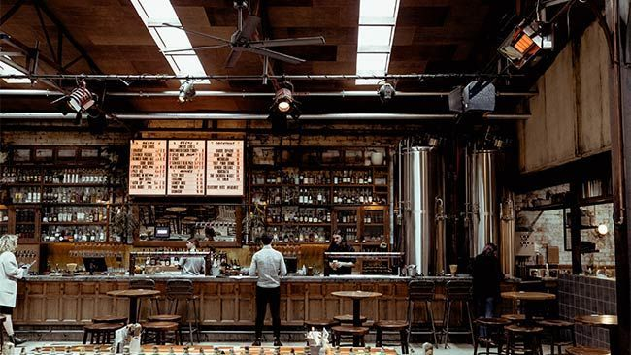](https://www.bodriggy.beer/)

## [Bodriggy Brewing](https://www.bodriggy.beer/)

Housed in an old gas conversion garage, this brewery, bottle shop, pub and cocktail saloon is fringed by greenery and polished concrete. You’ll find old faithfuls here alongside more experimental sours and pet nats on tap, with a margarita special on Mondays. 245 Johnston Street, Abbotsford

[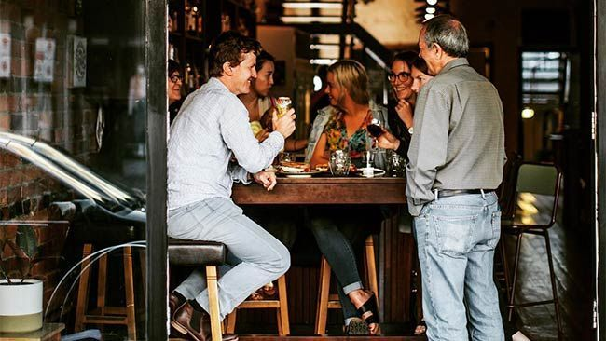](https://www.missmoses.com.au/)

## [Miss Moses](https://www.missmoses.com.au/)

Visiting this beer-focused neighbourhood bar feels like crashing a mate’s place – with its down-to-earth surrounds and homely menu of toasties and snacks. Expect 1960s American blues tunes spinning in the background as you mull over 40 different beer options ranging from IPAs to pilsners, sours and stouts. 581 Sydney Road, Brunswick

[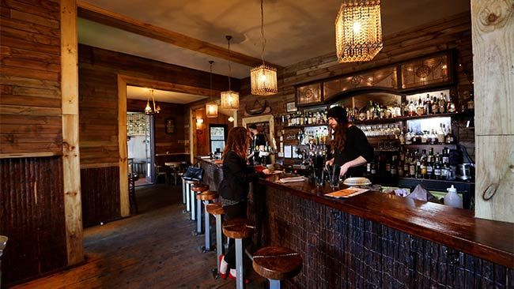](https://leonardshouseoflove.com.au/)

## [Leonards House of Love](https://leonardshouseoflove.com.au/)

Is it a log cabin or is it a bar? As the name suggests, the 70s free love vibes are strong at this South Yarra blink-and-you’ll-miss-it bar, which presents much like a regular house from the front and a log cabin once inside. 3 Wilson Street, South Yarra

[](https://www.delicious.com.au/gallery/15-iconic-sydney-cafes-have-stood-test-time/mcfxcw3y?utm_source=onsite&utm_medium=tout&utm_campaign=AMEX%20gallery%201)

[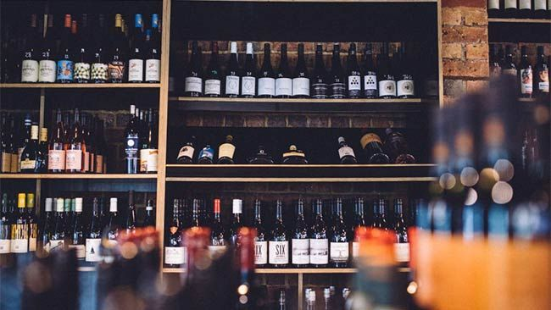](https://thewinecorner.melbourne/)

## [The Wine Corner](https://thewinecorner.melbourne/)

A bottleshop-cum-wine bar with an extensive-yet-curated selection of wines, spirits and beers from Australia and abroad that also happens to serve up killer snacks from 4pm daily. 50 Princes Street, Carlton North

[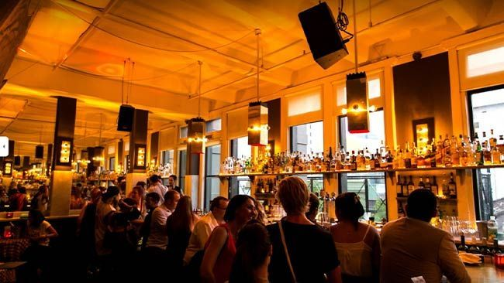](https://www.instagram.com/choochoosattoff/?hl=en)

## [Choo Choo’s](https://www.instagram.com/choochoosattoff/?hl=en)

A well stocked cocktail bar and Thai share plates are the order of the day (or night) at this locomotive-themed bar hidden inside an old train carriage, as the name suggests. Situated in a speakeasy-rich neighbourhood, you’ll often find local DJs spinning into the early hours here. Curtin House, 252 Swanston Street, Melbourne

[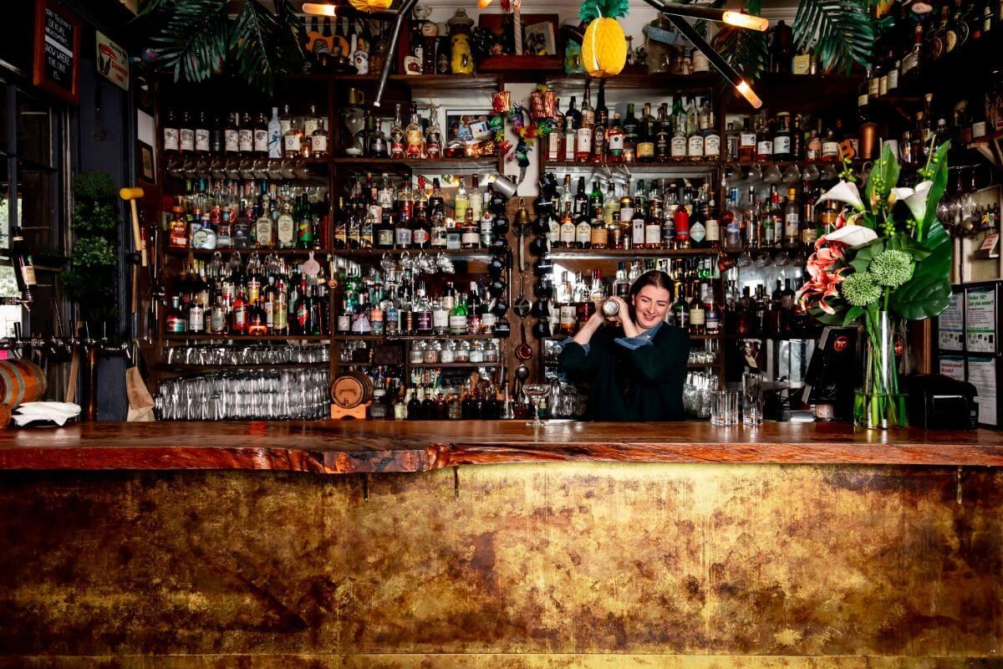](https://www.captainmelville.com.au/)

## [Captain Melville](https://www.captainmelville.com.au/)

Tucked up a rickety staircase inside Captain Melville, you’ll find a secret watering hole called Loch and Key. Warm timbers, sofas and the odd piece of taxidermy cosy up the late-night venue, which opens onto a balcony terrace boasting city views. The cocktail list is only six-strong but they’ll happily make you a bespoke drink to order. 34 Franklin Street, Melbourne

[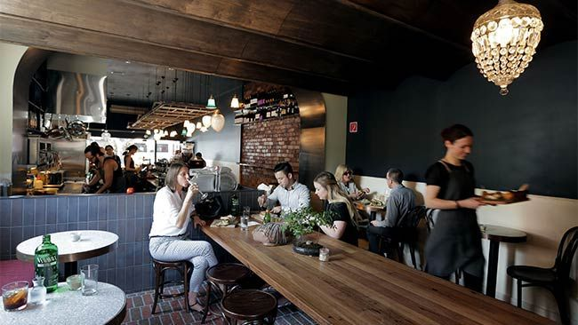](http://www.heartattackandvine.com.au/)

## [Heartattack and Vine](http://www.heartattackandvine.com.au/)

A cafe that moonlights as a bar, this Lygon Street favourite is paying homage to old-world Italian hospitality in the thick of Melbourne’s own Little Italy. An Italian-forward wine list and smart selection of cicchetti (Venetian small plates) make it the perfect spot for basking in aperitivo hour. 329 Lygon Street, Carlton

[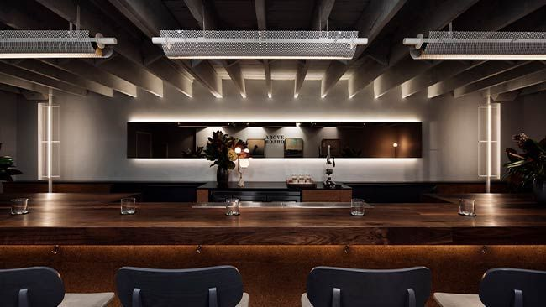](http://aboveboardbar.com/)

## [Above Board](http://aboveboardbar.com/)

Forget dropping a pin at this diminutive bar – it has no Google Map presence, with no more than 12 stools framing the island bar. Above Board serves up roughly 25 cocktails split into classics (Old Fashioned, Negroni) and signatures that might be spiked with blackberry liqueur, cherry brandy or absinthe. Level 1/306 Smith Street Chopper Lane

[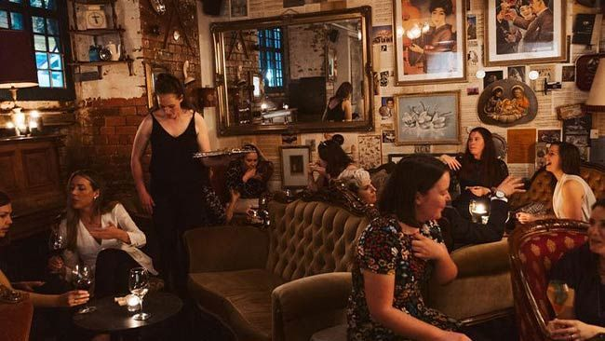](https://www.stateofgracemelbourne.com.au/)

## [Fall From Grace](https://www.stateofgracemelbourne.com.au/)

Essentially two bars in one, the gothic-style Fall From Grace is hidden down a staircase and behind a sliding bookcase inside big sister bar State Of Grace. Settle into one of the plush armchairs at this hidden cellar bar and sip on a New York Sour. 27 King Street Melbourne

[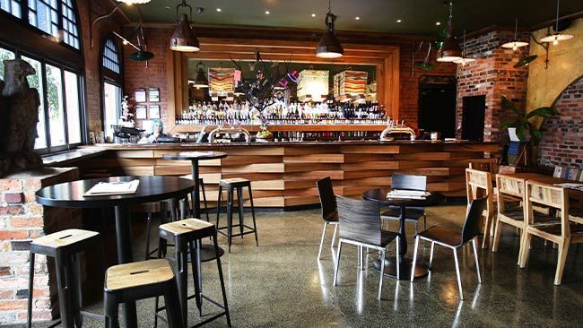](https://thewoodlands.com.au/)

## [The Woodlands Hotel](https://thewoodlands.com.au/)

Coburg’s oldest hotel has been revamped into a hidden wonderland featuring a pop-up beer garden and The Atrium bar, with its soaring ceilings, cosy fireplace and tropical plants. The drinks pay homage to local breweries and wineries, and the food side of things celebrates all your pub favourites. 84-88 Sydney Road, Coburg

[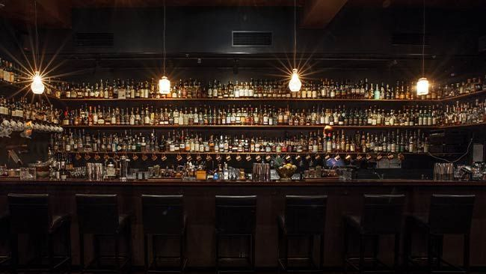](https://eaudevie.com.au/melbourne/)

## [Eau De Vie](https://eaudevie.com.au/melbourne/)

This 1920s prohibition era-inspired bar offers a range of seating options spanning intimate booths to bar seats and coffee tables, with a secret whisky room hidden behind a bookcase that is home to a library of exclusive, hard-to-find drops and a bottle shop to boot. 1 Malthouse Lane, Melbourne

[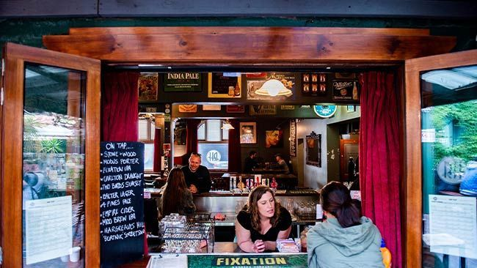](https://therainbow.com.au/)

## [The Rainbow Hotel](https://therainbow.com.au/)

Hidden in the backstreets of Fitzroy, this iconic pub is home to an excellent tucked away beer garden and deck that even your four-legged mate is welcome at. A solid selection of craft beers, friendly service and a roster of live music make it hard to beat. 27 St David Street, Fitzroy. This article was made possible by American Express and all venues mentioned are part of the Shop Small program by American Express.

# Oh boy! The Disney Wonder cruise ship is coming to Australia

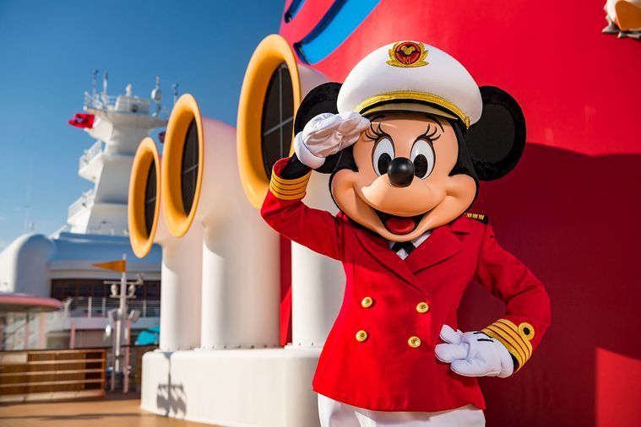

##### [BY DELICIOUS. TEAM](https://www.delicious.com.au/people-events/people/delicious-team/jm9n0yzl)

##### [DELICIOUS. TEAM](https://www.delicious.com.au/people-events/people/delicious-team/jm9n0yzl)

##### SEP 13, 2022

**But you'd better be quick, it sets sail for a limited time only. Words by Shireen Khalil.**

It’s something Disney fans in Australia have been waiting a very long time for. And finally, for the first time ever, Disney Cruise Line will offer “magical sailings” in Australia and New Zealand after it announced new destinations.

Ever since its inception back in 1998, the [Disney Cruise](https://www.escape.com.au/experiences/cruises/what-its-like-on-the-disney-wish-cruise-ship/news-story/52d9396cb893c27133c2ae78b4794dc2) Line has never sailed Down Under, nor to our neighbouring Kiwis. Instead, it has been sailing out of locations in North America and Europe.

However, the Disney Wonder, which originally launched in 1999, will now set sail from four new home ports – Sydney, Melbourne, Brisbane and Auckland. It will only be for a limited time, from two to six nights between October 2023 and February 2024.

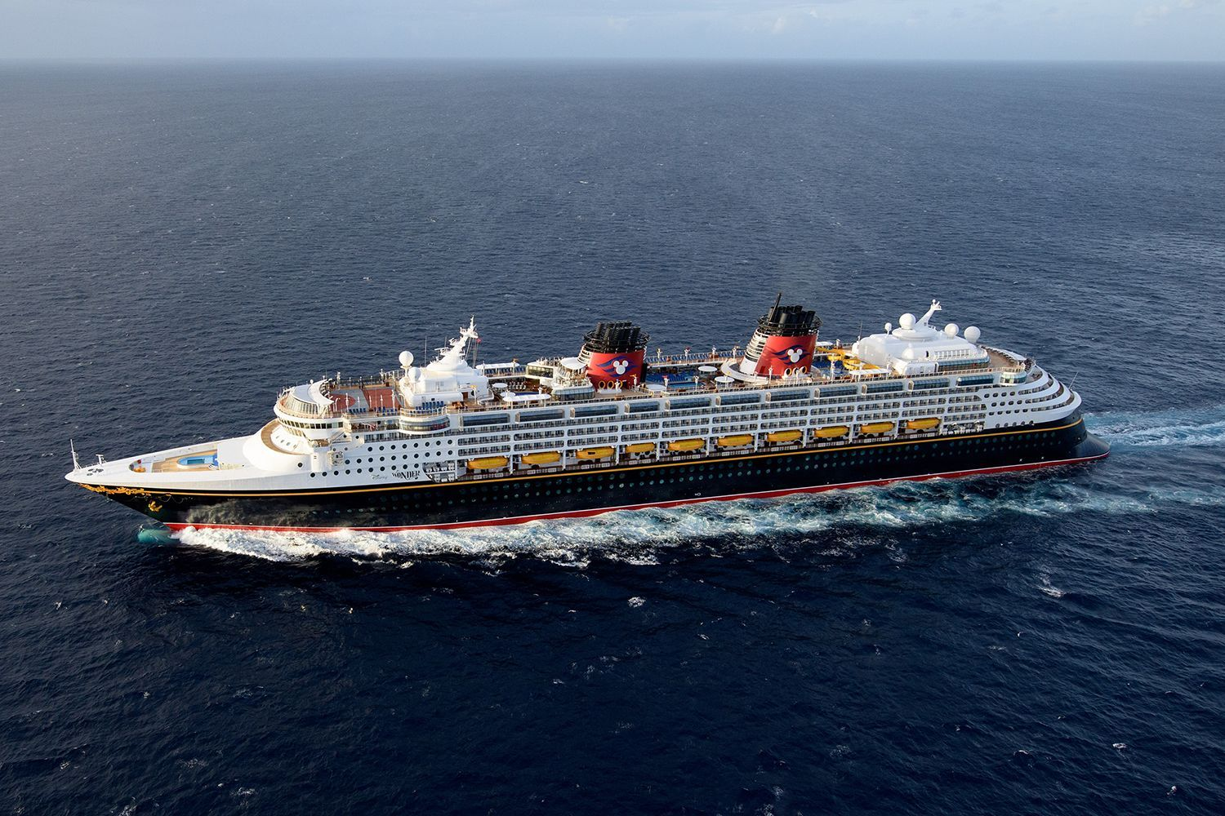

“We are so excited to bring the magic of a Disney [cruise](https://www.delicious.com.au/travel/international/article/covid-rules-safety-ships-new-era-luxury-cruising/eh792vl9) vacation close to home for guests in Australia and New Zealand,” Josh D’Amaro, chairman for Disney Parks, Experiences and Products, said.

“On these limited-time sailings, the ship is the destination, and our amazing Disney Cruise Line crew can’t wait to welcome guests on board as they are immersed in their favourite stories from Disney, Pixar, Marvel and [Star Wars](https://www.delicious.com.au/travel/international/article/disneys-star-wars-hotel-galactic-starcruiser-now-open/qw8g9ruf).”

***Related story:***[***Inside the Star Wars Hyperspace Bar on the Disney Wish cruise***](https://www.delicious.com.au/travel/international/article/inside-star-wars-hyperspace-bar-disney-wish-cruise/z3011qlo)



On-board will also be favourite Disney friends including Captain Mickey Mouse, Captain Minnie Mouse, Goofy and Pluto, and entertainment including original Broadway-quality shows.

Guests will also enjoy dining experiences with imaginative restaurants including Tiana’s Place, where they can meet Princess Tiana and enjoy a taste of New Orleans cooking, and Animater’s Palate, an interactive dining experience that celebrates Disney animation.

Kids will have their own Frozen adventures in [Disney’s](https://www.delicious.com.au/travel/international/article/inside-disney-worlds-epic-new-guardians-galaxy-ride/oz7ho2ft) Oceaneer Club, along with a multi-level replica of Andy’s Room from Toy Story and a place to summon their inner super hero at the Marvel Super Hero Academy.



And it’s not just the children who get to enjoy themselves. Adults will have their own exclusive spaces to rest and relax, including the adults-only Quiet Cove pool, dining at Palo and the rejuvenating Senses Spa & Salon.

It’s set to sail on October 28, 2023, departing from Sydney. [Bookings](https://www.disney.com.au/disney-magic-at-sea) are open to the general public from Thursday, September 29, 2022 at 8am AEST and 11am NZDT.

This article originally appeared on [*news.com.au*](https://www.news.com.au/travel/travel-ideas/cruises/disney-cruise-line-announces-the-disney-wonder-will-sail-to-australia/news-story/3cc7015702d26f0f4f2cfd7350ee17a9). It has been reproduced here with permission.

# There’s a pop-up theme park for dogs coming to Melbourne



*Photography: Alvan Nee*

**Who's a good boy?**

They say every dog has its day and it turns out, they’re right! Melbourne pooches will be having a very good day when a pop-up pupper theme park lands in [Melbourne](https://www.delicious.com.au/travel/travel-news/article/20-million-monopoly-theme-park-open-melbourne/8z5yv46a) this spring.

Theme Bark is a pop-up theme park for [dogs](https://www.delicious.com.au/travel/travel-news/article/little-albion-boutique-hotel-sydney-launches-dog-friendly-plush-pup-package/ldwbmbs8), and it’s coming to the Port Melbourne Industrial Centre for the Arts (PICA) on Saturday November 19th.

The family-friendly event will be positively packed with fun for your [favourite four-legged friend](https://www.delicious.com.au/eat-out/cafes/article/chez-misty-dog-friendly-cafe-creperie-opens-st-kilda-melbourne/c6cl96yf), including a giant *dogstacle* course, ball pit playpen and pooch [pampering services](https://www.delicious.com.au/travel/australia/article/langham-melbourne-launches-luxury-pet-friendly-accommodation-package/aovus0gp) like grooming.



***Related story:***[***KFC has released matching Christmas in July jumpers for you and your pooch***](https://www.delicious.com.au/eat-out/article/kfc-release-christmas-july-jumpers-you-dog/xsqs8pd9)

You can enter your lil bow wow into competitions, including the doggy dash, pup pageant and even a talent show called ‘Dog Factor’ which aims to find Melbourne’s next doggy superstar.

Meanwhile, the Barkery Lane pop-up market will bring together some of the best [dog-friendly retailers](https://www.delicious.com.au/eat-out/article/charcuterie-inspired-barkuterie-boards-newest-way-spoil-dog/4vl7mcc3), so you can shop for [treats](https://www.delicious.com.au/travel/australia/article/langham-melbourne-launches-luxury-pet-friendly-accommodation-package/aovus0gp), clothes, toys and accessories together.

Naturally, there’ll be plenty of [puppycinos](https://www.delicious.com.au/drinks/non-alcoholic/article/pg-tips-launch-dog-tea-international-dog-day/ccdg4ijh) and [doggy ice creams](https://www.delicious.com.au/food-files/news-articles/article/chobani-launches-daily-dollop-yoghurt-dogs/a7v37nr8) to go around, and food trucks, music and on-site bars for the bipeds

# 18 hacks, tips and tricks to help you save money on your next holiday

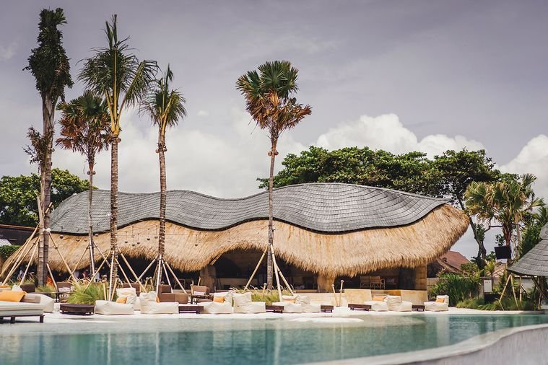

**Everyone – even the pros – love to save on travel. We ask them how they do it. Words by Mercedes Maguire.**

A [holiday](https://www.delicious.com.au/travel/travel-news/article/double-annual-leave-days/80uuw9ie) is a break from the daily grind, an opportunity to indulge in life’s little pleasures. And for me, that equates to a good spa treatment… or seven. But there’s such a premium attached to holiday spa treatments that the joy of being pampered is sometimes eclipsed by the cost. That’s why my favourite holiday hack is getting a massage from local women along the ocean front at Nusa Dua in Bali.

This location is like a Monopoly board of exclusive resorts, which come with equally exclusive spa treatment prices. But for the equivalent of $10-$15, you can get a one-hour, full body massage overlooking the ocean outside the resort walls.

Whenever I go to Nusa Dua, I check in with these women daily. Even with a 50 per cent tip, a week’s worth of massages equates to about the same as one massage in the resort.

Let’s face it, holidays may be a little harder to factor into the [household budget](https://www.delicious.com.au/eat-out/article/save-money-dining-out-restaurant/9yuvixo8) these days, so finding ways to get a great bargain on a holiday has never been more important.

But neither has the actual holiday, says Luke McLeod, a mindfulness expert and founder of meditation app Soul Alive.

“I think travel has a highly underrated positive influence on our overall mental health and wellbeing,” he says. “While it’s important to make sure planning a trip doesn’t add to financial stress, it shouldn’t deter you from travelling either. We’re often happiest when we’re working towards something meaningful.”

So, we asked the travel experts to put their money where their mouth is and found 18 of the best money-saving travel hacks around.

**FLYING**

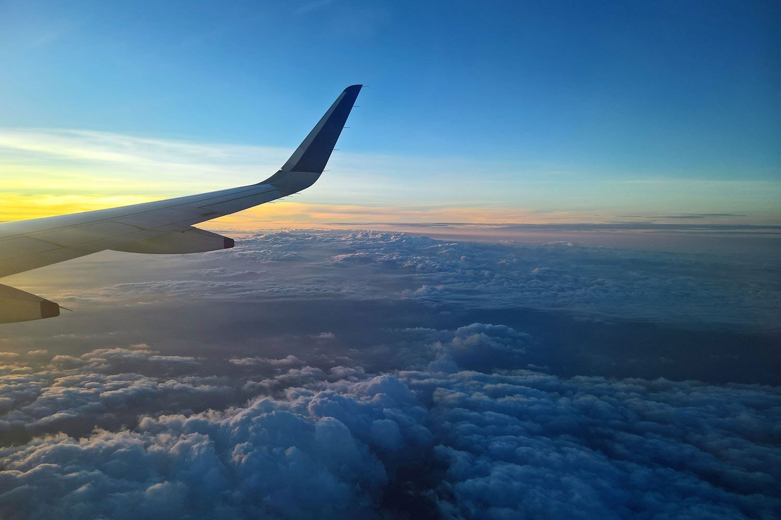

1. There are so many hacks for getting a flight upgrade for free and saving thousands, but Elena Fini from TripADeal found one that worked – quite by accident. “Get to the gate last and your seat might be upgraded,” she says. “I was about to miss my Dubai to Brisbane flight and, instead, I enjoyed a business class flight.”
2. The crack-of-dawn plane flights are often the cheapest, but that’s not a problem for Escape’s assistant digital editor Simone Mitchell. “If I need to scrimp I often book one of these cheap flights with terrible timing and book a night at the airport hotel before or after I fly,” she says. “Airport hotels are often way less expensive than city hotels and you also save money by getting public transport to the airport.”
3. Daniel Sciberras of the frequent flyer guide, Point Hacks, also looks for the first flight, but for different reasons. “It is usually priced much cheaper than later flights,” he says. “It’s less likely to be delayed due to the incoming aircraft but also, if you’re looking to indulge in luxury travel on the cheap, you have a greater chance of snaring an upgrade using your frequent flyer points as demand for these seats is lower at that time of day.”
4. Escape’s commercial managing editor Kelli Armstrong has learned the need to cancel or change flights over the past few years, so she always books flights as one-way. “If I want to change my return flight I can do it online and don’t have the headache, and extra fee, of having to call the airline to change the return because I’ve already commenced the booking.”

***Related story:***[***Inside the epic new first class suites for Qantas’s non-stop London flights***](https://www.delicious.com.au/travel/travel-news/gallery/inside-qantass-new-first-class-suites-non-stop-london-flight/aqv2mi0q)

**ACCOMMODATION**

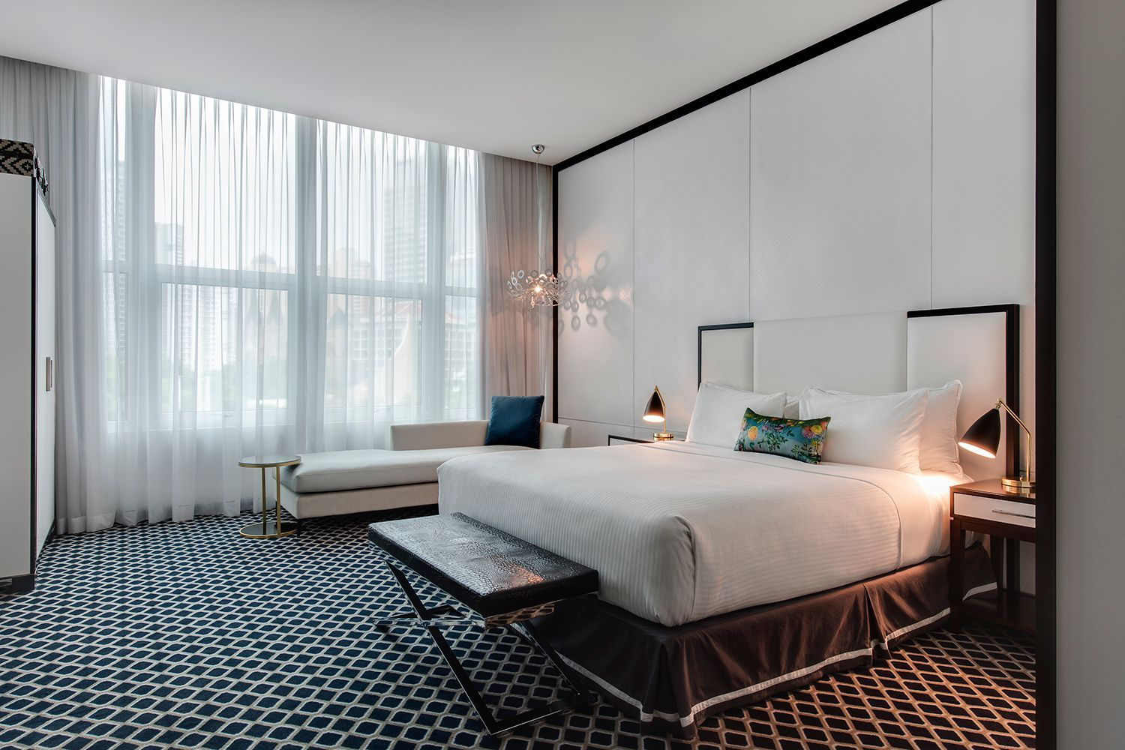

1. Ryan Thomas, CEO of MyHolidays.com, says it is possible to travel with kids and stay on budget – if you know where to stay. “When my family travels to Fiji, we take advantage of resorts that allow kids to stay, play and eat for free when sharing a room with parents and using existing bedding,” he says.
2. You often pay a premium to stay in the city centre of any country. But not Flight Centre general manager Brent Novak. “In most parts of the world, like Paris or Rome, public transport to city centres is cheap and dependable – especially trains,” he says. “Going suburban and ‘commuting’ is the perfect way to see more of a city for less.”
3. Travel expert Dana Brown, from Wild Hearted World, found you can save hundreds on rental accommodation by booking direct with a property management company over a rental platform. “I was booking two nights in the Hunter Valley for my group of friends and I found one property for $3100 on Airbnb, but I checked directly with the property management company and managed to save $1000,” she says. “That’s a lot of wine in the Hunter Valley.”
4. Aliisa Frassetto of Expedia finds good value lies in local knowledge. “Nothing beats a local recommendation and that’s why I always speak to the concierge,” she says. “They can also help you find the best value places to eat, cheap days at museums, free walking tours and more.”

## ****TRANSPORT****



1. Usually the word “pass” comes with some bonuses and this is exactly what Finder’s travel expert Angus Kidman found when he booked the NSW Discovery Pass, which helped him visit regional centres such as Wagga Wagga, [Canberra](https://www.delicious.com.au/drinks/bars-pubs/gallery/best-bars-canberra-2/4wlevoep), Port Macquarie and Tamworth. “A six-month first class pass costs $550, but I’ve regularly got more than $1200 worth of travel from it over that period.”
2. Public transport in some cities can be daunting, especially fresh off the plane from the airport, but it is always cheaper than a taxi or Uber, says SkyScanner’s Laura Lindsay. “In Lisbon I hopped on the local metro and the direct Aeroporto-Saldanha line takes you to downtown Lisbon in about 20 minutes, with a ticket only costing €1.50 compared to a €30 taxi.”
3. Daniel Finch of Wotif always checks if it’s cheaper to hire a car at the airport or city before booking. “Sometimes a quick taxi to the city before picking up the car might save you money, and other times the airport is the best option,” he says. “The Wotif team looked into it and… data indicates renting your car from the airport was more cost-effective, approximately 15 per cent cheaper.”
4. It can be easy to overpay at the car hire counter, but Peter Hosper of travel management company ATPI has one sure way to save every time. “You usually have a substantial excess in case of damage to the car but instead of paying up to $40 per day to waive it, simply take out travel insurance,” he says. “Or check with your credit card provider if you have travel insurance attached to your card.”

***Related story:***[***How I learned to love Canberra (and ate very well in the process)***](https://www.delicious.com.au/travel/australia/article/learned-love-canberra-thanks-thriving-food-scene/ubbqu4c9)

## ****MONEY****

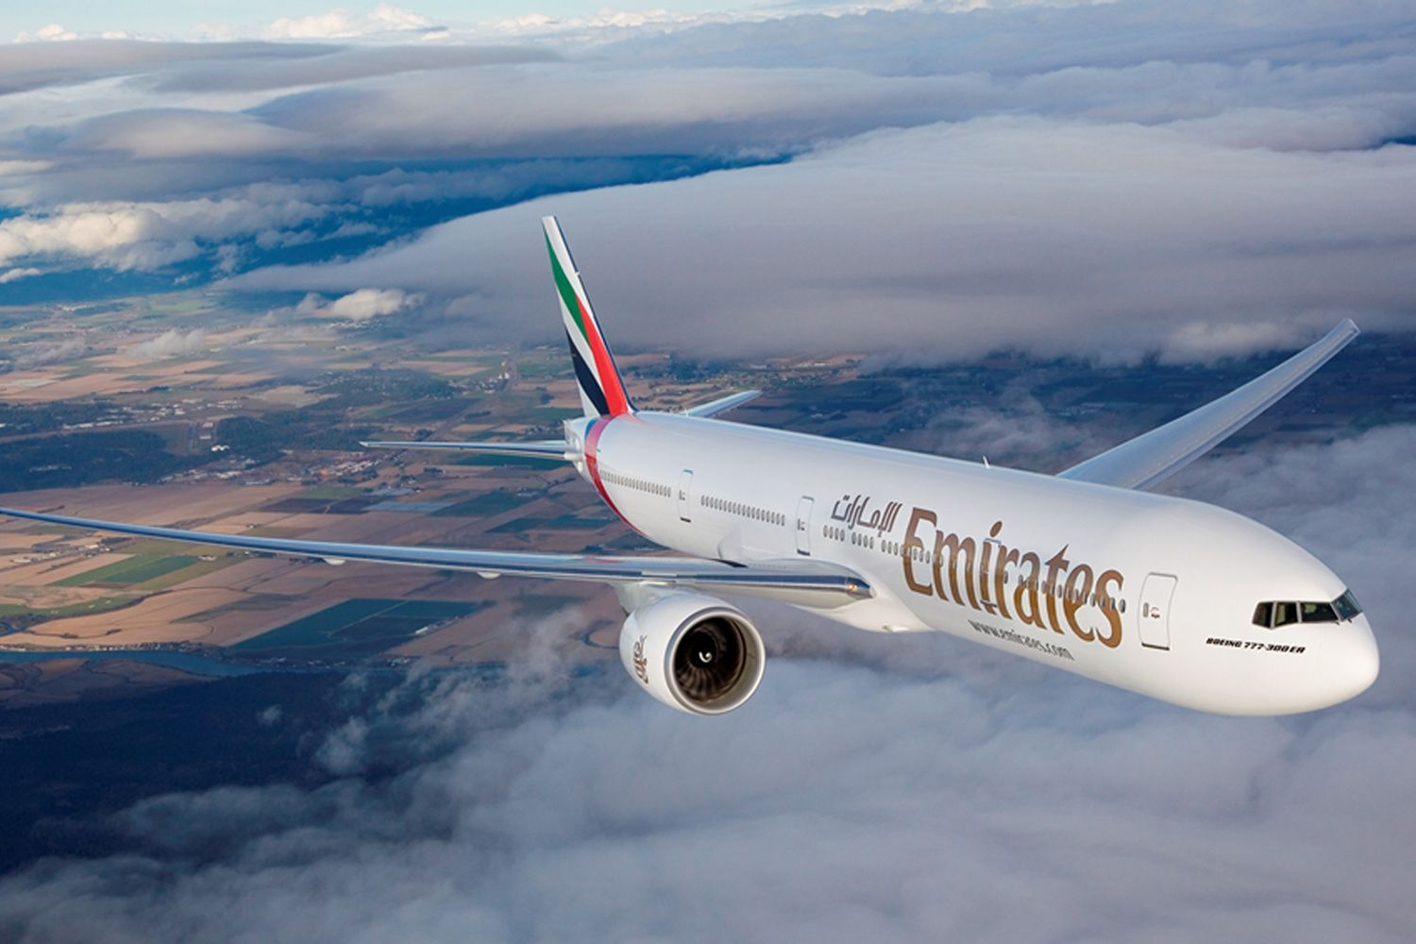

1. Using your debit or credit card overseas can add hundreds to your holiday, but not for Janeece Keller of FamilyTravel.com.au. “Use a global money account,” she says. “You can access your spending money in the local currency (or USD if the local currency isn’t supported) and save on the exchange rate and international transaction fees. On a 10-day international trip it can save you well over $100.”

## ****BOOKING****

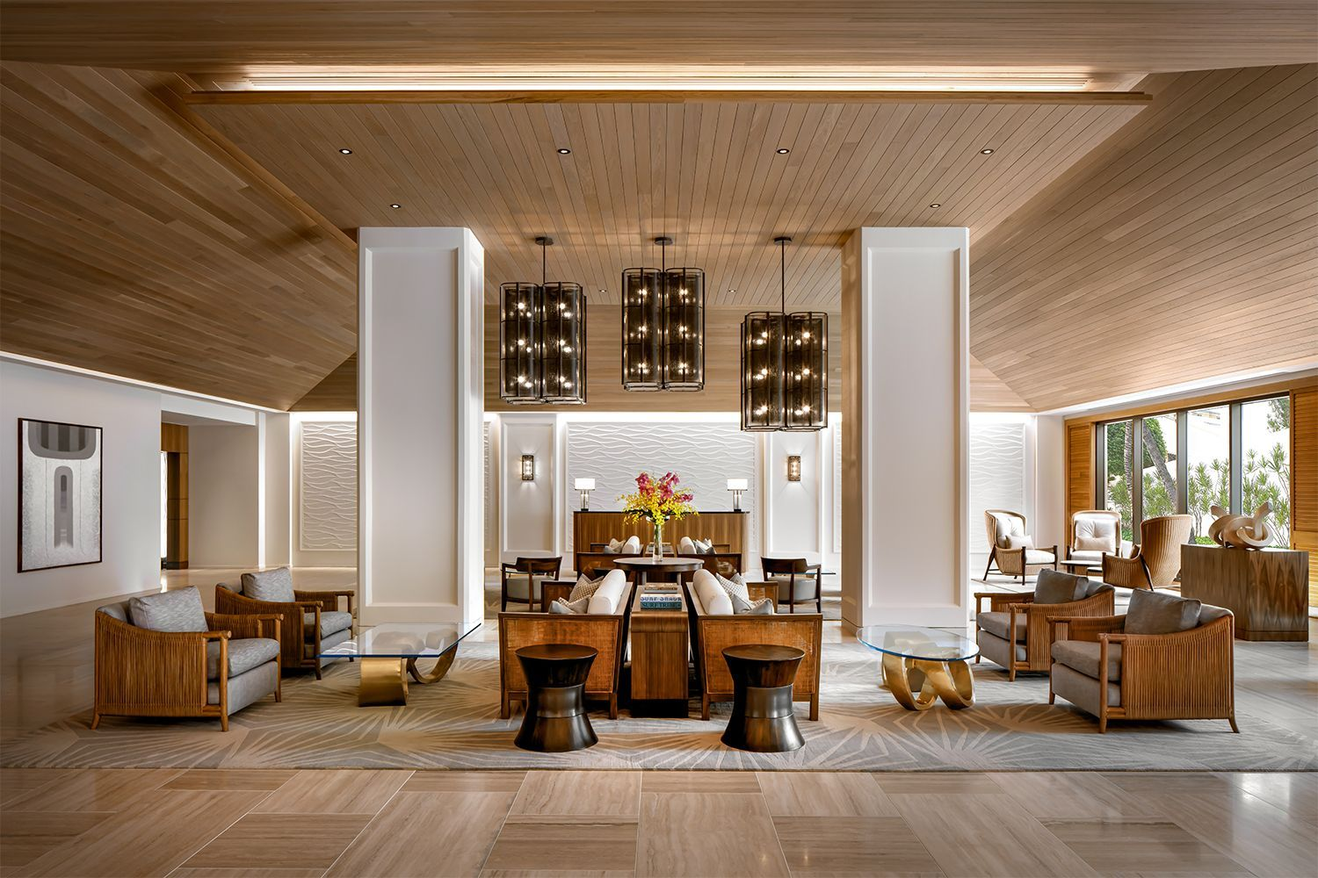

1. We’ve all heard that it can pay to book early and Anna Shannon of Travel Agent Finder wouldn’t travel any other way. “By booking a river cruise holiday with an air promo deal one year in advance, I was able to secure business class flights on a top airline return to Europe for $2999 per person,” she says. “People booking their flights a month out from departure were paying this price for economy because the planes were full.”
2. We all know that we can save money by travelling outside the busy Christmas period but Luxury Escapes co-founder Adam Schwab takes that rule one step further. “Most destinations are highly seasonal so you can pick up incredible deals to Thailand in July, Vietnam in late January or [Fiji](https://www.delicious.com.au/travel/international/gallery/best-fiji-restaurants-experiences-foodies-revealed/5w5dqxhy) in November,” he says. “You can save a huge amount if you travel during off seasons.”
3. Brendon Cooper, head of travel at Inspiring Vacations, can’t go past a coach tour for savings. “They really are excellent value when you consider it covers all transport, accommodation and sightseeing,” he says. “Comfortable three-star coach touring can be as little as $140 per person, per day in Europe and [Japan](https://www.delicious.com.au/travel/international/gallery/go-japan-tokyo-hokkaido/ff0ziewj), which has saved me hundreds of dollars per day.”

## ****DINING****

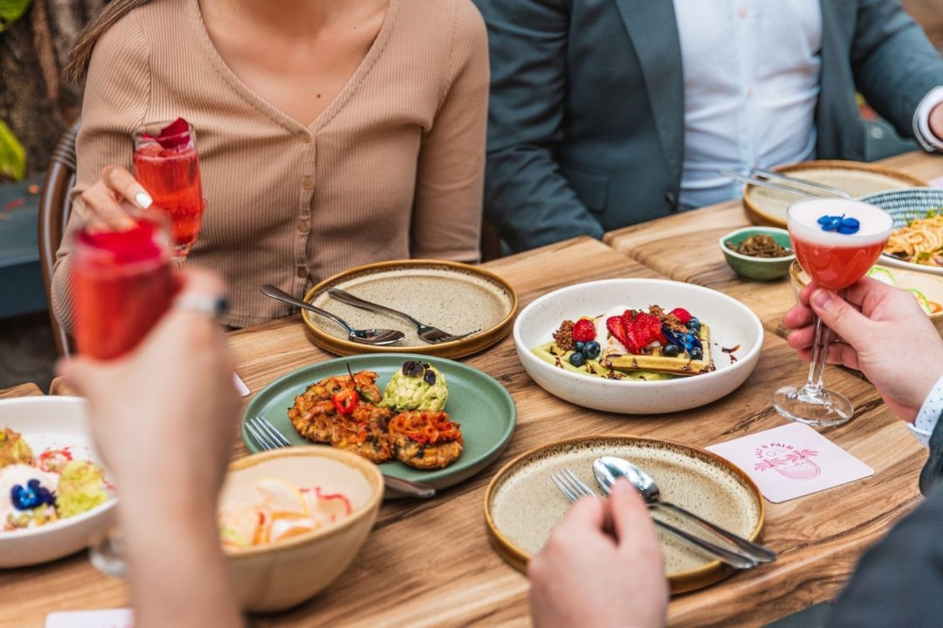

1. For Escape’s editorial director, Kerrie McCallum, often the best and most affordable food is found outside the restaurants. “I always research the best produce markets nearby and take a stash of snacks and lunch goods back to my room, in particular in Italy where you can find fabulous deli cuts, meats, cheese, great bread, cheap fruit and veg.”
2. Escape’s lists editor David Smiedt says it pays to be the early bird in some cities. “If you’re happy to sup before the sun goes down and be surrounded by people called Ernie, wearing denim shorts, there are massive savings to be had, especially in places like Miami, USA.”

# In Idaho, R & R means rapids and relaxation

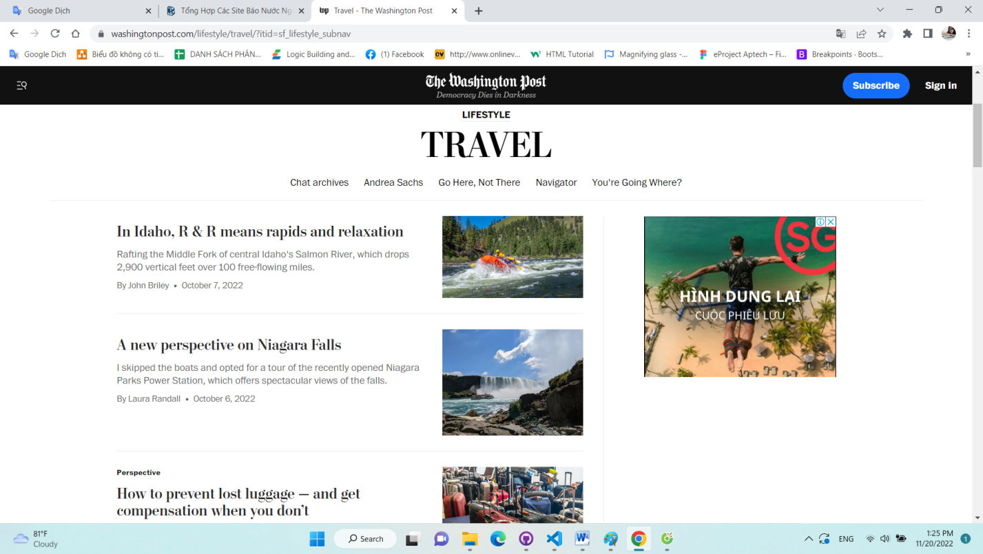

**[In Idaho, R & R means rapids and relaxation](https://www.washingtonpost.com/travel/2022/10/07/white-water-rafting-idaho-travel-vacation/)**

# Rafting the Middle Fork of central Idaho's Salmon River, which drops 2,900 vertical feet over 100 free-flowing miles.

By John Briley

October 7, 2022 at 8:00 a.m. EDT

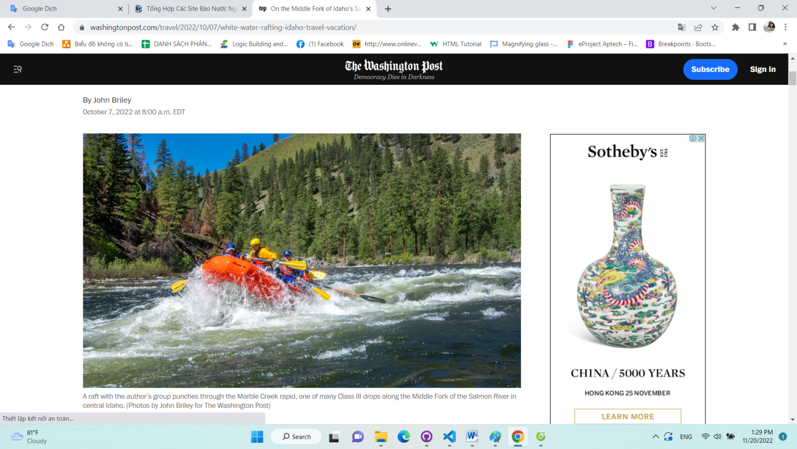

*A raft with the author’s group punches through the Marble Creek rapid, one of many Class III drops along the Middle Fork of the Salmon River in central Idaho. (Photos by John Briley for The Washington Post)*

Listen

13 min

Comment

14

Gift Article

Share

Nacho Libre knows rivers. Okay, maybe not the real Nacho, but definitely my friend Kurt, who has kayaked all over the world and is standing before me, cocktail in hand, dressed as the fictitious Mexican wrestler. We’re at a campsite along the Middle Fork of the Salmon River in central Idaho, and Señor Libre is on a roll.

“This is one of the best — if not *the* best — river trips in the country,” he says of the Middle Fork, which cleaves through the alpine forest, high desert and shadowy gorges of the 2.4 million-acre Frank Church-River of No Return Wilderness. We are here in mid-June with my wife, Cathleen, and 21 friends, many from the University of Colorado at Boulder, Class of ’80-something, on a five-day guided run of the river, which drops 2,900 vertical feet over 100 free-flowing miles and serves up a steady parade of Class III and IV rapids; Kurt and two others are kayaking while the rest of us are riding rafts.

“It’s the gradient, the scenery, the fact that there’re no dams,” Kurt continues, sweeping his drink across a view that features towering ponderosa pines, the luminous currents of the river and a hatch of caddis flies rising like dust into columns of sunlight. In short, the Middle Fork is a portal into bygone eras of natural purity, Native American and frontier history, and near-zero connectivity with the outside world. No cell reception, no roads, no evidence of the modern world.

[*In Northern Idaho, two ‘epic’ bike routes showcase the success — and potential — of the rails-to-trails movement*](https://www.washingtonpost.com/lifestyle/travel/bike-routes-montana-idaho-rails-trails/2021/08/05/874db136-f0a1-11eb-81d2-ffae0f931b8f_story.html?itid=lk_interstitial_manual_6)

Still, at the put-in, it’s hard to fathom we’ll have any peace over the coming days. Two dozen rafts are tied up along the shore, and teams are ferrying oars, dry bags and coolers from a dirt parking lot down a 100-foot wooden ramp to the boats. Shuttle buses steer around a frenzy of guides in frayed ball caps, clients struggling into wet suits and kayakers waiting for breaks in the action to shoulder their boats down to the water.

But minutes after we shove off into a chilly drizzle at elevation 6,000 feet, civilization feels very far away. The river sluices through a misty forest of lodgepole pines and Douglas firs, many skeletonized by wildfires, and starts into five miles of nearly continuous rapids.

Fortunately, we appear to be in capable hands. Our lead guide, Jamie Zahner, 56, a shaggy, ursine outdoorsman, has been running the Middle Fork for 20 years, the past 10 with our outfitter, [Middle Fork River Expeditions](https://www.idahorivers.com/). Standing in the company’s warehouse the night before our departure, Jamie impersonates a raft, a paddle, a variety of client prototypes, a leaning ponderosa pine tree (beneath which we’re instructed not to camp), the wind and the river itself as he preps us for the week ahead.

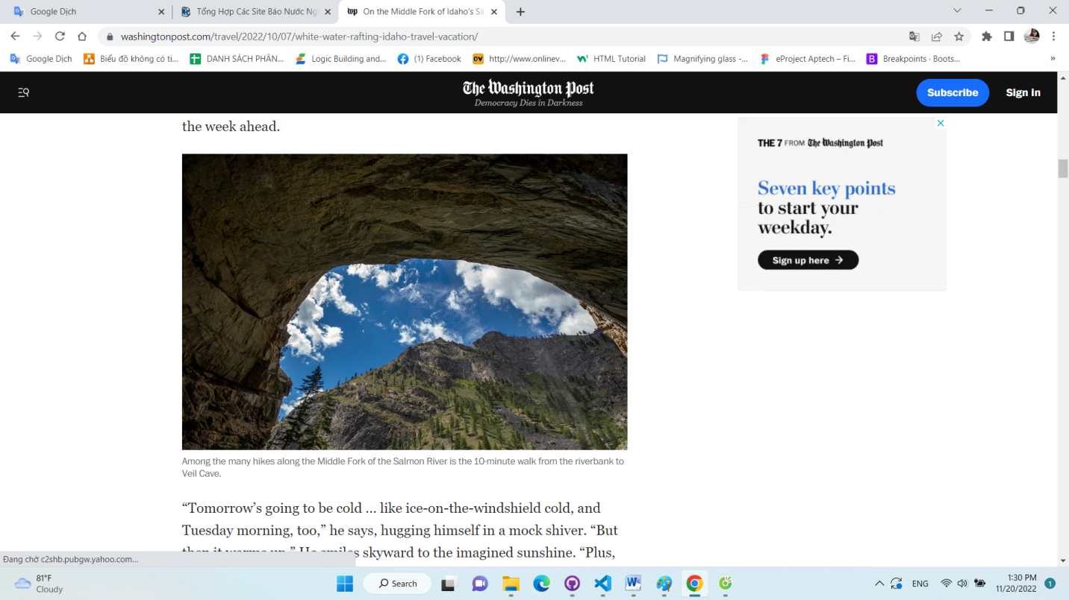

*Among the many hikes along the Middle Fork of the Salmon River is the 10-minute walk from the riverbank to Veil Cave.*

“Tomorrow’s going to be cold … like ice-on-the-windshield cold, and Tuesday morning, too,” he says, hugging himself in a mock shiver. “But then it warms up.” He smiles skyward to the imagined sunshine. “Plus, the river’s at a fun level right now, really cooking. You all know what to do if you see your buddy falling off a raft?” Jamie teeters, windmilling for a saving hand. “So pay attention. You fall in and it might be a while before we can get to you.”

Among our other six guides: Sadie Grossbaum: 31, gold dreadlocks, five months pregnant, works winters as a predator tracker, heading into Idaho’s snowy wilds at 2 a.m. to stalk mountain lions and wolves; Madeline Martin, a lithe 29, enjoys snorkeling in freezing rapids and teaches winter avalanche safety courses in Fernie, British Columbia; and Mark Martin (no relation to Madeline), fit, bearded and 38, encyclopedic knowledge of river life, moonlights as a conservation advocate. All our guides are trained in emergency response, wilderness medicine and swift-water rescue, and they could no doubt survive weeks in the backcountry on sticks, leaves and a handful of ants.

We, of course, could not. And so lashed to our armada are an embarrassment of clothes, food, booze, kitchenware, tents, sleeping bags and camp chairs, and the vital necessities: musical instruments, costumes, glow-in-the-dark bocce balls and hula hoops.

[*Consider Teton Valley over Jackson Hole*](https://www.washingtonpost.com/lifestyle/travel/teton-valley-jackson-hole-travel/2021/10/20/6fda096c-2dfc-11ec-8ef6-3ca8fe943a92_story.html?itid=lk_interstitial_manual_18)

Shortly after launch, we hit a train of six-foot standing waves that explode over the bows, smacking us with a 45-degree wake-up call. (The Middle Fork is fed predominantly by snowmelt, especially in spring and early summer.) It is indeed gasp-inducing cold, and the rapid doesn’t so much end as settle into a mile-long Class II/III ramble that culminates in Murph’s Hole, a Class III/IV pour-over with a habit of flipping even heavily loaded rafts.

We encounter no such drama, although John McKinney — who is audaciously kayaking the Middle Fork following a 15-year break from boating — takes the first of a few swims he’ll endure after failing to roll his boat upright in rapids.

At Mile 13, we reach our first camp, form a fire line to unload the rafts, disperse to pitch our tents and return to find that the guides have set up the kitchen and bar, complete with hors d’oeuvres, and built a fire. They have also, at the end of a very private trail, set up the “groover,” a five-gallon bucket with a toilet seat and a stellar view.

After dinner, and after Cathleen and I follow a whisker of trail in the fading daylight up to a rocky moraine with steam rising from its far border, and after we sink into a 106-degree hot spring beneath ambling clouds and piercing stars — after all that, on our return to camp, we hear the faint strains of live music. It’s my friend Dan Rubinoff — a tall, scraggly-haired hippie — on acoustic guitar, and his partner, Joice Moore, playing a bass plugged into a toaster-size, battery-powered amp.

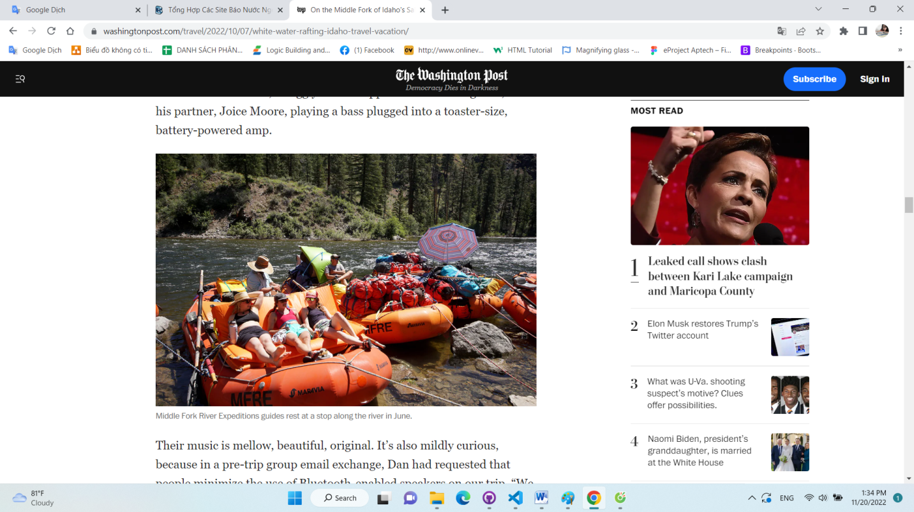

*Middle Fork River Expeditions guides rest at a stop along the river in June*.

Their music is mellow, beautiful, original. It’s also mildly curious, because in a pre-trip group email exchange, Dan had requested that people minimize the use of Bluetooth-enabled speakers on our trip. “We are traveling a long way to be in one of the most incredible remote wilderness areas left in the country,” he wrote. “We spend a lot of time on rivers and prefer the natural sounds that those areas give us.” He signed off, “Love ya, Rube.”

When I ask him about the seeming contradiction, he doesn’t blink. “People have been making live music around campfires for thousands of years,” he tells me. So even though Joice’s bass is amplified, “it’s totally different” from piping canned music from a phone through a speaker. Fair enough, brother.

The next morning, hot coffee in hand, I listen to those natural sounds — the timeless wash of the river, the calls of osprey, canyon wren and western tanager, the wind through the pines — while watching fog billow down the mountainside.

We’re slow to break camp, but nobody seems to care: The Middle Fork is clipping along at 5,500 cubic feet per second — by late summer, it will drop well below 1,000 CFS — and we should reach our next camp with time to spare. However, the severe terrain and ever-changing weather here can scuttle even the best-laid plans.

In 2006, not far below our first camp, a natural dam broke high on the riverbank, sending a massive flow of fallen trees, soil and rocks into the river at Lake Creek — where a rapid had been created only a few years prior by a similar debris flow. In the 2006 breach, a mess of logs washed a half-mile downstream before sealing off one of the Middle Fork’s marquee rapids, Pistol Creek.

“We had groups backed up for three days,” Jamie tells me in Camp 2 as he flips (wild-caught Alaskan) salmon filets over the fire. “Hundreds of people. We all just sat there until the Forest Service showed up with dynamite and cleared it out.”

Pistol today is striking — a plunging, narrowing S-turn with a lateral current that, Sadie warns us as we approach it, endeavors to smash us into a rock wall on river left and, if things go poorly, bounce us into a massive, churning hole. (With a few well-timed oar strokes, she reduces the smash to a nudge and the hole to a roadside attraction.

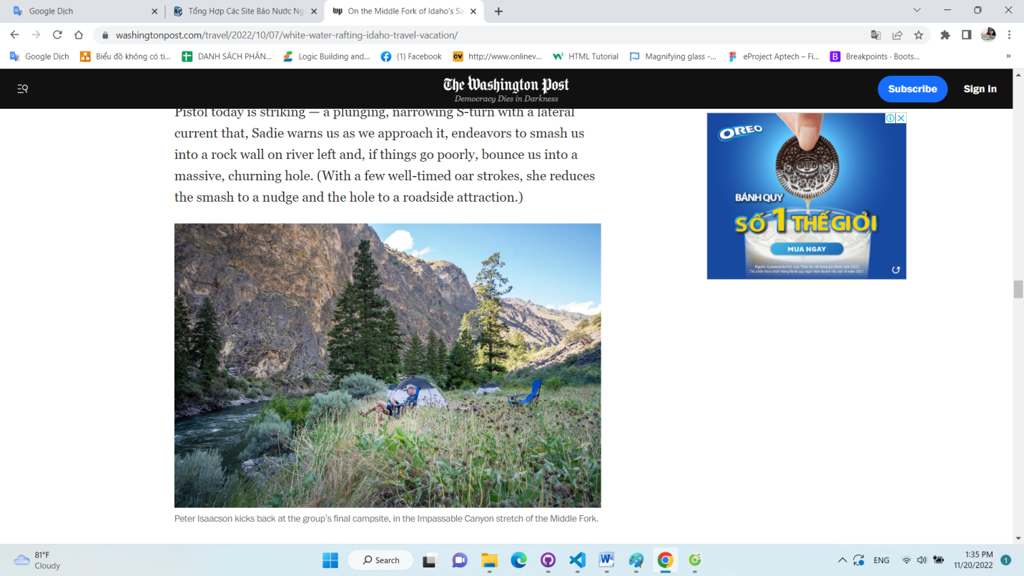

*Peter Isaacson kicks back at the group’s final campsite, in the Impassable Canyon stretch of the Middle Fork.*

The first recorded run of the Middle Fork occurred in 1926; filmmaker Henry Weidner canoed it, taking four months and shooting 800 reels of film for a nature documentary. The first descent in a rubber raft followed in 1929, but recreational trips didn’t take off until after the signing into law of the 1968 Wild and Scenic Rivers Act. The Forest Service started issuing permits to outfitters in the 1970s, and the industry continued to grow after the 1980 designation of the area as wilderness. And although new development is prohibited in wilderness areas, the Frank Church-River of No Returncontains active airstrips for small planes and a few old ranches and miners’ cabins, all of which predated the wilderness designation.

What also predated that, of course, were the 10,000 years that the Shoshone Indians and other tribes lived here, subsisting on bighorn sheep (which still thrive here) and native salmon (which don’t), before their forcible removal by the U.S. Army in the late 1800s. At various stops, we see remnants of the Indians’ time — rounded depressions, mostly, which served as firepits inside their teepees, along with an obsidian arrowhead that Mark finds at our second camp.

Day 3 carries us through some of the week’s calmest pools, but even here there are highlights: our bright orange rafts drifting dreamlike over crystalline green waters, a waning moon rising over a ridge, Rube actually mooning me from a raft as I take my 200th photo of the day.

From our third camp, in a massive grove of ponderosas, Cathleen and I run a trail two miles downriver, through forest, meadow and sage, before turning up Loon Creek, which pours forth from the mountains in a turquoise cascade. This delivers us to the nicest hot spring of the week, a 6-by-15-foot log-and-earthen berm within steps of the creek.

Upon our return, we confirm that we are in fact in ursus country. We are playing music — Dan, Joice, Cathleen, our friends Ned and Bill, and I — when two bears,one green and one blue, twirl into the clearing. They pose no threat, other than demanding danceable tunes, and are trailed by Nacho Libre, a pregnant nun and Groucho Marx.

And if you’re thinking that a costume night in the wilderness is needlessly indulgent, please note that the following evening, our guides break out *their* masquerade assortment — a feature, they assure us, of every trip. As a fierce windstorm strafes the gorge and we scatter to batten down our tents, I catch a glimpse of a lion, a Nordic queen and Pippi Longstocking calmly cooking us dinner.

By Day 4, we’ve dropped into the mountain mahogany, juniper and parched, treeless hillsides of the high desert. We’ve also arrived in summer, with highs in the 80s, cloudless skies and, for some of us, tentless nights beneath the spangled heavens.

That afternoon, we beach the boats and walk to a wall adorned with Shoshone petroglyphs, including one of a dude squaring off against bighorn sheep. From here it’s a 10-minute float to camp, but the guides give us the option to hike while they deadhead the rafts. We follow switchbacks up to a rocky ridge with bird’s-eye views of the river 800 feet below, as it hews through an entrancing landscape — groves of riverside pines, wildflower-laced meadows and craggy summits, all swaddled in dazzling sunbeams.

On the last morning, we break camp by 8 a.m. and file downstream as the river squeezes between the 3,000-foot-high slabs of Impassable Canyon, so named because there are no roads or trails in this some 20-mile stretch of charging white water. Coming around a bend, I spot a flash of bright red on a riverside rock — McKinney, I suspect, emptying his kayak after a swim. But as we draw near, the form reveals itself: Nacho Libre in his cape, mask and shiny high-top boots, standing one-legged and holding his kayak paddle-spear-like, as if posing for a petroglyph.

He is facing upriver, an inveterate white-water miner, basking for one more moment in the glow of the mother lode.

*Briley is a writer based in Takoma Park, Md. His website is*[*johnbriley.com*](http://www.johnbriley.com/)*.*

##### If You Go

### Where to stay

**Triangle C Cabins**

1 Benner St., Stanley, Idaho

208-774-2266

[*triangleccabins.com*](http://triangleccabins.com/)

Simple log cabins — with heat, air conditioning and full bathrooms — on a 2.5-acre property about a half-mile from the center of Stanley and a three-minute walk to Middle Fork River Expeditions’ main warehouse. Cabins from $204 in rafting season; two-night minimum on weekends.

### What to do

**Middle Fork River Expeditions**

915 Eva Falls Ave., Stanley

800-801-5146

[*idahorivers.com*](http://idahorivers.com/)

Middle Fork River Expeditions runs six-day trips on the Middle Fork and main stem of the Salmon River from late May through September. It also offers fly-fishing trips and “musical adventures” featuring professional musicians. Most trips are in oar boats with one paddle raft, although clients may rent inflatable kayaks or stand-up paddleboards (Main Salmon only), or bring their own hard-shell kayaks. Trips from $1,899 (Main Salmon) and $2,599 (Middle Fork) per adult, with discounts for ages 16 and under and for large groups; cost includes tents, sleeping bags and pads, dry bags, wet suits and meals.

# A new perspective on Niagara Falls

I skipped the boats and opted for a tour of the recently opened Niagara Parks Power Station, which offers spectacular views of the falls.

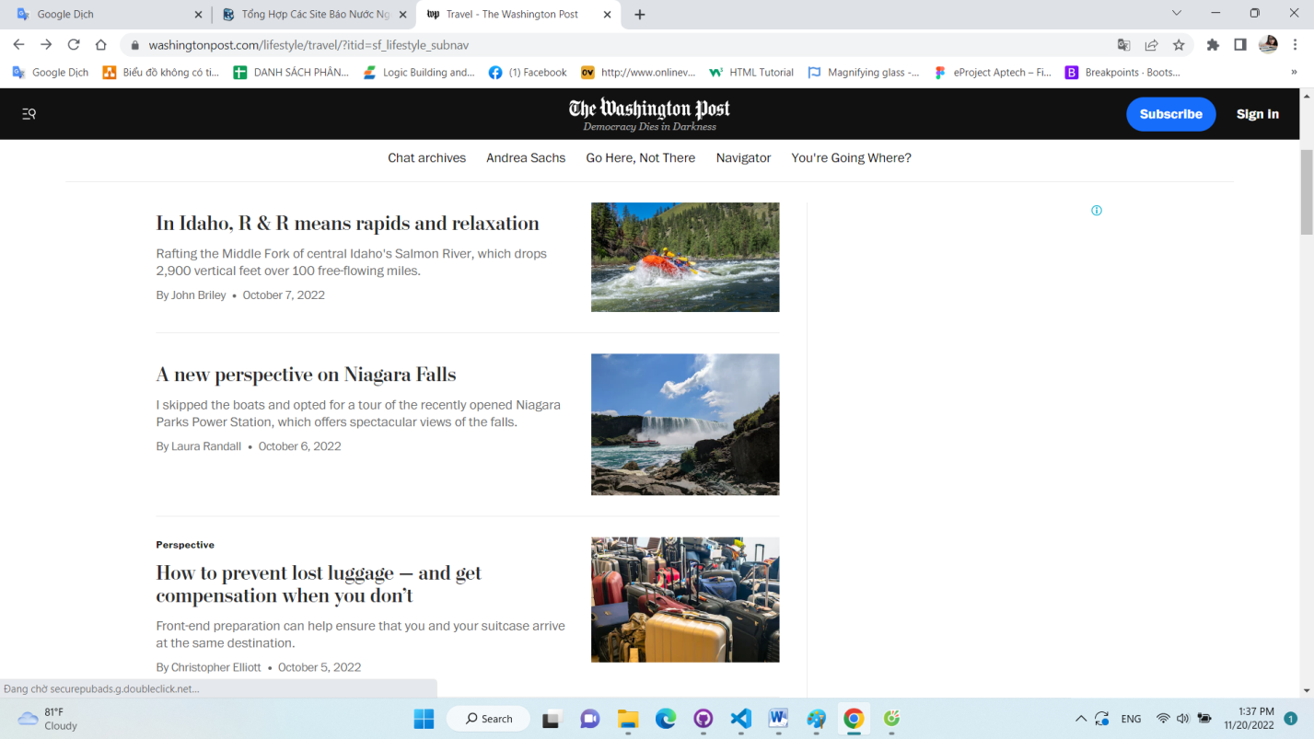

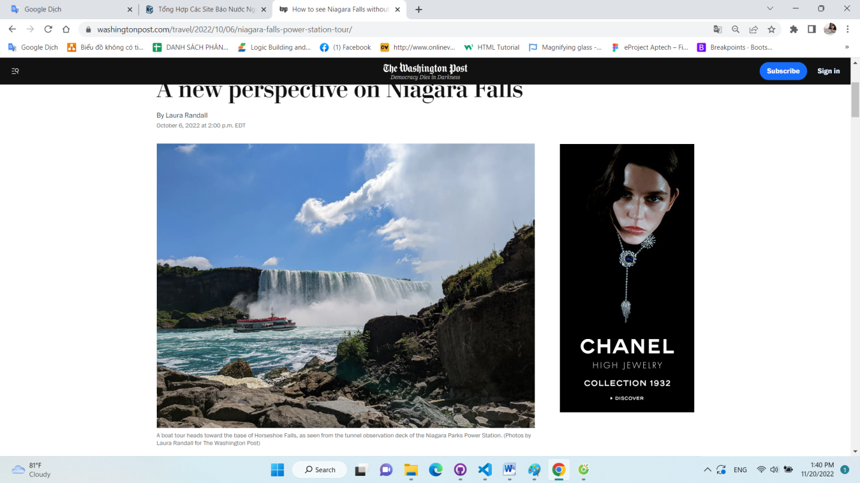

*A boat tour heads toward the base of Horseshoe Falls, as seen from the tunnel observation deck of the Niagara Parks Power Station. (Photos by Laura Randall for The Washington Post)*

Listen

8 min

Comment

12

Gift Article

Share

For more than a century, the imposing Beaux-Arts-style building perched beside Horseshoe Falls harnessed the fierce flow of the Niagara River to bring electricity to western New York and southern Ontario.

Now, Canada’s first major hydroelectric power station is the newest major tourist attraction on the Canadian side of the falls. Amid a sea of commercialized activities that include zip lines, casinos and a climate-controlled [SkyWheel](https://www.cliftonhill.com/attractions/niagara-skywheel), the [Niagara Parks Power Station](https://www.niagaraparks.com/visit/attractions/niagara-parks-power-station) offers visitors a unique perspective of one of the world’s most famous natural wonders.

Decommissioned in 2006, the power station sat idle for years until the [Niagara Parks Commission](https://www.niagaraparks.com/), the self-funded government agency that oversees the area, took over and set in motion a plan to bring it back to life as a tourist attraction. After a nearly $19 million renovation, the 65,000-square-foot main hall opened to the public in July 2021, followed a year later by a walkable tunnel that ends at a large platform with unparalleled views of the entire Niagara Gorge.

[*Near Niagara Falls, U.S. and Canadian forts from the War of 1812 still face off*](https://www.washingtonpost.com/lifestyle/travel/near-niagara-falls-us-and-canadian-forts-from-the-war-of-1812-still-face-off/2018/11/21/74fa6a7c-e8ef-11e8-a939-9469f1166f9d_story.html?itid=lk_interstitial_manual_6)

The viewing platform at the end of the tunnel was the finishing touch of the restoration and is a key step in understanding the hydroelectric process from start to finish. Visitors descend by glass elevator to the wheel pit, where they follow the same path the spent water once took on its way back to the lower Niagara River. Here, the close-up views of Horseshoe Falls emphasize the power of the water and how it was harnessed back in the 1900s to generate electricity.

### Pristine equipment

Beginning operation in 1905 using patents developed by Nikola Tesla and George Westinghouse, the facility is one of the few power stations from the early 20th century to close with all its equipment intact,said Marcelo Gruosso, senior director of engineering and parks operations at the Niagara Parks Commission.

The people who worked at the Canadian Niagara Power Co. “took exceptional care and pride in it,” he said. “Everything you could imagine was still there when it closed. They even left the drawing board.”

Gruosso and his team had access to 1,500 archival photos dating as far back as 1901, chronicling “every step of the build,” he said. That included the construction of a huge temporary cofferdam to divert the thundering water from the building site. More than a century later, workers used modern technology and tools to build a similar watertight enclosure to hold back the river so they could reinforce the walls.

Then there’s the marvel that is the tailrace tunnel (the channel that discharged the tailwater back to the river), built in the early 1900s with little more than pickaxes, shovels and rudimentary dynamite.

Engineers weren’t sure what they would find when they first explored the idea of opening the tunnel to visitors. They built a swing stage, a scaffolding platform akin to those used in high-rise window cleaning, that allowed them access to the cavernous space beneath the power station to assess the tunnel’s condition.

“Once we saw how incredibly good the condition of the tunnel was after 100 years of use, we said, ‘Okay, we definitely have a winner here,’ ” he said.

On a recent visit, a dozen or so visitors stood on the platform, basking in the sunny August morning and unobstructed views of the Niagara Gorge. Horseshoe Falls felt stunningly close, its rushing water a soundtrack that invited lingering. The [Maid of the Mist](https://www.maidofthemist.com/) and [Hornblower](https://www.toniagara.com/tours/hornblower-voyage-to-the-falls) boat cruises, long a fixture of Niagara tourism, barreled past, carrying poncho-clad passengers to and from the base of the falls.

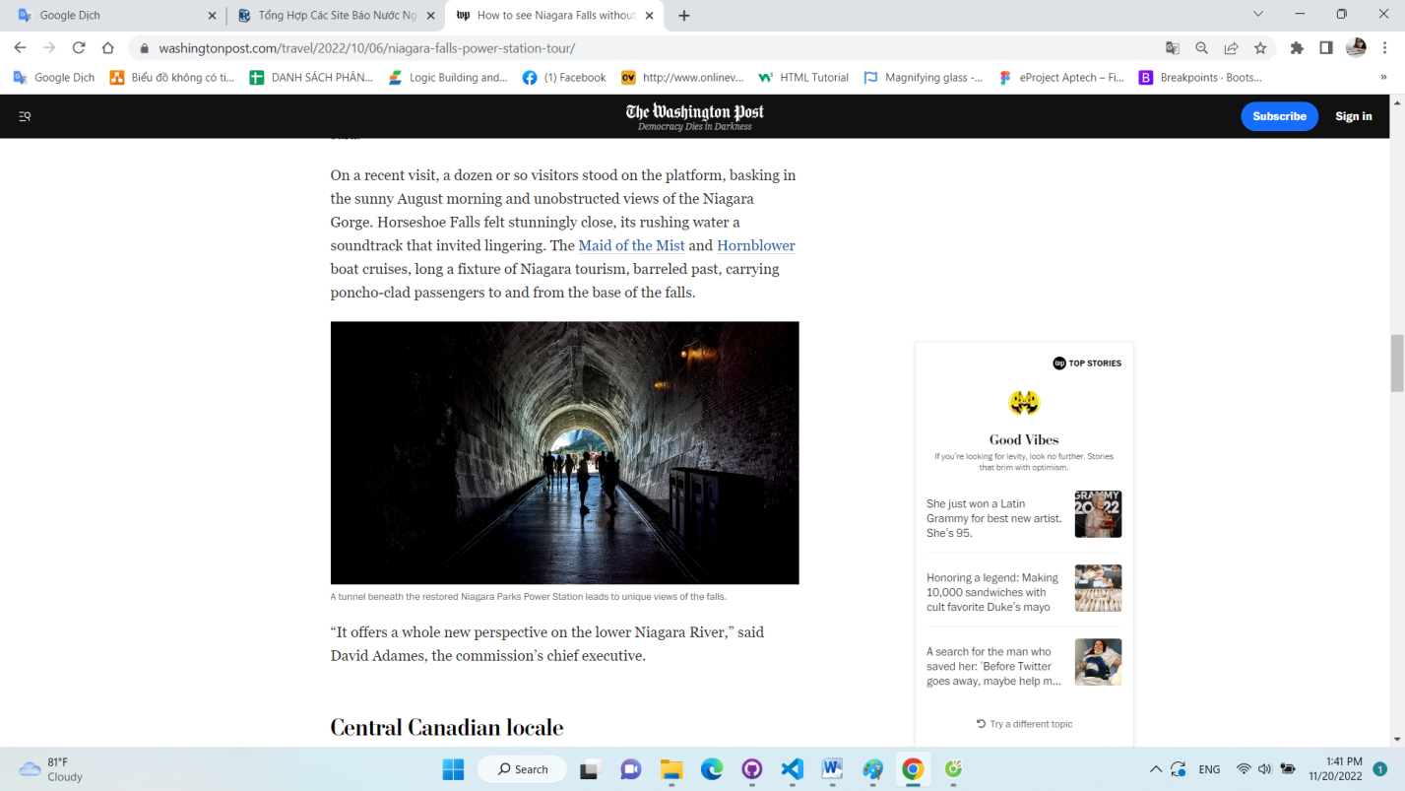

*A tunnel beneath the restored Niagara Parks Power Station leads to unique views of the falls.*

“It offers a whole new perspective on the lower Niagara River,” said David Adames, the commission’s chief executive.

### **Central Canadian locale**

The power station is an easy walk from [Table Rock Centre](https://www.niagaraparks.com/visit/welcome-centres/table-rock-centre/), a prime shopping and eating hub in [Queen Victoria Park](https://www.niagaraparks.com/visit/nature-garden/queen-victoria-park/), yet it feels far removed from the bustling, selfie-taking crowds that tend to dominate the area. A landscaped walkway leads past a key piece of hydroelectric equipment known as an exciter unit (now a blue-and-white art installation) to the main entrance. It’s the first hint that the experience ahead might go beyond a typical nuts-and-bolts engineering tour.

Inside, the light-filled “generator hall” features 51 large arched windows, limestone and granite floors, and the original 14-foot-high red-brass doors, each weighing 3,500 pounds. Interactive exhibits, vintage photographs and repurposed artifacts show how the water entered the building via a 575-foot-long forebay, then flowed through huge steel tubes known as penstocks to spin the blades in turbines that powered the generators to produce electricity.

[*A six-province jaunt through Canada provides a chance to revel in the classics*](https://www.washingtonpost.com/travel/2021/10/22/top-places-visit-canada-reopening/?itid=lk_interstitial_manual_27)

Visitors can opt for a self-guided or guided tour of the power station’s main hall, which intersperses history exhibits with interactive displays and original equipment such as motorized oil switches, giant wrenches and all 11 alternating-current generators (painted a striking robin’s-egg blue). Computerized screens hooked up to an original control panel let children test their hydropower knowledge and solve simulated emergencies. There are also exhibits detailing Nikola Tesla’s groundbreaking inventions and his famous DC vs. AC “currents war” with Thomas Edison; a paean to female scientists and staffers; and a scale model of the plant as it looked during peak operation.

The gift shop is also a must-see, not only for its eclectic selection (Tesla socks, upcycled beer glasses, triple-gear wall clocks), but also for its location beside a 100-foot section of the original forebay, where water from the Niagara River first entered the power station. Visitors can peer over a glass protector to observe the inner forebay, which, through underwater arches, filtered the incoming water into the plant before it churned through the penstocks.

Giant turbines showcase Ontario's power-generating history in the main exhibit hall of the Niagara Parks Power Station.

In the evening, the power station hosts “[Currents: Niagara’s Power Transformed](https://www.niagaraparks.com/visit/attractions/currents-niagara-night-show),” a sleek, highly immersive light-and-sound show that brings the machinery to life through music, special laser effects and 3D mapping and imagery.

About 200,000 people visited the power station in its first year of operation, according to the commission. With the tunnel’s opening in July, officials expect the number to grow to 300,000 to 350,000 annual visitors, thanks in part to the attraction’s ability to appeal to a wide range of interest levels, said Adames, the CEO.

“There are so many stories to tell, starting with those who are simply curious about what’s behind those beautiful stone walls,” he added. “There’s the story of hydroelectric generation, the story of innovators at the turn of the century, the human story of the people who worked in the plant and the competition of the people building [power] plants on both sides of the border. It has all of it.”

*Randall is a writer based in Los Angeles. Her website is*[*authorlaurarandall.com*](https://authorlaurarandall.wordpress.com/)*.*

##### If You Go

**Niagara Parks Power Station**

7005 Niagara Pkwy., Niagara Falls, Ontario

877-642-7275

[*bit.ly/niagara-power-station*](https://www.niagaraparks.com/visit/attractions/niagara-parks-power-station)

The Niagara Parks Power Station was Canada’s first major hydroelectric plant; it’s now a tourist attraction with interactive exhibits and repurposed equipment showing visitors how the power of the Niagara River was harnessed to generate electricity.Open daily at 10 a.m.; closing times vary. Check website for details. Regular admission about $20 per person for ages 13 and up; about $14 for ages 6 to 12; and children 5 and under are free. Guided tours and admission from about $28 per person ages 13 and up and about $19 per person ages 6 to 12. Night shows from about $22 per person for ages 13 and up and about $15 ages 6 to 12.

1. [A sunny new frontier: Senegal is offering bargain-basement winter breaks - and now you can fly direct](https://www.dailymail.co.uk/travel/escape/article-11444923/Senegals-offering-bargain-basement-winter-breaks-fly-direct-Tui.html)

Rob Crossan checks into the gargantuan Riu Baobab resort in Senegal. Tui has launched its first direct-flight, package-tour holidays to the African country, he reveals.

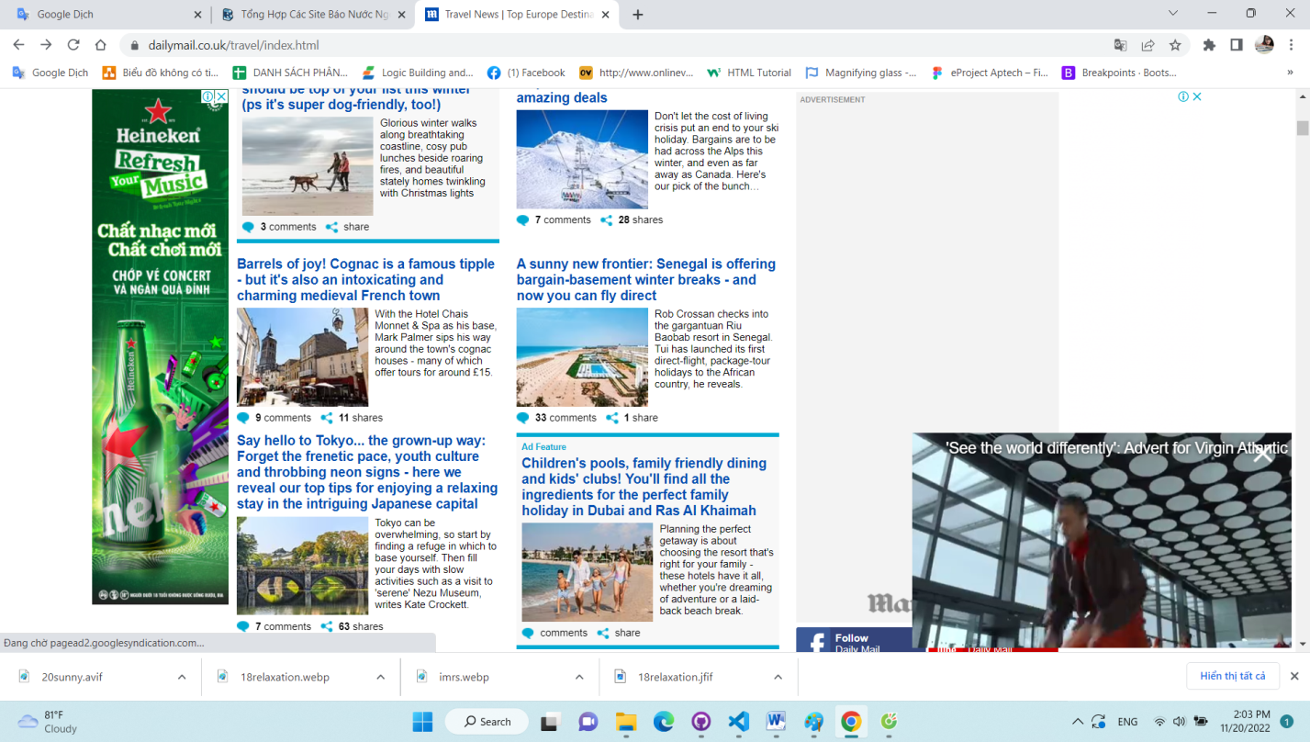

The creaking seems to be nothing more than the gentle listing of the wooden pirogue boat as it softly lolls on the green-tinged waters of the Sine-Saloum delta.

But the creaking is actually the sound of dinner in this coastal region of Senegal. What I can hear are oysters slowly opening their shells in cages submerged along the delta’s edge.

They are then caught and cooked by the Serer people, one of the dominant groups in this West African coastal region, which has just become a whole lot easier to access from the UK.

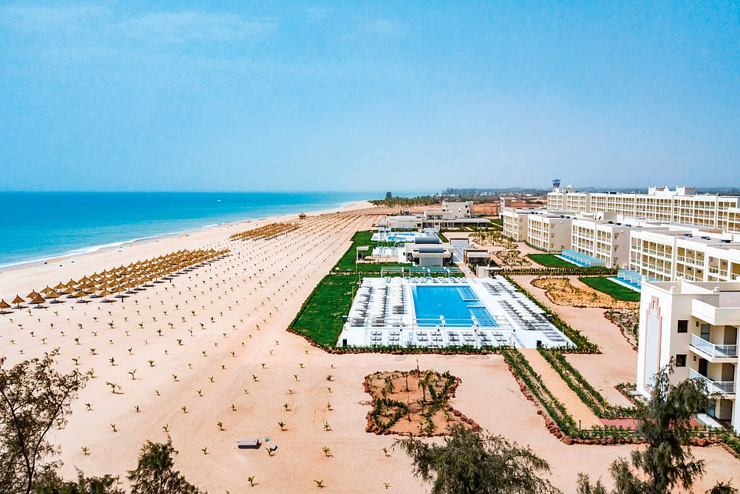

**+7**

View gallery

**Vibrant nation: Rob Crossan checks into the gargantuan Riu Baobab resort in Senegal. Tui has launched its first direct-flight, package-tour holidays to the West African country, he reveals**

British tour operator Tui has launched its first direct-flight, package-tour holidays to Senegal — a country where, up until now, tourism has been almost entirely made up of visitors from France, the colonial ruler of this vast nation until 1960.

ADVERTISEMENT

My experience of floating serenely through the Sine-Saloum Delta was probably the quietest moment I had in this vibrant West African nation.

## RELATED ARTICLES

* [Previous](https://www.dailymail.co.uk/travel/escape/article-11444923/Senegals-offering-bargain-basement-winter-breaks-fly-direct-Tui.html)
* [1](https://www.dailymail.co.uk/travel/escape/article-11444923/Senegals-offering-bargain-basement-winter-breaks-fly-direct-Tui.html)
* [Next](https://www.dailymail.co.uk/travel/escape/article-11444923/Senegals-offering-bargain-basement-winter-breaks-fly-direct-Tui.html)
* [**[](https://www.dailymail.co.uk/travel/travel_news/article-11439541/The-amazing-winners-2022-landscape-photography-contest-strict-rules-photoshopping.html)No 'deceptive' photoshopping allowed! The extraordinary...**](https://www.dailymail.co.uk/travel/travel_news/article-11439541/The-amazing-winners-2022-landscape-photography-contest-strict-rules-photoshopping.html)[**[](https://www.dailymail.co.uk/travel/travel_news/article-11324341/Flying-fur-st-class-TikToker-reveals-clever-hack-taking-dogs-flights-carry-luggage.html)Travelling fur-st class! TikTok influencer reveals clever...**](https://www.dailymail.co.uk/travel/travel_news/article-11324341/Flying-fur-st-class-TikToker-reveals-clever-hack-taking-dogs-flights-carry-luggage.html)[**[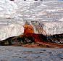](https://www.dailymail.co.uk/travel/travel_news/article-11435619/Twenty-amazing-facts-Antarctica-mysterious-realm-contains-90-Earths-ice.html)Revealed: Twenty amazing facts about Antarctica - the...**](https://www.dailymail.co.uk/travel/travel_news/article-11435619/Twenty-amazing-facts-Antarctica-mysterious-realm-contains-90-Earths-ice.html)[**[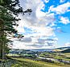](https://www.dailymail.co.uk/travel/travel_news/article-11434453/The-best-places-visit-2023-named-Lonely-Planet-South-Scotland-New-Mexico-make-cut.html)The 30 best places to visit in 2023: Lonely Planet names...**](https://www.dailymail.co.uk/travel/travel_news/article-11434453/The-best-places-visit-2023-named-Lonely-Planet-South-Scotland-New-Mexico-make-cut.html)[**[](https://www.dailymail.co.uk/travel/travel_news/article-11427869/Youve-shopping-wrong-Raymond-Blanc-cookery-school-director-benefits-FROZEN-PEAS.html)You've been shopping all wrong! Top chef reveals why FROZEN...**](https://www.dailymail.co.uk/travel/travel_news/article-11427869/Youve-shopping-wrong-Raymond-Blanc-cookery-school-director-benefits-FROZEN-PEAS.html)[**[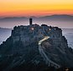](https://www.dailymail.co.uk/travel/travel_news/article-11408851/Secret-wonders-Book-Hidden-Places-reveals-little-visited-gems-Scotland-USA.html)Secret wonders of the planet revealed: Fascinating book...**](https://www.dailymail.co.uk/travel/travel_news/article-11408851/Secret-wonders-Book-Hidden-Places-reveals-little-visited-gems-Scotland-USA.html)

## SHARE THIS ARTICLE

Share

Riu Baobab resort is the fulcrum for Tui’s entry into Senegal: a white-washed behemoth with more than 500 rooms on the fudge-yellow sands of the Atlantic coast.

It’s around a 75-minute drive along the flat, acacia and scrub-dominated landscape from the international airport in the capital city, Dakar.

There are local touches to my room, with wooden masks and large black-and-white art prints of djembe drums on my wall.

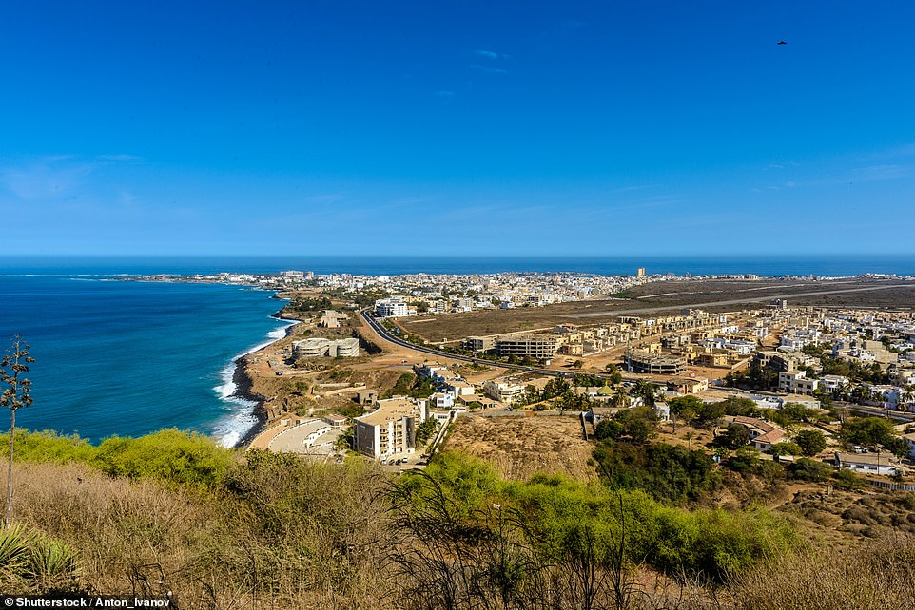

**+7**

View gallery

**The Riu Baobab resort is a 75-minute drive along the flat, acacia and scrub-dominated landscape from the international airport in the capital city, Dakar (above)**

Though this is far from a boutique safari-esque experience. The tubby, middle-aged men drinking lager and eating chicken nuggets in the swim-up alfresco bar remind me of a flooded Wetherspoons.

And although there are Senegalese options on the menu, the main restaurant buffet is predominantly stocked with British staples.

A winter temperature of 30c is one draw; another is the all-inclusive option (it works out from £116.50 per day, per person with all food and alcohol), which is remarkable value, especially factoring in the water slides for children, evening entertainment and live music.

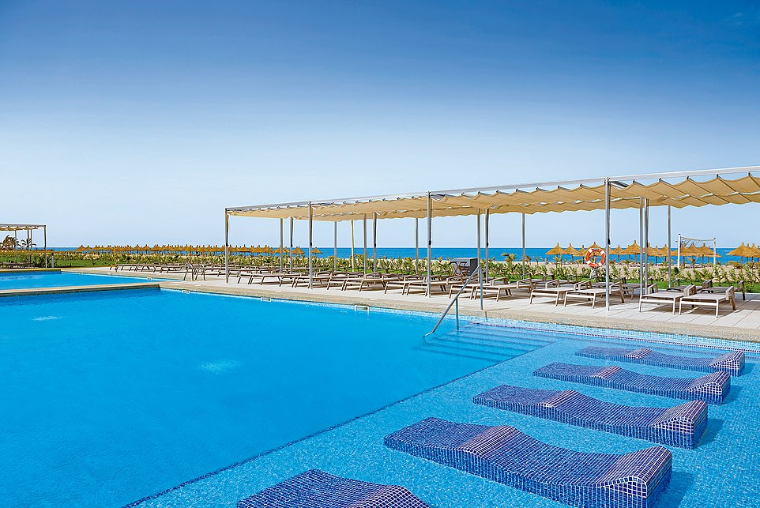

**+7**

View gallery

**Rob finds that there's a predominantly British crowd at Riu Baobab resort (above)**

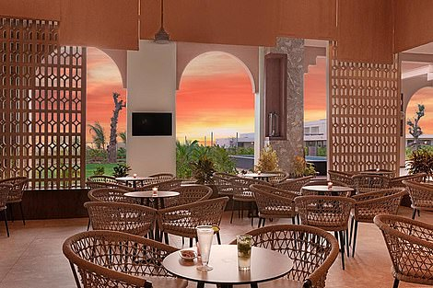

**+7**

View gallery

**Riu Baobab resort's all-inclusive option works out from £116.50 per day, per person with all food and alcohol**

The local infrastructure can be dodgy, as I find during a seven-hour power blackout one evening, which means eating our dinner and finding the way to our rooms by mobile phone light. But these appear to be teething problems borne with good humour by the predominantly British crowd.

If you’re used to the vast expanse of the Kruger National Park in South Africa or Chobe in Botswana, then you’ll probably consider the day trip to the nearby Bandia Reserve something of a playpen.

But within its 13 square miles is a wealth of giraffes, eland, buffalo, zebras, sunbirds and even a couple of rhinos who, sadly, decided not to make an appearance during my 4x4 drive around. At the centre of the reserve is a baobab tree that holds a dark secret.

For, in a tradition dating back centuries and only outlawed in 1962, this baobab trunk (along with many others in Senegal) was used as a burial ground for sages, singers, musicians, poets and storytellers, known as griots to the Serer people.



**+7**

View gallery

**Rob goes on a serene boat trip through the green-tinged waters of the Sine-Saloum delta (above)**



**+7**

View gallery

**Guests staying at the Riu Baobab resort can take a day trip to the nearby Bandia Reserve (pictured), home to a wealth of zebras**

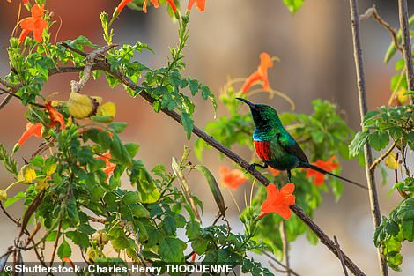

**+7**

View gallery

**Sunbirds are native to Senegal and its Bandia Reserve, Rob reveals**

Most human skeletons have now been removed but a skull remains on show at the base of the tree in Bandia.

Back at the resort I can’t resist taking one last dawn walk along the beach as the sun tips its hat upwards towards another day of balming heat. The undertow tug of the Atlantic warns me to keep my sea adventures to nothing more than a toe-tickling dip.

Yet the fishermen in the village of Pointe Sarene, a 30-minute walk from the resort, are hardier than me, tugging their pirogue boats towards the shore at 7am loaded with a nocturnal catch of dorada and captain fish.

I venture inside a shack on the shoreline that sells everything from soap powder to car axles and partake in a cup of touba coffee infused with cloves, which is quite a bargain at 70CFA (around 9p) for a cup. I suspect Senegal will shortly be on the radar of those of us keen to escape the rigours of a British winter.

# Vegan inflight meals are taking off across the globe, here's what airlines are offering

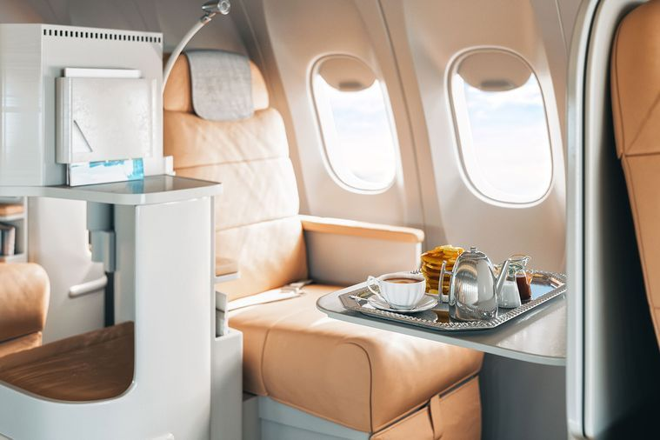

*First class plane meal. Source: istock*

**It's another way international airlines can help make air travel more sustainable.**

As an industry, aviation is a big contributor of CO2 emissions so it’s only normal they look at ways to offset this.

From switching to bamboo cutlery, offering carbon offsets to passengers to signing the Global SAF (sustainable aviation fuel) Declaration and now offering vegan meals, many airlines are trying to make a commitment to becoming more environmentally friendly.

While vegan menus aren’t necessarily new for some airlines, the difference is that they are being taken a lot more seriously. Rather than just a plate of cooked vegetables and a side of fruit, airlines are now becoming more creative and serving [plant-based](https://www.delicious.com.au/recipes/collections/gallery/raw-vegan-recipes/23q17ak1) koftas and elaborate desserts.

Emirates is the latest airline to unveil a new menu to meet the demand for plant-based cuisine onboard, announcing a multimillion-dollar investment in October 2022. A curated menu of gourmet vegan dishes has been introduced for First and Business Class, while Economy Class has a refreshed selection of plant-based produce.



***Related story:***[***Why vegans are flying with Emirates***](https://www.delicious.com.au/travel/travel-news/article/why-vegans-flying-emirates/q6xyx91a)

[Vegan](https://www.delicious.com.au/recipes/collections/gallery/46-vegan-recipes-that-arent-just-sides/beoxrbfm) options are available to order and pre-order onboard as well as in Emirates Lounges. Serving vegan options since the 1990s, mainly for religious requirements, the airline has noticed a sizeable increase in interest in vegan dishes over the last decade.

With over 180 plant-based recipes in its repertoire, the new vegan menu features unique koftas made with plant-based products from the world-renowned Beyond meat company – only for the pointy end of the plane though. Other core ingredients include the inimitable tofu, cauliflower steak, mushroom ragout, mango salad timbale and the list goes on.

[Singapore Airlines](https://www.delicious.com.au/travel/travel-news/article/singapore-airlines-new-economy-class-sustainable-meal-packaging/pm3nbh8q) is another popular airline among vegans. Options usually have a Western or Asian twist such as spaghetti marinara served with salad, fruit, or chilli with rice, steamed veggies and salad. They even serve vegan appetisers before the entrée!

Since 2018, Cathay Pacific has added variety to its vegan repertoire, serving Beyond Burgers in their Pier First Class Lounge in Hong Kong. It was also the first airline to serve OmniPork. OmniPork is a vegan version of pork made of a blend of pea protein, non-GMO (genetically modified organism) soy, shiitake mushrooms and rice. In October 2019, the airline served OmniPork dishes to Business Class passengers including OmniPork Bolognaise with Garganelli [pasta](https://www.delicious.com.au/recipes/collections/gallery/51-pasta-recipes-to-curb-those-carb-cravings/xjv8q2jk) on all long-haul flights departing from Hong Kong.

Those flying out of Air New Zealand to the US can enjoy the Bill Gates-backed Impossible Burger. Originally served only in Business class, the airline is looking to expand their vegan offering and meals are available in all classes upon request.



In 2020, Qatar launched its first à la carte vegan menu for Business Class. A true culinary experience for passengers leaving Doha, the menu includes sophisticated dishes including smoked moutabel; spiral courgettes and arrabbiata sauce; tofu and spinach tortellini; Asian barbecue tofu, noodles, scallions and shiitake; fried tofu with vegetable tagine; and cauliflower couscous and kalamata bruschetta. Vegan options are also available in economy via pre order.

[Qantas](https://www.delicious.com.au/travel/travel-news/article/qantas-launches-new-inflight-food-menu-domestic-economy/y7ve6l6b) is reported to be developing a vegan menu, with plant-based dishes and faux meat alternatives expected to be part of in-flight and airport lounge menus by the end of the year. The airline’s head chef, Neil Perry, is looking into plant-based meats like Beyond, Impossible and V2 – an [Australian](https://www.delicious.com.au/travel/travel-news/article/australian-airline-bonza-launches-new-domestic-inflight-menu/x8x0h4pb) product. The new vegan menus are likely to debut in Qantas airport lounges first, before rolling out across domestic and international flights.

But really, vegan meals still aren’t the norm and are mostly only brought aboard after being requested, with the creme de la creme menus served on selected routes and in business or first. To make sure you get a vegan meal on your next flight, it’s best to call the airlines at least one week before your departure to pre-order your meal.

This article originally appeared on [*escape.com.au*](https://www.escape.com.au/travel-advice/i-cant-believe-its-not-meat-airline-vegan-menus-are-taking-off/news-story/baeb1633e77844fb2ec68dff8eb7d533). It has been reproduced here with permission.

# Singapore bound? Here's where to eat, play and stay on your next holiday

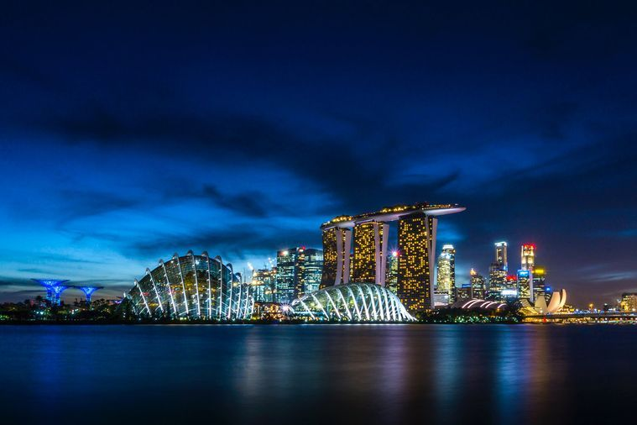

San Marina Bay, Singapore. Source: Mike Enerio, Unsplash.

**Travel inspo, incoming.**

Singapore is a diverse and vibrant dining scene. With borders open, hotels which opened just prior to the pandemic and newer ones are in full swing. Eating is a national pastime and, invariably, that means eating out, whether at a humble hawker stall or at one of the eye wateringly expensive fine dining restaurants.

## 10 BEST FOOD EXPERIENCES AND RESTAURANTS IN SINGAPORE

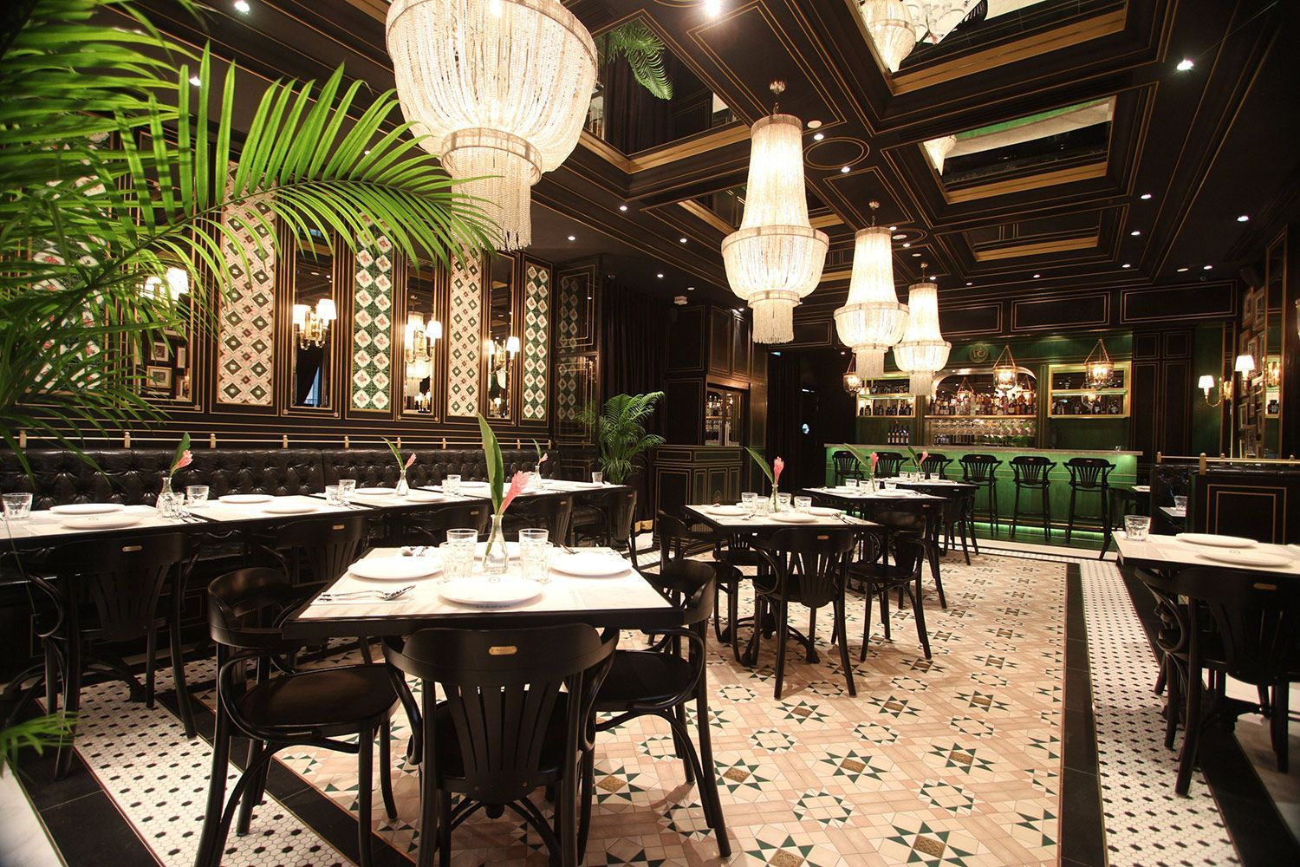

### **1. National Kitchen by Violet Oon**

A culinary icon with several restaurants, [Violet Oon](https://violetoon.com/national-kitchen-by-violet-oon-national-gallery-singapore/) is Nyonya or Peranakan, a descendant of early Chinese migrants intermarried with local Malays and a fine exemplar of their cuisine. Located in what was once the Historic City Hall, the dark wood and floral-printed Straits Chinese décor is as good as the authentic food.

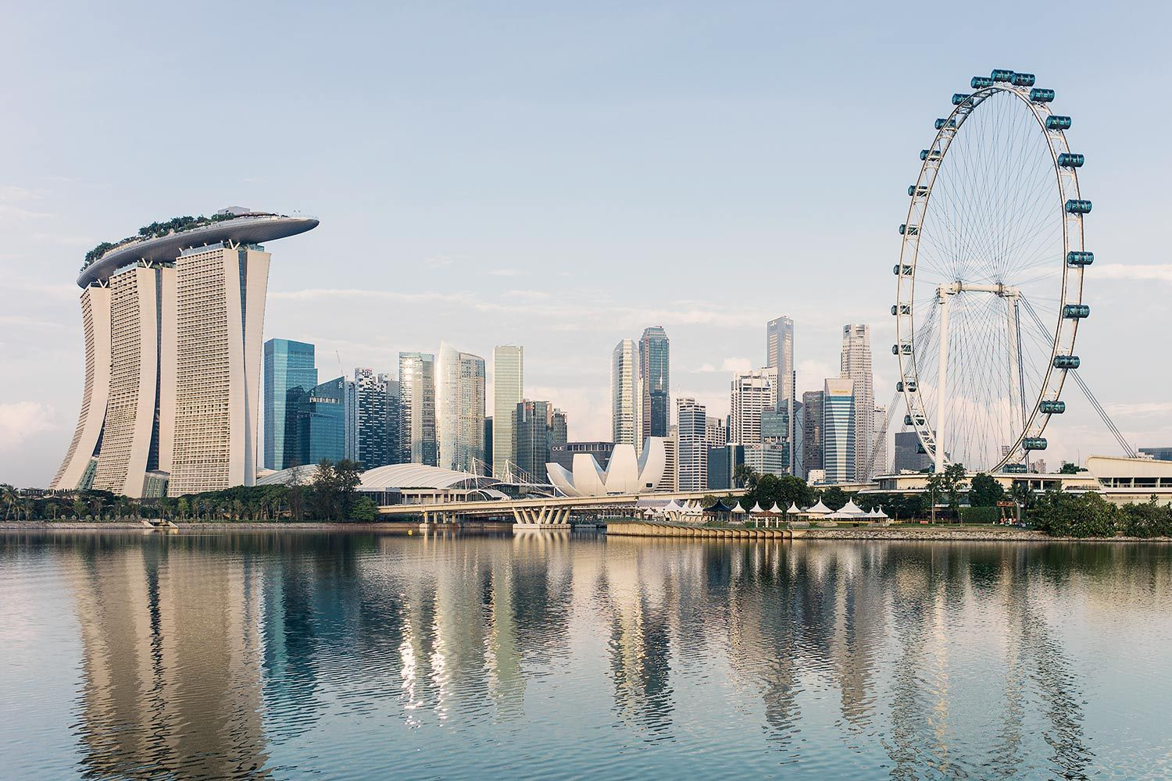

### **2. Thevar**

[Thevar](https://thevar.sg/)offers a creative contemporary take on Indian food, with sublime service which has seen it now awarded two Michelin stars. The flavours and names like Chettinad chicken roti may be familiar but the presentation is elegant, a degustation of complex flavours, fresh produce and integrated spicing in perfect-sized portions.

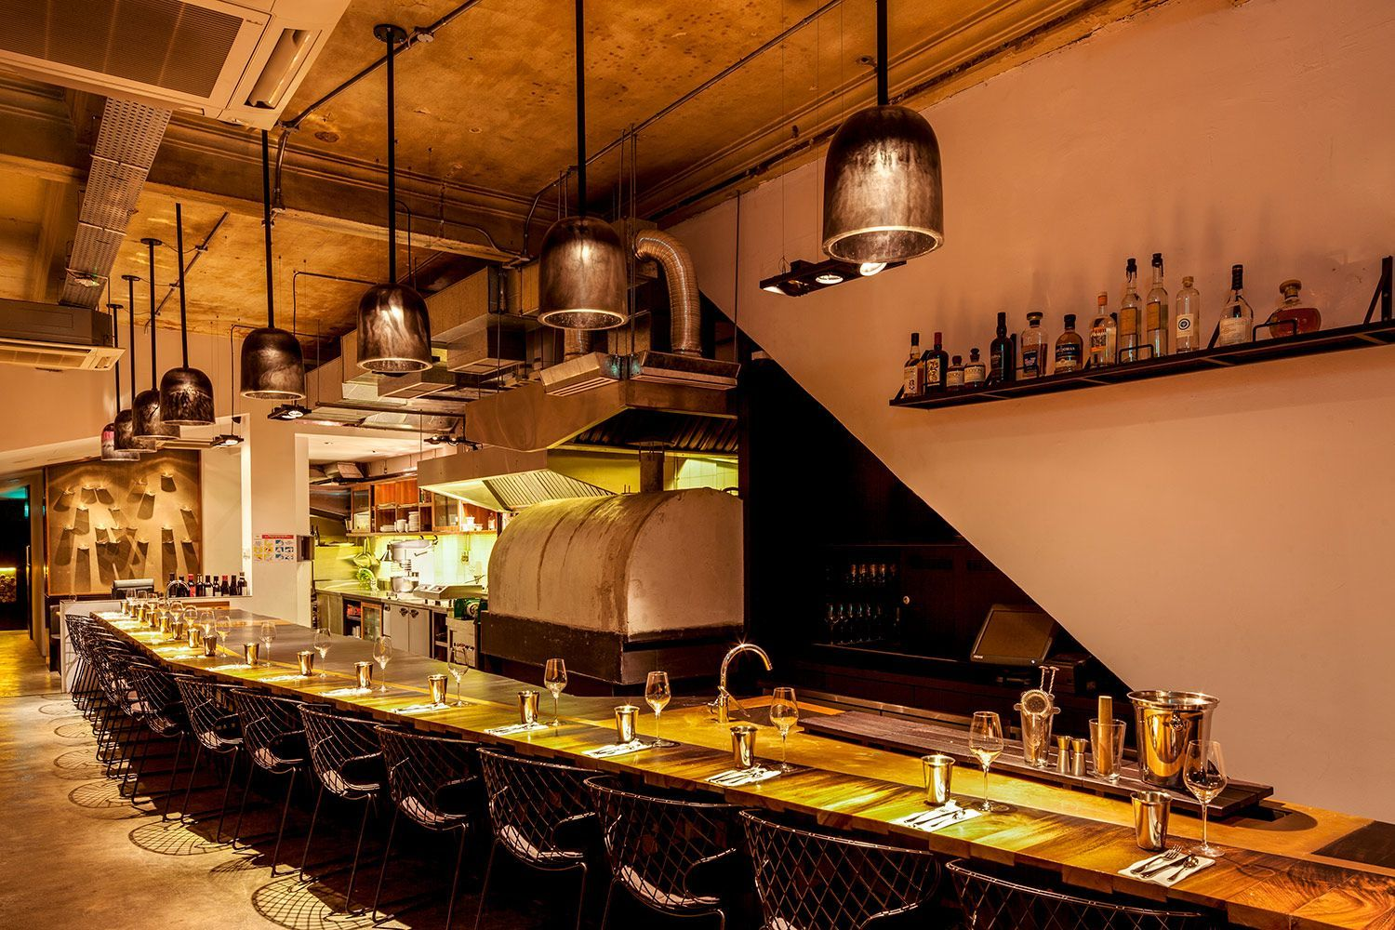

### **3. Burnt Ends**

[Burnt Ends](https://burntends.com.sg/) has moved to Dempsey Hill, with both a Michelin star and ranking in World’s 50 Best Restaurants.  Perth-born Dave Pynt directs the modern Aussie style BBQ with relaxed service, chefs often bringing out dishes and discussing them. The menu changes daily and it’s not all about fabulous meat as fish, crab and vegetables are also given the wood-fire magic.

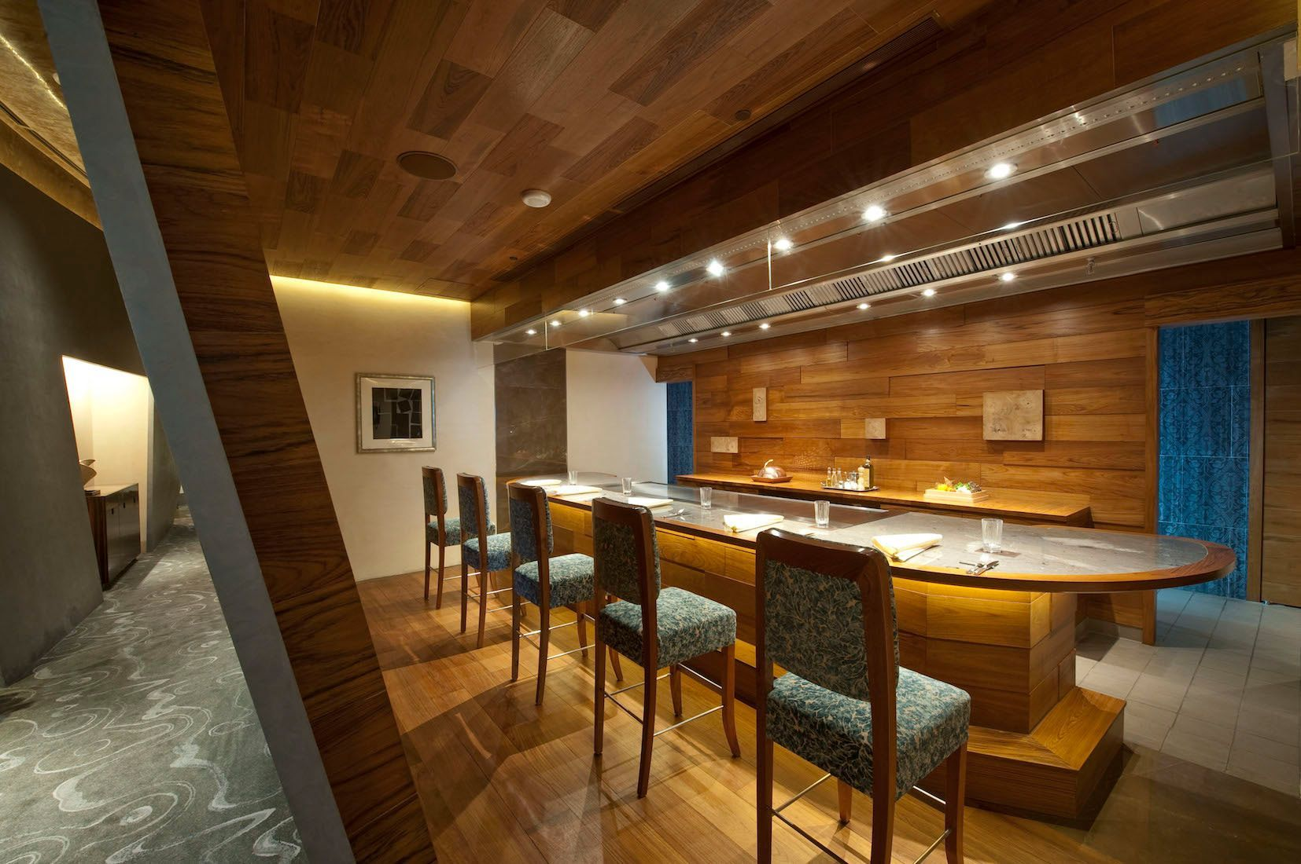

### **4. Waku Ghin by Tetsuya Wakuda**

[Waku Ghin](https://www.tetsuyas.com/waku-ghin) by Tetsuya Wakuda has reopened after 2 years’ extensive renovations, retaining two Michelin stars. Walk in to eat informally at The Bar with Japanese-style cocktails, sake and wine or go all out at the 10-seater Chef’s Table for an incredible omakase experience of the best produce and seasonal specials. Who else would serve cold Capellini Pasta with Winter black Truffle and Oscietra Caviar?

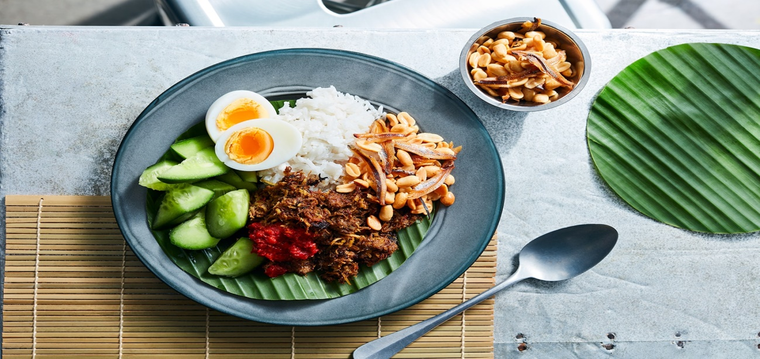

### **5. Coconut Club**

[Coconut Club](https://www.thecoconutclub.sg/) serves upmarket Nasi Lemak (hawker coconut rice). The owner was so obsessed with this dish that he hunted down the best coconuts from Malaysia, finding the perfect breed to perfect his Nasi Lemak. He makes several of the condiments and accompanying side dishes from scratch. Their coconut based desserts are also a true winner.

***Related story:***[***Melissa Leong’s foodie guide to Hua Hin, from squid jerky to mango sticky rice***](https://www.delicious.com.au/travel/international/gallery/melissa-leongs-guide-hua-hin-eat-drink-stay/khbkvwap)

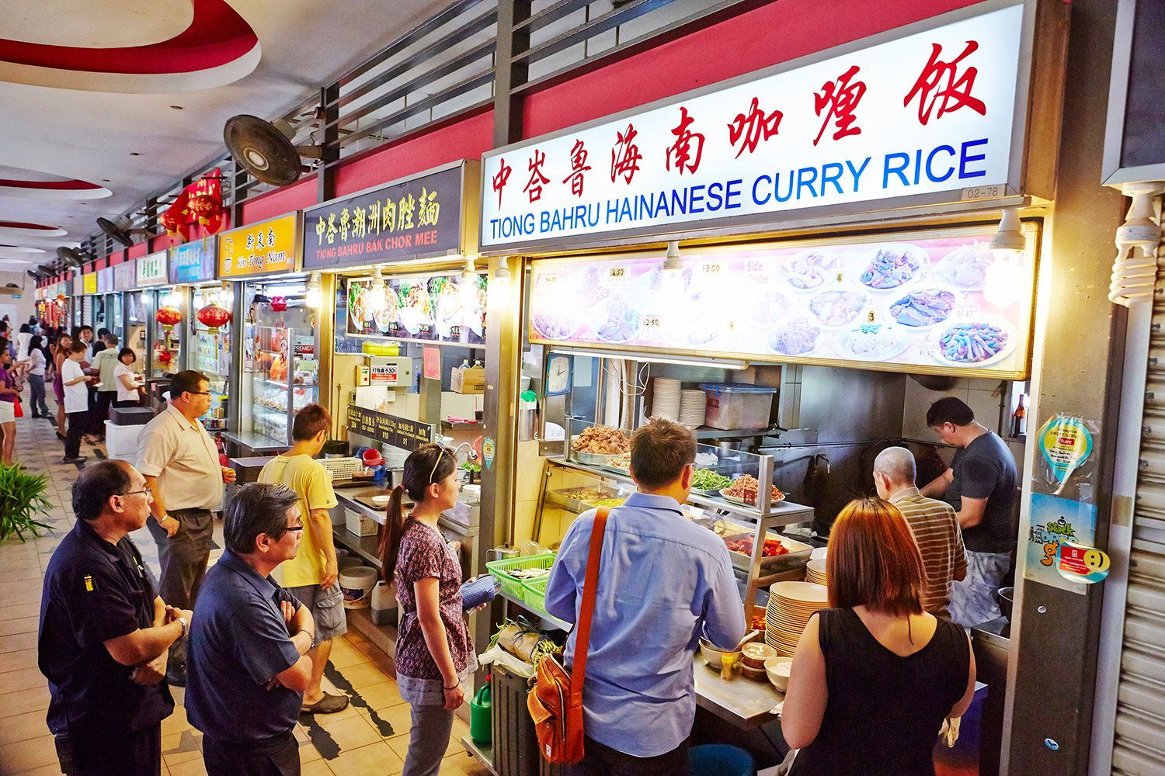

### **6. Hawker Centres**

Hawker Centres are vibrant all over Singapore. Amoy Street Food Centre is great for Ah Ter Teochew Fish Ball Noodles; Ho Kee Bak Chang (traditional Hokkien rice dumplings, and salted egg yolk version), Famous Curry Puff; Good Day for beef hor fun (thick rice noodles in gravy), A Noodle Story for “Singapore-style ramen” and Coffee Break – third-generation hawkers serving traditional coffee or Da Mai – Hakka thunder tea rice.

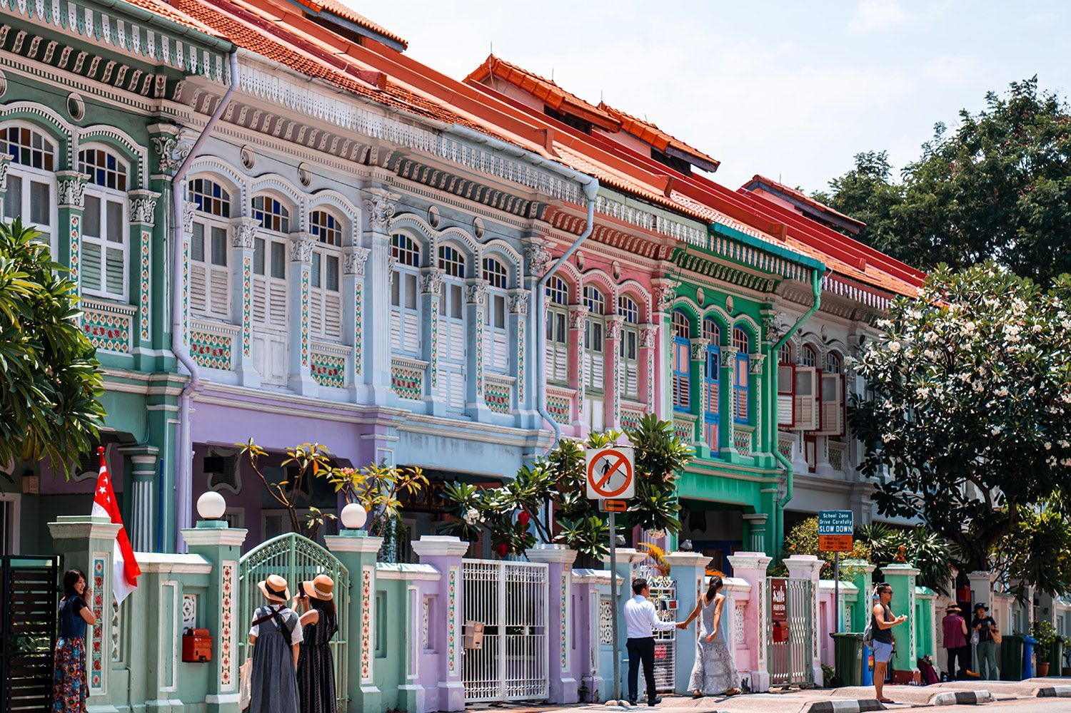

### **7. Asador**

[Asador](https://www.asadorsingapore.com/)opened in 2021 in Joo Chiat, a modern, stylish Spanish restaurant with a Basque parilla grill using different wood for different flavours. No cooking of the dry-aged beef tartare with smoked bone marrow but delicate handling of grilled baby corn, harissa mayo & sweetcorn. Cochinillo or roast suckling pig is a must.

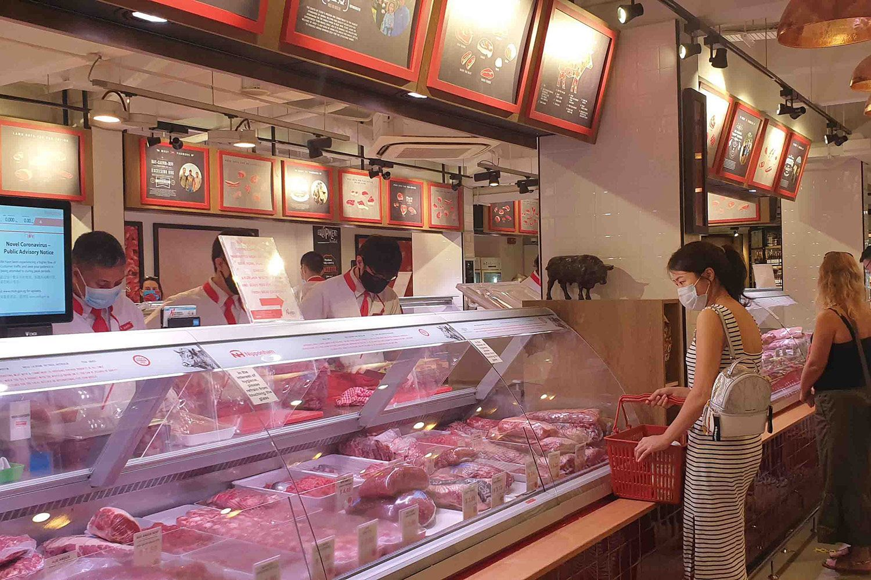

### **8. Huber’s Butchery**

[Huber’s Butchery,](https://www.hubers.com.sg/) Dempsey Road, is a must if you have the opportunity to cook, though there are pre-prepared foods too. A family-run high-end butchery it manufactures and processes top quality meat products and also supplies cheese, wine, seafood and all manner of pantry and deli items as well as equipment. It is a foodies’ wonderland.

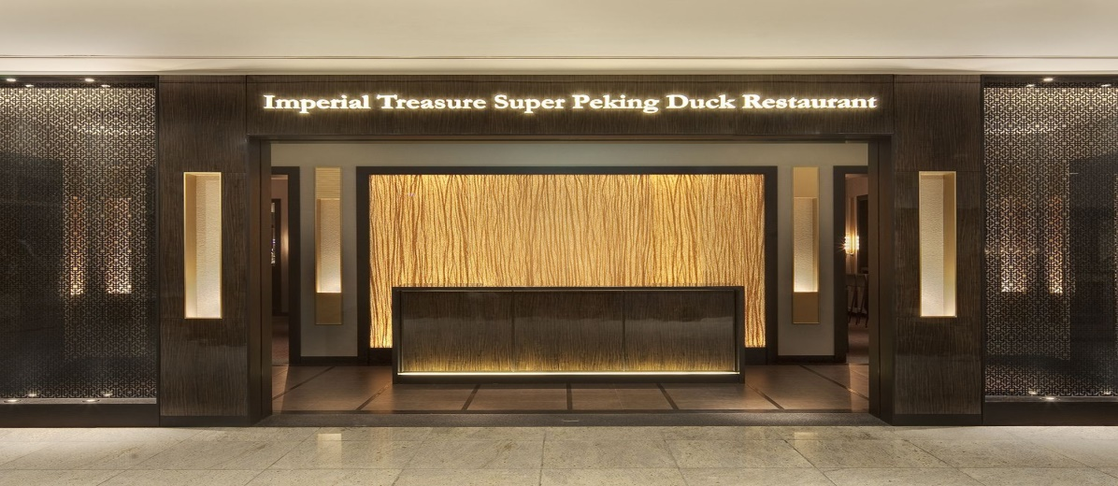

### **9. Imperial Treasure Super Peking Duck**

Peking Duck is all over Singapore but is superb at [Imperial Treasure Super Peking Duck](https://www.imperialtreasure.com/restaurant/ImperialTreasureSuperPekingDuck-2) in Paragon, Orchard Road. This is the real deal, prepared in the traditional method, the skin carved tableside with pancakes, green onions, celery and hoisin sauce, with various options for the meat in a second course.  Order in advance.

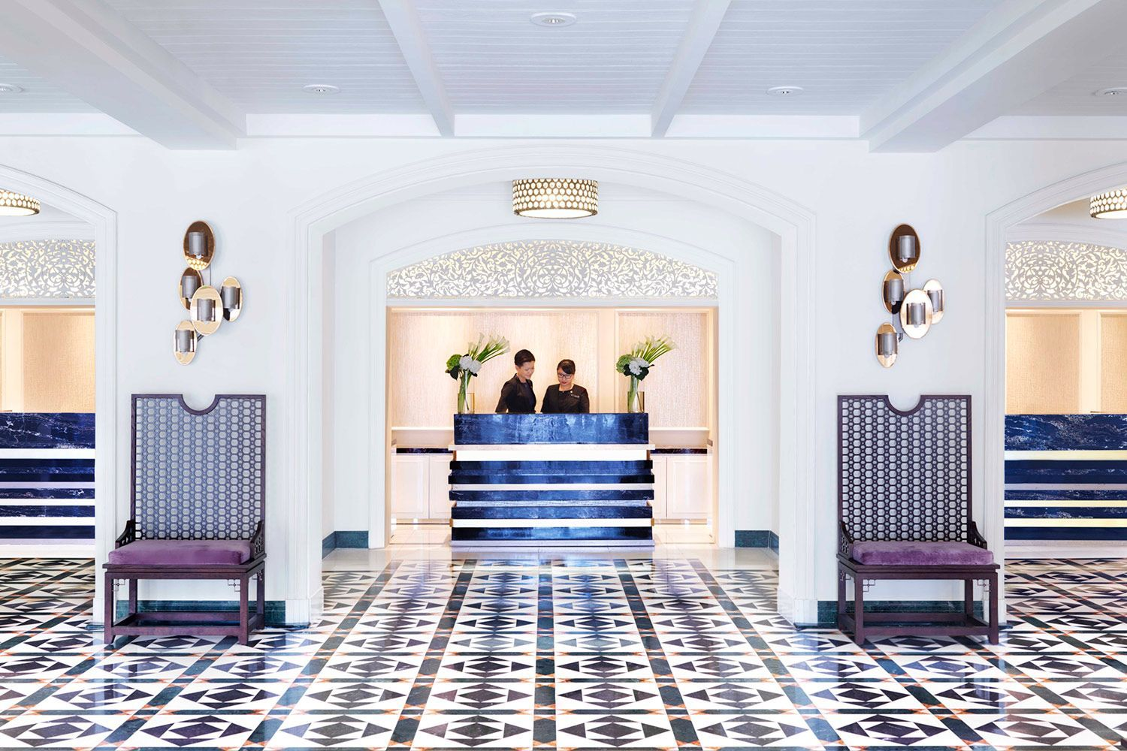

### **10. A DayAway**

There’s more than food on offer if you escape for [a DayAway in Singapore](https://mydayaway.com/) which offers exclusive daytime experiences in prestigious hotels you might not otherwise see. This could be a pool, cabana and dining experience at the Dusit Thani Laguna or InterContinental Hotel which also offers High Tea in the luxurious Presidential suite; cocktails, duck and dessert at The Duxton Reserve or Swim & Savour Kaiseki at the Pan Pacific Hotel.

***Related story:***[***What to do if your flight is cancelled, according to an airline worker***](https://www.delicious.com.au/travel/travel-news/article/if-flight-cancelled-according-airline-worker/ksvu26it)

## 5 BEST NEW HOTELS IN SINGAPORE

### **Raffles Singapore**

### **1. Raffles Hotel Singapore**

[Raffles Hotel](https://www.raffles.com/singapore/) is an historical icon, its second major restoration maintaining the golden age luxury, charm and service. Every detail is taken care of: amazing accommodation, cocktails at the Writer’s Bar, history tours, High Tea in the Grand Lobby or special dining at La Dame de Pic, recently awarded a Michelin Star.

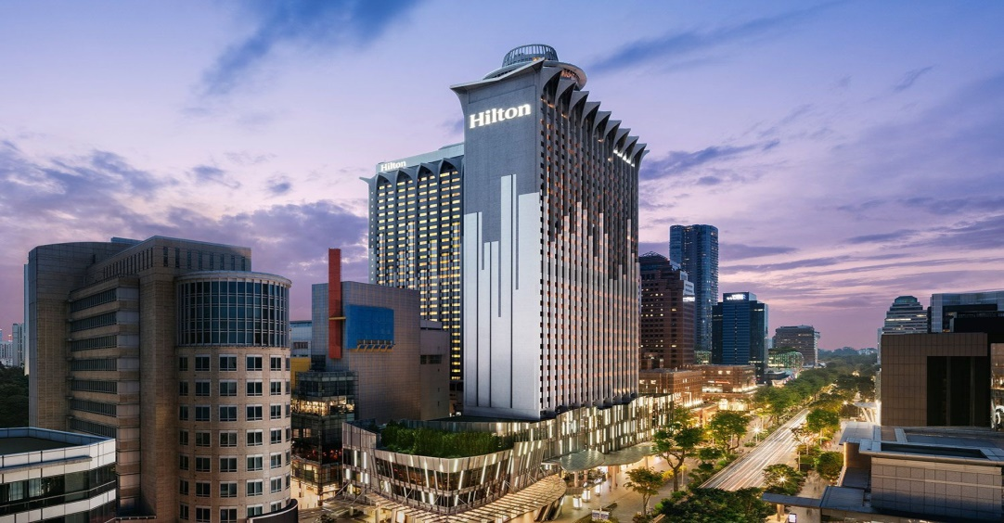

### **2. Hilton Singapore Orchard**

[Hilton Singapore Orchard](https://www.millenniumhotels.com/en/singapore/orchard-hotel-singapore/) (formerly Meritus Mandarin Orchard) is the largest hotel in the Asia Pacific. Right on Orchard Road it nevertheless has a strong botanical influence in its interiors and eco-friendly focus. The design manages not to make it feel huge though this also allows five different dining options including Osteria Mozza by Nancy Silverton, all-day multi-cuisine dining in Estate and Shisen Hanten with two Michelin stars.

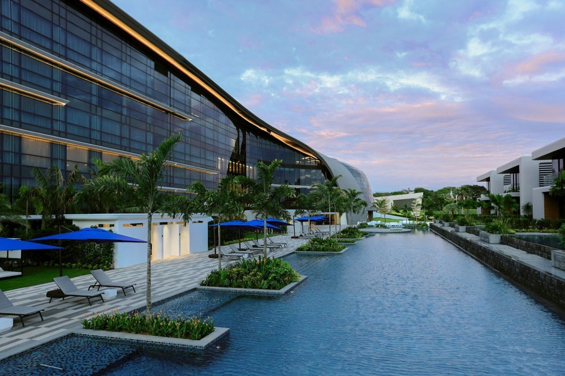

### **3. Dusit Thani Laguna Singapore**

[Dusit Thani Laguna](https://www.dusitthanilagunasingapore.com/)Singapore has direct access to two championship golf courses and three beautiful swimming pools.  With its own brand of Thai hospitality, it also focusses on wellness with an Eat Well, Sleep Well programme. There are a range of dining options including Thai, Yue (Guangdong), Nikkei, Punjab Tandoor and Mediterranean.

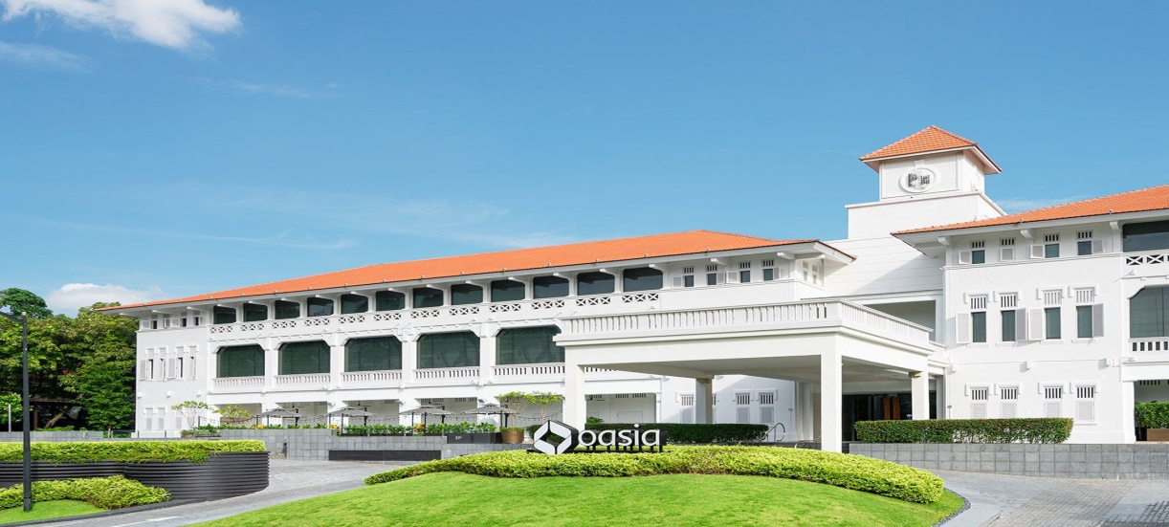

### **4. Oasia Resort Sentosa**

[Oasia Resort Sentosa](https://www.oasiahotels.com/en/singapore/hotels/Oasia-Resort-Sentosa) is a new addition to the resort offerings on Sentosa, designed to relax, recharge and refuel the mind. Offering several luxury wellness activities, the property boasts an infinity pool, gym and all day dining facilities featuring fresh produce grown in the hotel’s own garden.

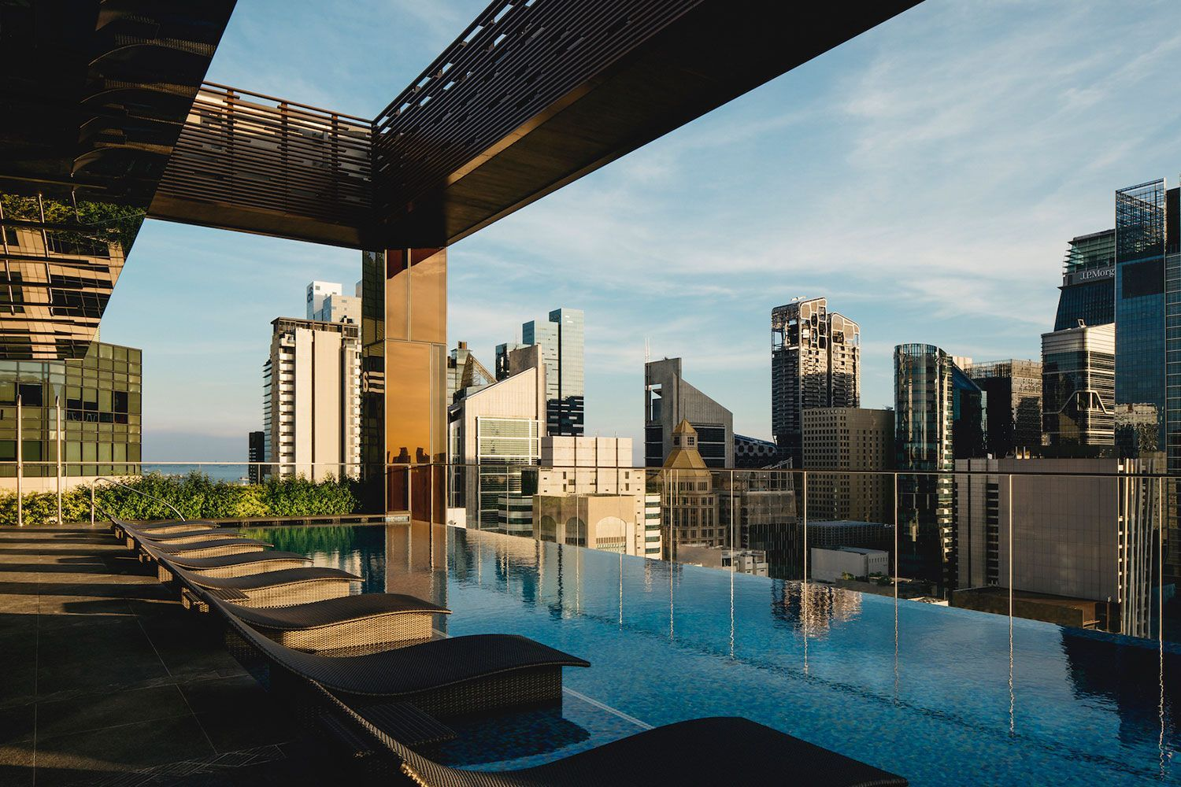

### **5. The Clan Hotel**

[The Clan Hotel](https://www.theclanhotel.com.sg/)in the CBD takes its name from the clan associations that dotted the neighbourhood, as Singapore’s forefathers helped Chinese settlers make the land their own. It offers a different take on Singaporean hospitality. There’s a free precinct tour led by The Clan Keeper including the history of Amoy Street, Telok Ayer Street and Chinatown. 30 stories high there is a Sky Pool, Gym and Terrace.